Complementary Methodologies:

Positioning Theory and Grounded Theory

Emily Rochette
The University of Melbourne
rochette@student.unimelb.edu.au

Christine Redman
The University of Melbourne
redmanc@unimelb.edu.au

Paul Chandler
Australian Catholic University
paul.chandler@acu.edu.au

How do science teachers assess their use of digital technologies? This research investigates teachers’ complex work as they prepare to enact the Victorian Curriculum (Victorian Curriculum and Assessment Authority [VCAA], 2016) to understand how teachers’ beliefs have become reified and discursively active (Davies & Harré, 1990; Harré, 2002). Positioning theory (Harré & van Langenhove, 1999) was the overarching philosophy in the research design. Although not unknown, positioning theory is an appropriate methodology because it is complementary to the well-established constructivist grounded theory methodology (Charmaz, 2014). An excerpt from an interview transcript illustrates how positioning theory can be applied to grounded theory coding procedures.

Introduction
This paper introduces research being completed for a Doctor of Philosophy at the University of Melbourne. Positioning theory (Harré & van Langenhove, 1999) was the overarching philosophy used in the research design to understand how science teachers assess their use of digital technologies. In this paper, I draw on the epistemological and theoretical perspectives of both positioning theory and constructivist grounded theory (Charmaz, 2014) to justify utilizing positioning theory as a methodology in its own right. Interview data drawn from one teacher demonstrates how positioning theory can be applied to grounded theory coding procedures.

Purpose of the Research
This research sits at the intersection of the Digital Technologies and Science learning areas of the Victorian Curriculum (VCAA, 2016c). The Digital Technologies learning area aims to provide practical opportunities for students to develop an understanding and become confident users of digital systems for current and future needs (VCAA, 2016b). According to the VCAA, the Digital Technologies curriculum directly complements the Science Curriculum (VCAA, 2016a).
Drawing on data of the 2013 Staff in Australia’s Schools (SiAS) survey (McKenzie, Weldon, Rowley, Murphy, & McMillan, 2014), Weldon (2016) reported that nationally ten percent of general science teachers were considered out-of-field. These teachers did not have the teaching methodology nor second-year tertiary study in any science. Geoscience refers to a sub-discipline of Earth science including the physical structures of the Earth and the processes that act on them (King, 2008). These topics should be taught at levels eight through ten of the Victorian Curriculum (VCAA, 2015), yet internationally geoscience is largely taught by out-of-field general science teachers (King, 2008, p. 189; Lewis & Baker, 2010). Further, the Digital Technologies curriculum standards seem to assume and expect that teachers are able seamlessly integrate digital technologies into their geoscience pedagogies.
Sitting at this curricular crossroads, I sought to offer a model supporting out-of-field general science teachers to teach topics mandated by the curriculum and understand the affordances of the digital tools, if any. To begin I needed to understand how science teachers assess their uses of digital technologies in their classes and positioning theory (Harré & van Langenhove, 1999) was considered the best methodology to do so.

Methodological Similarities: Positioning Theory and Constructivist Grounded Theory
Although not unknown, positioning theory (Harré & van Langenhove, 1999) has not been formally labeled a methodology in handbooks of qualitative research. Positioning theory, however, can be considered an overarching research methodology due to its similarities with the well-established constructivist grounded theory methodology (Charmaz, 2014).
Positioning theory has its roots in social constructionism (Harré & van Langenhove, 1999; Howie & Peters, 1996) where descriptions of the social world are possible, numerous and depend on the identity of people who contribute to them and the places and times these descriptions are formulated (Harré & van Langenhove, 1999). Grounded theory methodology began with an objectivist stance (Glaser, 1978; Glaser & Strauss, 1967), but took a constructivist turn with the work of Charmaz (2014) who has affirmed that constructivist grounded theory analyses align with the constructionist ontological perspective.
Both positioning theory and constructivist grounded theory take an interpretive theoretical perspective. Positioning theorists study performance style, the ways people do things and the meanings ascribed to their actions (Harré & Moghaddam, 2003). Action hinges on judgement and who people are, their identity, is a product of interpersonal actions including:

- What a person is physically and temperamentally able to do;
- What a person has done, is doing or will do; and
- What a person is forbidden or permitted to do (Harré & van Langenhove, 1999).

Grounded theory has emerged from the pragmatist theoretical tradition (Strauss, 1991) which informed Blumer’s (1969) symbolic interactionism. Consider the following quote from Blumer (1969):

... human beings interpret or ‘define’ each other’s actions instead of merely reacting to each other’s actions. Their ‘response’ is not made directly to the actions of one another but instead is based on the meaning which they attach to such actions (p. 19).

For the constructivist grounded theorists, and positioning theorists, reality is indeterminate and fluid. There is a dynamic relationship between action and meaning where individuals actively create and mediate meaning (Charmaz, 2014).
For both positioning theorists and constructivist grounded theorists data collection begins with participants’ meaning making. Harré et al. (2009) remind us that participant’s discursive practices, what they say and do, are indicative of the normative frames which people think, feel, act and perceive. Similarly, Charmaz (2005) suggests that understanding ‘what things mean to people makes what they do with them comprehensible [and] how people act toward things in their worlds indicates their relative significance’ (p. 521).
From epistemology to data collection, this brief discussion of the similarities between positioning theory and constructivist grounded theory justifies utilizing positioning theory as a methodology for research design. In the next section, the positioning theory triad and constructivist grounded theory coding procedures are used to analyze interview data to understand a teacher’s perceptions of his digital technology use in the science classroom.

The Positioning Theory Triad and Line-by-Line Coding
Understanding teachers’ self-assessments of their digital technology use is underpinned by the assumption that teachers’ discursive practices are reasoned through their pedagogical beliefs and sense of personal agency. Figure 1 illustrates the positioning triad, a conceptual framework I have used to analyze and interpret interview data.
Within a participant’s discursive practices lie assumptions that inform behaviors and surface expectations. A mis-/match between what is said and done can be telling of an individual’s sense of personal agency. The term position refers to a cluster of rights and duties that allow individuals to perform actions with significance. As a teacher, I have certain rights that I may ask the students to attend to. I also have duties to which I must attend for my students. Similarly, students have rights they may claim and duties they may assume. Harré (2012) reminds us that symmetry may not exist between our self-identified rights and others’ duties. Although it is my right as a teacher to assign homework after every lesson, the students may not accept their duty to complete it! Story lines close the positioning triad and emerge from participants’ interpretations of the social world.
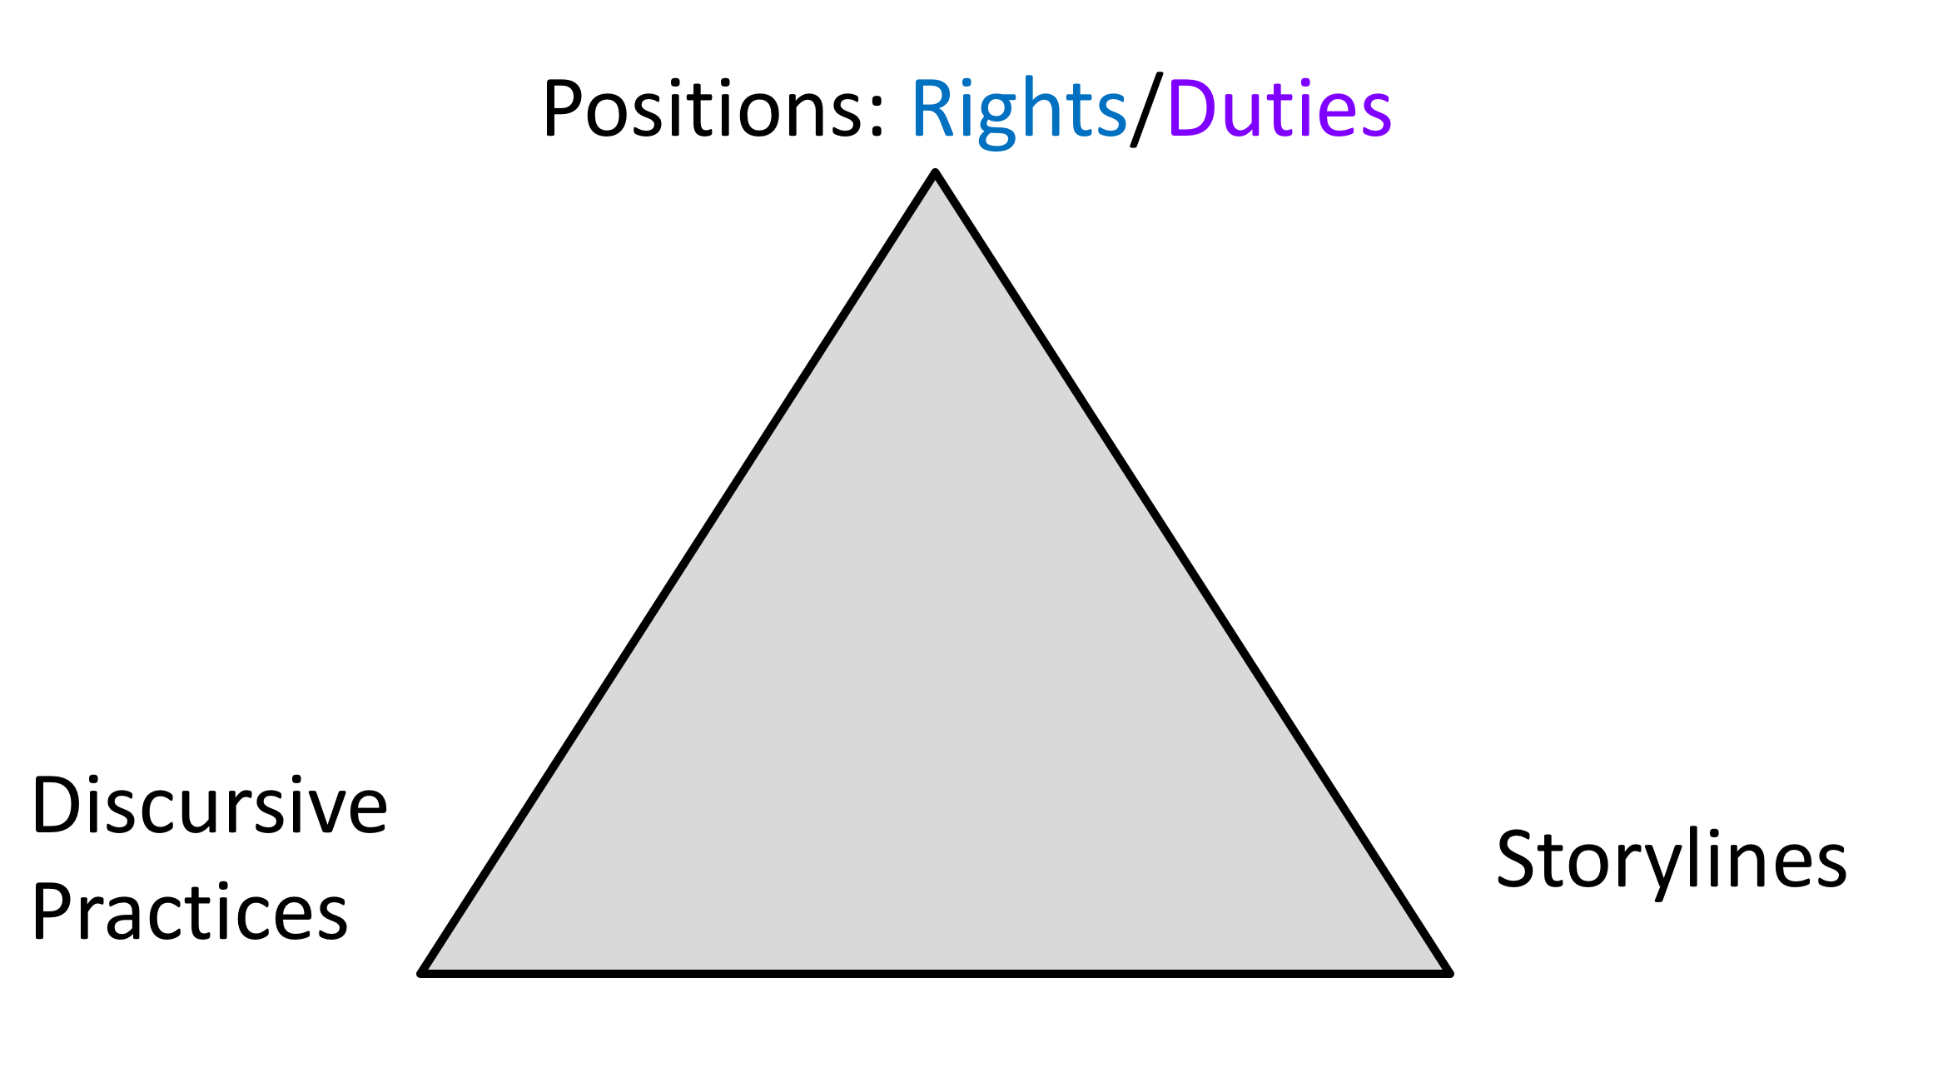
Figure 1: The Positioning Theory Triad

To begin to understand how teachers self-assess their digital technology use in science, interview data was coded line-by-line to “explicate how people enact or respond to events, what meanings they hold, and how and why these actions and meanings evolved” (Charmaz, 2014, p. 113). Table 1 shows an example of this coding utilizing data from Ethan, a career research scientist turned teacher in his second year of service at Riverside High.

Table 1
Interview data coded line-by-line using the positioning triad

Line-by-Line Coding: | Interview Transcript:
Teacher-identified student duties to be able to use software  Teacher-identified student rights to be taught about websites and search terms  Teacher-identified student duties to know the conventions of the Internet  Teacher-identified student rights to be taught about conventions of the Internet  Teacher self-identified duty to teach planning but not technology | Well, I think, uh, Microsoft Office would be one and to quite a high detail, so things like knowing how to format document, creating charts, adding labels, how to use, um, PowerPoint properly. Um, uh, they-I think they need to know how to use Google properly, how to do proper searches, be taught what’s a reliable website what’s not, how to use search terms, how to narrow down what they’re looking for. Um, and, uh, I think they need to know there’s certain conventions in, um, surfing the web and using the net in general, like there’s buttons and buttons take you to somewhere and you’re-there’s certain conventions with that, there’s a digital literacy if you like. And maybe that needs to be formally taught as well.  *** Later in the same interview ***  Um, so I focus a lot on the planning, um, and not so much on actually teaching them how to do it in terms of the technical stuff.

In the first section of this transcript, Ethan is speaking about the digital skills his students are expected to develop. The rights and duties of Ethan’s students seem to change moment-by-moment as he tentatively reflects that students have the right to ‘maybe’ be taught these skills. In the second part of the transcript, Ethan is explaining how he scaffolds students working to complete summative assessments with digital technologies. Utilizing the positioning triad, these excerpts suggest that although Ethan is able to identify the desirable digital skills his students must work toward developing, he does not personally have the duty to teach them these skills. This assumption may inform Ethan’s classroom practice to teach science content as opposed to digital skills. For Ethan, the storyline that begins to emerge is that science teachers are not teachers of digital technologies.
This research is based on data from 10 teachers and six year nine student participants that have been initially coded in the same way. Focused coding of these rights and duties yielded two types of digital technology use in Riverside High science classrooms:

- Technology use to transmit science content; and
- Technology use to facilitate doing science.

Although Ethan was a career research scientist, he was observed to utilize digital technologies to transmit science content: “...if there’s a website out there that has all of the content that I’m trying to teach, if I can just say to the students: Have a look at this, play around with the animations, um, I’ve got a sheet here, you can answer some questions...”
Finally, these codes were categorized into a continuum for digital technology use by Riverside High teachers shown in Figure 2. Teachers were not presumed to sit neatly within the boundaries of the levels of this continuum, however reflections of their practice overall were indicative of their place within this continuum at the time of our conversations. At the beginning of this study, Ethan sat at the second tier of novice. These categories served to inform the design of a unit of work to support teachers in ways that not only met their skills and existing practices, but also sought to build their capacities to teach geoscience content with both familiar and new digital technologies.

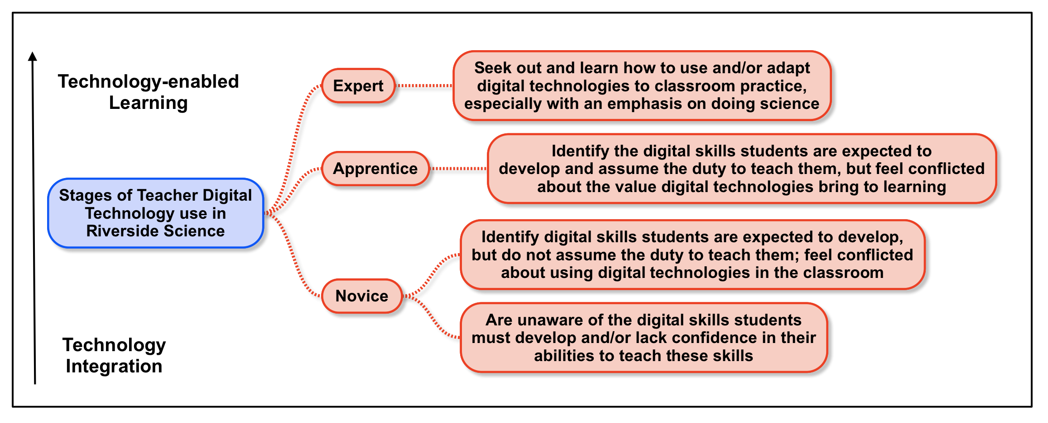 Figure 2: Continuum for Digital Technology Use by Riverside High Science Teachers

Conclusion
This paper has introduced research utilizing positioning theory as an appropriate methodology for research design. An example of line-by-line coding was provided to show the discursive practices and moment-to-moment positioning illustrated an emergent storyline from one science teacher’s self-assessment of his digital technology use in the classroom. Focused coding and categorization of data from 10 teachers and six student participants were used to create a continuum for digital technology use that served to inform a unit of work to scaffold out-of-field teachers utilizing digital technologies to teach geoscience.

References

Blumer, H. (1969). Symbolic interactionism : perspective and method. Englewood Cliffs, N.J.: Prentice-Hall.
Charmaz, K. (2005). Grounded Theory in the 21st Century: Applications for Advancing Social Justice Studies. In N. K. Denzin & Y. S. Lincoln (Eds.), The SAGE handbook of qualitative research (3rd ed., pp. xix, 1209 p.). Thousand Oaks: Sage Publications.
Charmaz, K. (2014). Constructing grounded theory (2nd ed.). Los Angeles: Sage.
Davies, B., & Harré, R. (1990). Positioning: The discursive production of selves. Journal for the theory of social behaviour, 20(1), 43-63.
Glaser, B. G. (1978). Theoretical sensitivity : advances in the methodology of grounded theory. Mill Valley, Calif.: Sociology Press.
Glaser, B. G., & Strauss, A. L. (1967). The discovery of grounded theory; strategies for qualitative research. Chicago,: Aldine Pub. Co.
Harré, R. (2002). Cognitive science: A philosophical introduction: Sage.
Harré, R. (2012). Positioning theory: Moral dimensions of social-cultural psychology.
Harré, R., & Moghaddam, F. M. (2003). Introduction: The Self and Others in Traditional Psychology and in Positioning Theory. In R. Harré & F. M. Moghaddam (Eds.), The self and others : positioning individuals and groups in personal, political, and cultural contexts (pp. vi, 322 p.). Westport, Conn.: Praeger.
Harré, R., Moghaddam, F. M., Cairnie, T. P., Rothbart, D., & Sabat, S. R. (2009). Recent advances in positioning theory. Theory & Psychology, 19(1), 5-31.
Harré, R., & van Langenhove, L. (Eds.). (1999). Positioning theory: moral contexts of intentional action. Malden, Mass: Blackwell.
Howie, D., & Peters, M. (1996). Positioning theory: Vygotsky, Wittgenstein and social constructionist psychology. Journal for the theory of social behaviour, 26(1), 51-64.
King, C. (2008). Geoscience education: An overview. Studies in Science Education, 44(2), 187-222.
Lewis, E. B., & Baker, D. R. (2010). A call for a new geoscience education research agenda. Journal of Research in Science Teaching, 47(2), 121-129. doi:10.1002/tea.20320
McKenzie, P., Weldon, P. R., Rowley, G., Murphy, M., & McMillan, J. (2014). Staff in Australia’s schools 2013: Main report on the survey.
Strauss, A. (1991). The Chicago tradition’s ongoing theory of action/interaction. Creating sociological awareness, 3-32.
VCAA. (2015). The Victorian Curriculum Science F-10. Retrieved from http://victoriancurriculum.vcaa.vic.edu.au/science/curriculum/f-10
VCAA. (2016a). Digital Technologies: Learning in Digital Technologies Retrieved from http://victoriancurriculum.vcaa.vic.edu.au/technologies/digital-technologies/introduction/learning-in-digital-technologies
VCAA. (2016b). Digital Technologies: Rationale and Aims. Retrieved from http://victoriancurriculum.vcaa.vic.edu.au/technologies/digital-technologies/introduction/rationale-and-aims
VCAA. (2016c). Victorian Curriculum Retrieved from http://victoriancurriculum.vcaa.vic.edu.au/
Victorian Curriculum and Assessment Authority [VCAA]. (2016). Foundation - 10 Curriculum. Retrieved from http://www.vcaa.vic.edu.au/Pages/foundation10/f10index.aspx
Weldon, P. R. (2016). Out-of-field teaching in Australian secondary schools.

Acknowledgements
I would like to thank the organizers of the Contemporary Approaches to Research in Mathematics, Science, Health and Environmental Education symposium for providing a space for this work to be presented. Conference attendees who offered feedback are thanked for thoughtful questions which have helped me to reflect on this work. I would also like to thank my supervisors, Christine Redman and Paul Chandler, for their continuous advice, feedback and reflections that challenge and stretch my thinking. Finally, my thanks are offered to the teachers and students at Riverside High who offered their time and reflections which made this research possible.

