FACULTYOFBUSINESS&LAW
LEARNING INNOVATIONS

CLOUDDEAKIN UNIT PREPARATION GUIDE T2 2016

Updated on 07 June 2016

Table of Contents
CloudDeakin Unit Preparation Guide 3

Introduction 3
CloudDeakin Support contact details 3
Echo Support….................................................................................................................................................. 4
Faculty Standard Template......................................................................................................................... 5
Before starting 7
Checklist 10

Appendix 1 – Adding a Video/ Welcome Message 12

Appendix 2 – Managing Discussion Forums 13
Appendix 3 – Managing Resources 18
Appendix 4 – Assignment Dropbox 23

Appendix 5 – Groups 41
Appendix 6 – Quizzes 48
Appendix 7 – Grades 49
Appendix 8 – BB Collaborate 52
Appendix 9 – Echo Recordings 54
Appendix 10 – eReadings 56

Appendix 11 – CloudDeakin Advanced Features 57

CloudDeakin Unit Preparation Guide

Introduction
This guide is designed to assist you in preparing your CloudDeakin Unit for the new trimester. It covers some of the more commonly used tools in CloudDeakin that you will be required to use to get you started for a new trimester.

CloudDeakin Support contact details

Faculty Business and Law Learning Innovations CloudDeakin Support Team provides phone, email, virtual (via Lync/Skype for Business) and in-person support Monday to Friday between 9am to 5pm.
For all CloudDeakin support queries, feedback, issues and assistance, please contact:

Email: bl-learninginnovations@deakin.edu.au

Phone: +61 3 522 73303 (or +73303)

In-person:

Burwood – located at LB5.225
Maria Lentini and Saad Sheikh

Geelong Waterfront – located at AD3.107-01
Ismail Zengin

Echo Support:
For access to previous Echo recordings, editing lecture recordings and linking of recordings to CloudDeakin, please contact Faculty of Business and Law Learning Innovations CloudDeakin Support : bl-learninginnovations@deakin.edu.au or +61 3 522 73303, Mon-Fri, 9am-5pm

For all Echo bookings, admin queries or venue assistance including, technical and venue training, please contact and report all issues to eSolutions Helpdesk:

Hours of operation
- Monday to Friday: 8 am - 8 pm
- Weekends: 11 am - 5 pm

eSolutions Service Desk can be contacted by any of the methods below:

Internal phones 888
Geelong 03 5227 8888
Melbourne 03 9244 6888
Warrnambool 03 5563 3888
Off campus 1800 463 888
International +61 3 5227 8888

Student access
Students are automatically enrolled 1 week prior to trimester starting.

Faculty standard template

Faculty CloudDeakin units for each trimester are setup using the standard Faculty template.

- Generic welcome news item, this item is set to draft and can be customized by accessing the news tool.
- Resource modules, please note those noted with * are empty folders ready for staff to upload content to, these can be removed or edited:

Unit Information & Introduction
Links to the PDF & WWW version of unit guides are automatically uploaded to this folder by BL-CloudDeakin Support.

*Learning Resources

Echo Class Recordings
A link to the Student Guide for Trouble Shooting Echo is attached to this module, there are also links to the CloudDeakin student guides for Echo.

*Assessment Resources
    - *Assignment 1
    - *Assignment 2
    - *Exam
    - Plagiarism and Collusion Support Resources for students

Cloud Classrooms (Bb Collaborate or Skype for Business)

- Generic Assignment Folder Submissions:
  - Check your draft - Turnitin is setup for students to check their draft assignments against Turnitin, this assignment folder is not used for marking students work.
  - Tx Year Unitcode Assignment Setup EXAMPLE Only, is setup for staff to base their assignment dropboxes on for the trimester. This shows where to embed the assignment declaration into your assignment folder.
- Generic Discussion forums (Discussions are located under the collaborate link in the navigation):
  - General Unit Discussion Forum
  - Assessment Discussion Forum
  - Peer Learning, Networking and Community Forum

As Unit Chair you can create new items and customise the existing template. Starting each
trimester with a fresh CloudDeakin unit based on the template means that you will be free of any potentially confusing out-of-date information, files, discussions, online tests, assignment dropboxes and grade items created in past trimesters. However, if you require content from a past trimesters CloudDeakin unit BL Learning Innovations can copy it over for you. Content that can be copied from a previous trimester includes:

- Resources (content) – modules and topics
- Site files
- Discussion forums and topics

- Quizzes/testbanks
- Checklists
- Widgets
- Modified navbar

Note: Copying resources from a previous trimester will not include previous discussion messages, student assignment submissions or student grades.

Please Note:

- Whilst you can copy over assignment folders from a previous trimester it is best to create new assignment folders each trimester especially. Group assignment folders revert to individual when copied from a previous trimester.
- Grade items are not copied from a previous trimester because in the past it has proven confusing for students to see old items in the grades items that do not correspond to the assessment items in the Unit Guide, however if you are copying a quiz from a previous trimester you should ask Faculty Learning Innovations CloudDeakin Support to include the corresponding grade items.

Before starting
A fresh look will be applied to CloudDeakin from T2 2016, a new template (Homepage) and navigation has been applied to all units across Deakin. New widgets such as the Video Post (to put up welcome videos), My Toolkit (to provide quick access to staff to relevant guides and resources), Unit team widget (that picks information off the Deakin Profile system) and a student help widget (library, learning and tech help) have been added to the navbar. The navigation bar has been modified along with the addition of the ‘My Tools’ button.

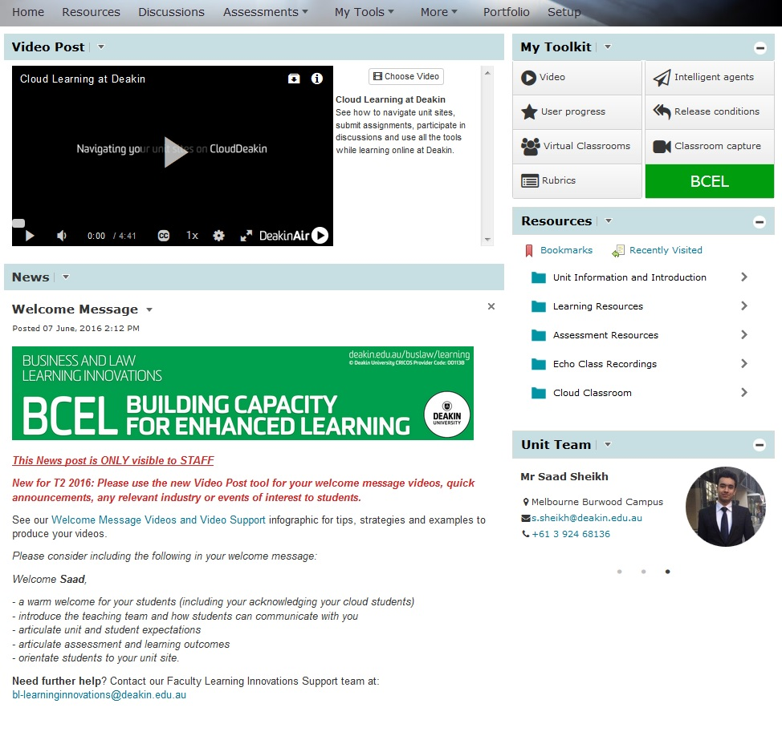

Help with CloudDeakin

Staff Support

BL Learning Innovations Cloud Deakin Support (email: bl-learninginnovations@deakin.edu.au or phone: ext. 73303) is the first point of contact for questions, requests and to report issues about information and communication technologies associated with teaching and learning throughout the Faculty of Business and Law.

Tech Check

If this is your first time using CloudDeakin you must:

- Ensure your computer meets the recommended computer standards.
- Run a system check before you log in. If you receive a warning for any area, go to the Recommended Browsers and Settings page and follow the instructions.

Staff Help Guides

Staff help guides on how to use the various CloudDeakin tools is available on the Learning@Deakin website.

Learning Innovations Website

The Learning Innovations Website has been setup to discuss ways of using and implementing a mix of Web 2.0, CloudDeakin and other eLearning tools in teaching and learning to enhance the student experience in the Faculty of Business and Law. You can also subscribe to the website to receive weekly updates on new postings.

Staff/Student Help widgets
At the top of the homepage there are staff only and student widgets. The staff widget called ‘My Toolkit’ provides further resources and guides for navigating the unit site as well as fully utilising the tools and technologies available for teaching and learning. The student widget provides quick links to library, learning and tech help resources.

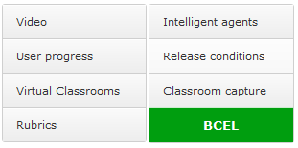

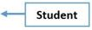
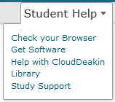

Student Support

The eSolutions Service Desk is the first point of contact for questions, requests and to report issues about information and communication technologies associated with teaching and learning throughout the University.

Student Help Guides

Student help guides on how to use the various CloudDeakin tools.

Checklist
Use the following checklist to manage tasks that should be completed before trimester starts.

Completed | CloudDeakin Tool/Task
☐ | Video Post/News Item – Add a welcome message for students in the newsfeed area along with the welcome video added using the Video Post tool. See Appendix 1 for instructions.
☐ | Discussion Forums/Topics – The Faculty of Business and Law unit template provides three generic Forums for General Unit, Assessment and Peer Learning, Networking and Community discussions. You can add extra to suit the needs of your student cohort. You also need to remove any redundant forums that may have been brought over if you requested content to be copied from a previous semester. See Appendix 2 for instructions.
☐ | Resources – Review content items and remove any redundant items. Check the order of your content and add/delete modules/sub modules to make it easy for students to find what they are looking for. See Appendix 3 for instructions.
☐ | Assignment Dropbox – Create new Assignment Dropbox/es for online assessment/marking. A sample assignment dropbox with the correct naming convention is included as part of the unit template to help you start. See Appendix 4 for instructions.
☐ | Groups – Groups can be used to organise students' work on projects or assignments. See Appendix 5 for instructions.
☐ | Quizzes – Reset release conditions for existing quizzes and setup new quizzes.  See Appendix 6 for instructions.
☐ | Grades – Remove redundant grade items, add new grade items and link assessments (dropbox & quizzes) with grades. See Appendix 7 for instructions.
☐ | Blackboard Collaborate / Skype for Business – Create new sessions for trimester. Copy session URL as quick link in CloudDeakin. See Appendix 8 for instructions.
☐ | EchoSystem (lecture recording) - Notify BL Learning Innovations if you need a previous trimester’s recordings or alterations made to the current schedule. Manage current recordings and/or stream, upload desktop recordings. See Appendix 9 for instructions.
☐ | eReadings – Check and update existing and create new links to eReadings. See Appendix 10 for instructions.

Completed | CloudDeakin Tool/Task
☐ | Advanced functionality – CloudDeakin’s advanced features enable you to interact and engage with your students. See Appendix 11 for further information.

Appendix 1 – Adding a Video and Welcome Message
The state of your CloudDeakin unit on first login can impact “the first impression” students will have about you, the unit and possibly learning online. It is important to make your students feel welcome and create the feeling of a learning community with your students.

Adding a welcome video message in the Video Post area on the homepage of your CloudDeakin unit site is a quick and easy way to personalise it. This only needs to be around 2-3 minutes long. You can add a few sentences to provide a description of your video.

You can also add a welcome message to the news item area including a quick introduction of yourself, the team, the unit and provide brief information to students on how to get started whilst highlighting student expectations, assessment and unit learning outcomes.

To get started, first view the video on how to make the best use of the Video Post tool. You will also find important tips & tricks for your video in this infographic. These resources will help you in creating and uploading your video. For further information around the tool, please visit the Learning Innovations site or contact us at bl-learninginnovations@deakin.edu.au.

Appendix 2 – Managing Discussion Forums
The Discussions tool is a learner engagement space (or communication and collaboration space) where you and your students can read and reply to messages on different topics, share thoughts about unit materials, ask questions and share files.

Before you create a discussion topic, you must create at least one forum. You can use forums to organise your discussion topics in categories. Discussion topics do not stand alone, but are categorised into Forums. A Forum can contain any number of discussion topics. For example: in a unit with three assessments, an Assessment Forum could contain 3 discussion topics, one per assessment.

The standard response time to discussion posts is 48 hours or 2 business days.

Instruction on settings available, creating a new forum and topic and posting a discussion message are available on the CloudDeakin Guides website

Cloud Discussions Student Etiquette Statement

The General Discussion forum (top most forum) contains the following etiquette statement with relevant links that all students must adhere to:

‘All students and staff have the right to work and study in an environment that is supportive, inclusive, fair and safe including face-to-face and cloud learning environments. Please refer to the online etiquette guidelines on Communicating Online. Know your Student Rights and Responsibilities including University policies on Information and Communications Technology Use and Conditions of Information Technology use.’

Adjusting the Discussions view

Staff have the option of using either the reading view or the grid view. The default is set to grid view, however this can be changed from the ‘settings’ area when you are on the discussions page.

- Click on the settings button, when you are on the discussions page.

- You can then change the view for the discussions messages.

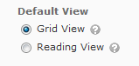

Grid view: Selecting this option will display the discussion posts in the traditional Grid View, with post subjects displaying in a grid.

Reading view: Selecting this option will display the discussion posts in Reading View, where the entire text of a post displays for all posts.

With the 10.6 CloudDeakin upgrade, as you scroll through the discussion messages, a light blue colored line next to each message will disappear (in 5 seconds or so), indicating that the user has either read or viewed the discussion post.

The discussion tool is can now be access from the navigation menu item “Discussions”.

Structure of Discussion Forums

Below are some examples of how discussion forums can be set up, depending on the nature and size of the unit:

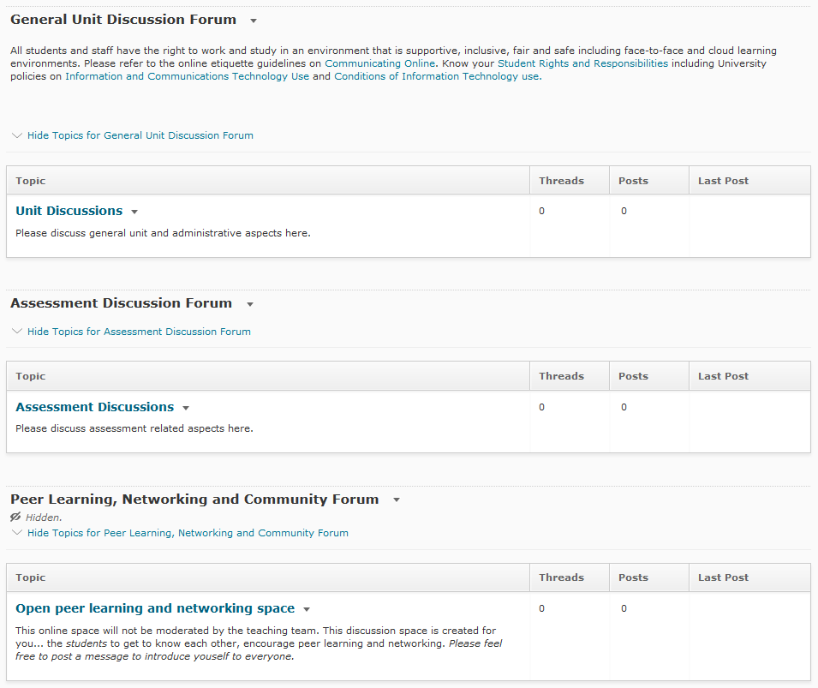

The standard discussions forum template is applied to all units for the trimester. The ‘General Unit Discussions Forum’ on the top with the etiquette statement, followed but an ‘Assessment Discussion Forum’ and a ‘Peer Learning, Networking and Community Forum’. The last forum is automatically hidden for students but essentially can be visible for students to discuss and learn from one another. This forum is not necessarily manned by staff.

Following are some more good examples of structuring your discussion space:

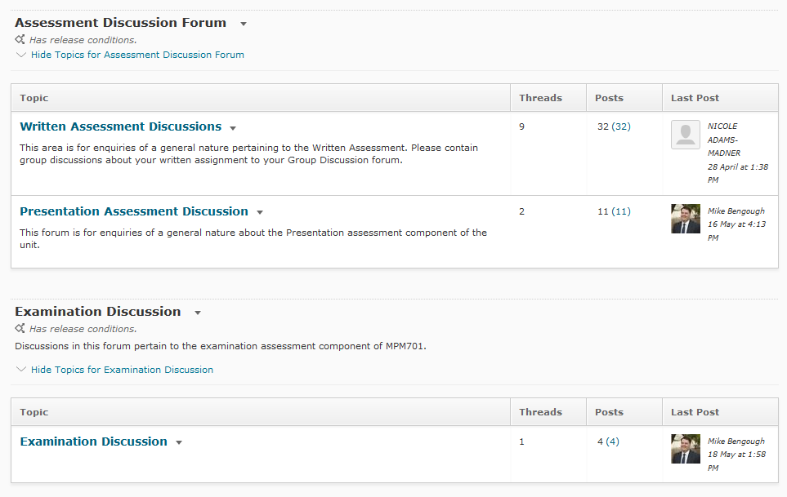

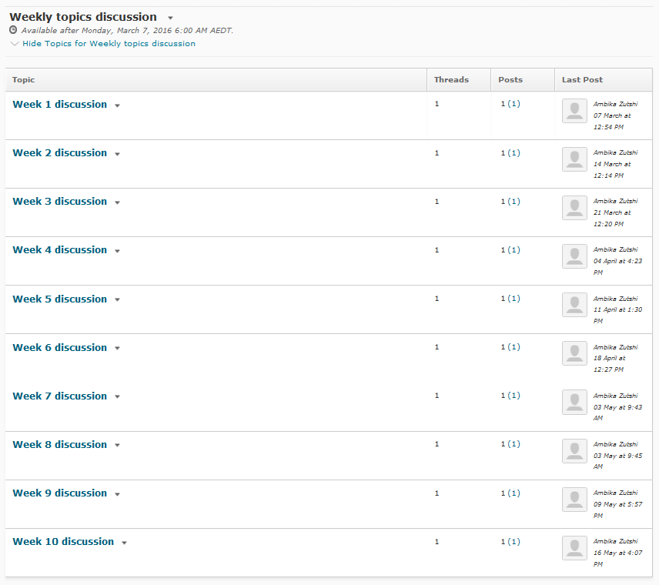

Tips and hints using discussion tool
- You and your students can choose to subscribe to a discussion forum to receive updates via email.
  - Select the subscribe link next to the heading of the Discussion Forum

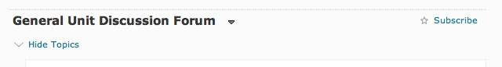

  - Choose whether you want an instant notification or to include in your summary of activity. Please note: If you haven’t already setup your notification settings you can also do this from this dialogue box.

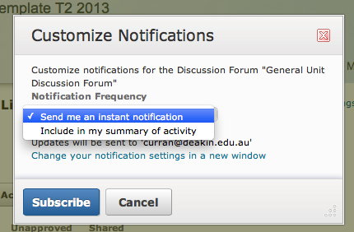

  - You can manage your subscriptions from the “Subscriptions tab” at the top of the discussion tool window.

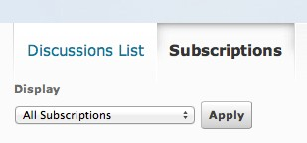

- You can automatically create restricted topics for groups from the “Group Restrictions tab” at the top of the discussion tool window.
  - Select the group and forum and then select the link “Automatically create restricted topics”.

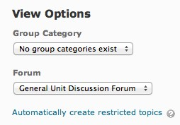

- The “Statistics tab” at the top of the discussion tool window provides statistics on usage per user and per topic/forum.

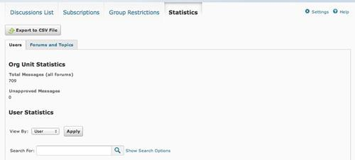

- To copy, reorder or delete a topic or forum, make sure you are on the “Discussions List tab”, select the button “more actions”.

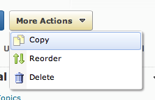

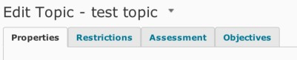
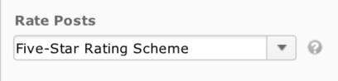

Appendix 3 – Managing Resources
The resource tool enables you to create, edit, organize and delete modules and topics in your unit. The resource area also enables you to link to other tools in CloudDeakin that you are using, which means you can setup the resource area to provide one area for the students to access their learning materials from. For example you can provide links to:

  - Assignment folders
  - Discussion Forums/Topics
  - EchoSystem recorded lectures
  - Quizzes

Instructions on using and managing the resource tool in CloudDeakin are available on the CloudDeakin Guides website

Tips and hints using the resources tool
  - The drag and drop function to add files from your desktop, only works in the browser Mozilla Firefox.
  - When moving content modules make sure you place your cursor over the para icon next to the title of the module

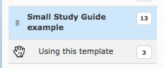

    - Hold your mouse down and drag the module to where you want it placed. A line appears which indicates where the module will be placed.

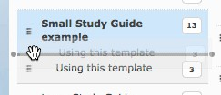

    - If you want a module to become a sub-module drag it on top of the module you want it placed into, you’ll notice the module turns orange, release the mouse when it does.

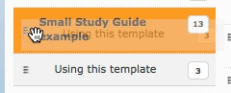

  - To delete a module select it in the table of contents first. From the drop down menu “Actions” select delete module

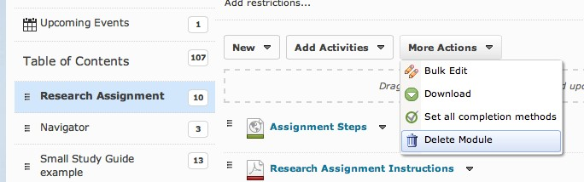

  - To add a module, scroll until you see the last item in the Table of Contents list. Type in the name of the new module in the “Add a module” box.

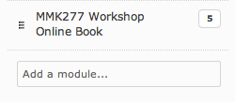

  - To add a new sub module, select the module in the table of contents list you want the module to sit inside first. At the bottom of the files, list for that module type in the title of the sub-module in the “Add a sub-module” box.

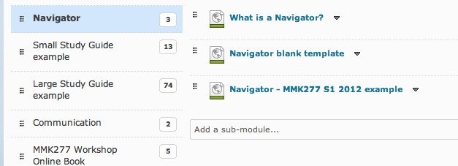

  - To hide files modules from students you need to set the properties of the file/module to draft. First select the drop down menu next to the item and select edit properties.

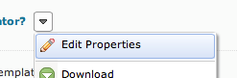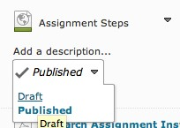

HTML Style Sheets to Organise Resources

Staff members can organise their content by using one of the Business and Law stylesheets, namely, ‘bl-designs-green’, ‘bl-designs-blue’, ‘bl-designs-teal’ and ‘bl-designs-teal2’.

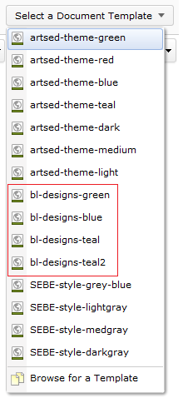
You can select one of these HTML styles from by clicking on ‘New’ > ‘Create a File’ > Select a Document Template from any folder/module under the List of Resources. Please make sure that you do not change the stylesheet once you have added your content, as this action deletes everything in the stylesheet.

An example of how HTML stylesheets can be used to professional organise content:

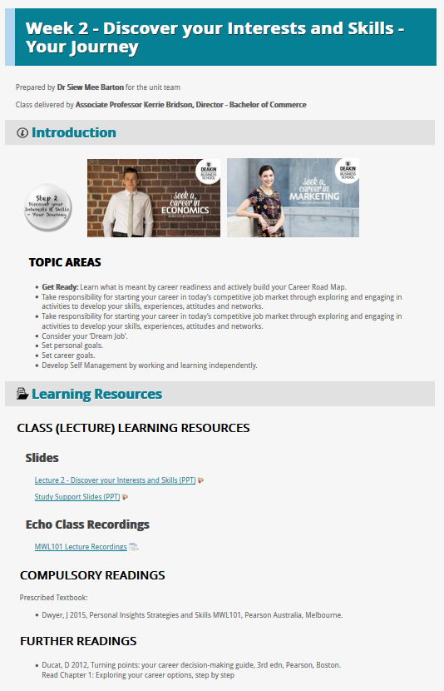

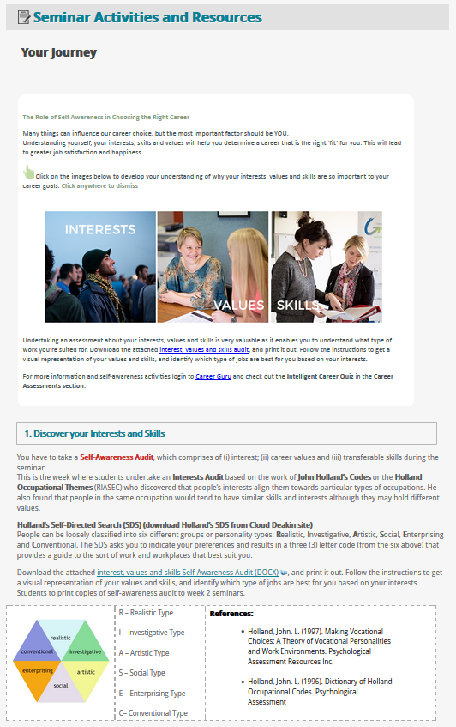

Appendix 4 – Assignment Dropbox (now grouped under Assessments)
The Assignment tool manages the electronic submission and marking of assignments for students and staff.

Why use the Assignment tool?
Students can submit, check against Turnitin and resubmit their assignments online. Once assignments are submitted, staff can:
  - Check submission times
  - Grade assignments
  - Leave feedback
  - Return submissions with comments
  - Download assignments as zip files
  - Sort assignments by students

All from within the Assignment folders. Instructions on setting up and marking online using the assignment tool in CloudDeakin are available on the CloudDeakin Guides website

Tips and hints using assignments
  - If Plagiarism Detection is enabled for the assignment folder, it automatically checks the option “Allow other files to be checked against submission” in the plagiarism detection options (at the bottom of the screen). The system is not setup to be able to check student submissions against other student submissions. Once a student has submitted a file and ‘index files for plagiarism detection’ is turned on, it will store that assignment in the Turnitin database, and any subsequent submissions to any other folder will result in a 100% similarity report.

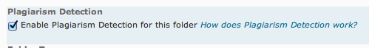

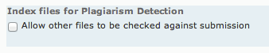

  - Students no longer complete an assignment declaration (plagiarism) checklist before submitting their work via the assignment folder. The plagiarism declaration, which can be found in the “T2 2016 Unitcode Assignment Setup EXAMPLE Only” Submission folder, needs to be copied into the custom instructions. Each new assignment folder must have this statement copied into the custom instructions.
IMPORTANT INFORMATION FOR STUDENTS - PLEASE READ
PLAGIARISM AND COLLUSION
Plagiarism and collusion constitute extremely serious academic misconduct. They are forms of cheating, and severe penalties are associated with them, including cancellation of marks for a specific assignment, for a specific unit or even exclusion from the course. If you are ever in doubt about how to properly cite a reference, consult your lecturer or the Study Support website http://www.deakin.edu.au/current-students/study-support/study-skills/handouts/refer-plag.php
- Plagiarism occurs when a student passes off as the student’s own work, or copies without acknowledgement as to its authorship, the work of any other person.
- Collusion occurs when a student obtains the agreement of another person for a fraudulent purpose, with the intent of obtaining an advantage in submitting an assignment or other work.
Work submitted may be reproduced and/or communicated by the university for the purpose of detecting plagiarism and collusion.
Students are reminded that assessment work, or parts of assessment work, cannot be re-submitted for a different assessment task in the same unit or any other unit, without the approval of the Unit Chair of this unit. This includes work submitted for assessment at another academic institution. If students wish to reuse or extend parts of previously submitted work then they should discuss this with the Unit Chair prior to the submission date. Depending on the nature of the task, the Unit Chair may permit or decline the request.
DECLARATION
By clicking the SUBMIT button above or below, you are declaring that the attached work is entirely your own (or where submitted to meet the requirements of an approved group assignment, is the work of the group), except where material quoted or paraphrased is acknowledged in the text. You are also declaring that it has not been submitted for assessment in any other unit or course.

  - If plagiarism detection is enabled make sure in the restrictions tab you give the students enough time to get their Turnitin report in time to resubmit if necessary. Reports can take up to 24hrs to generate therefore if you set the start time too close to the due date students may not have enough time to generate the report and resubmit.

  - You no longer have to create a late submission folder. CloudDeakin has a function called “Has End Date”. Which means any submissions submitted after the due date will be marked late between the “Has Due Date” date/time to the “Has End Date” date/time. Students do not see the “Has End Date” date/time in the properties of the assignment folder.
All late submission are time-stamped in red as can be seen in this example on the left.
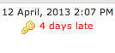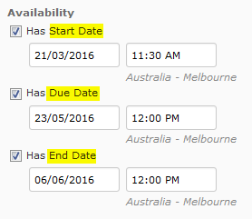

  - Students who have been granted late submissions should be added to the special access under the restrictions tab of the assignment folder settings

  - You cannot change the folder type from individual to group or vice versa once it has been setup. You will have to recreate the folder if you need to change type.

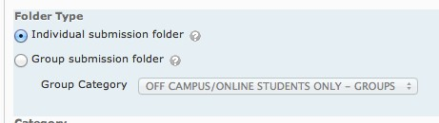

  - If your assignment is a group assignment you will need to setup your groups first before creating the assignment dropbox. The automatic creation of groups only works when students are enrolled in the unit as it bases the amount of groups created on the number of students enrolled. Students are enrolled in the unit 1 week before trimester starts. Contact BL-Learning Innovations Support for assistance with creating groups if you haven’t done this before.
  - If students are required to upload more than 1 document to the assignment folder you cannot use the option overwrite submissions in the submission options for the properties for the assignment folder. There have been cases where students upload their assignment file and then an old assessment declaration form which in turn overwrites the assignment and leaves the only the declaration form for submission. It appears that the student hasn’t uploaded an assignment and causes confusion for staff and students. BL-CloudDeakin support can impersonate students and provide staff with the history of the dropbox folder if there is any question that this may have occurred.

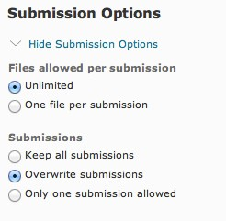

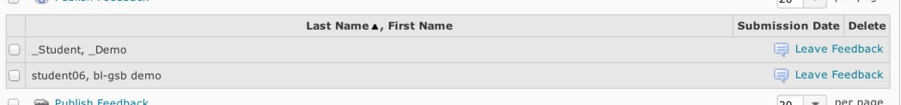
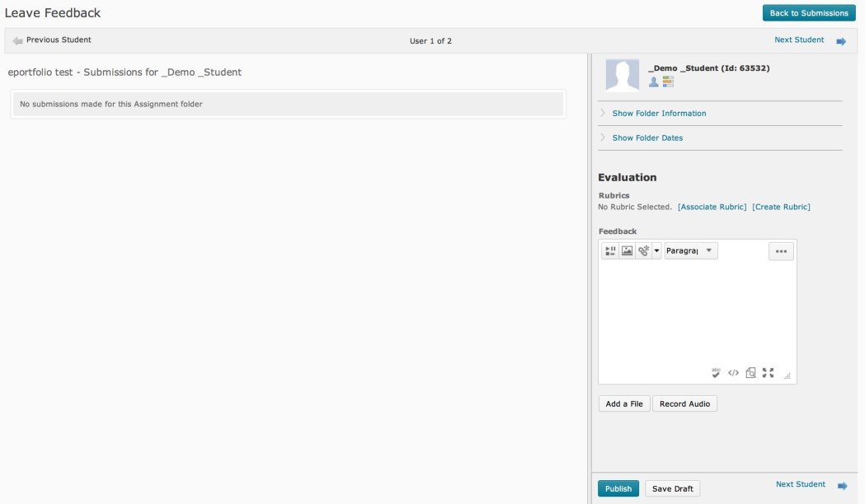

Evaluate non-submissions and system-external submissions
Unit Chairs can now evaluate a student using the Assignment (Dropbox) tool, even if no submission was made to the Assignment (Dropbox) folder. This could be used when Unit Chair want to assign a student a comment and a grade after the due date has passed, or the submission occurs outside of CloudDeakin.

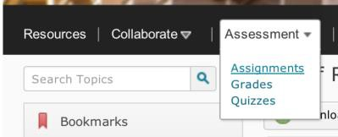

Leave feedback link is available for all students, with or without submissions.

Restore deleted assignment folders
Assignment (Dropbox) folders can be restored from the Event Log.

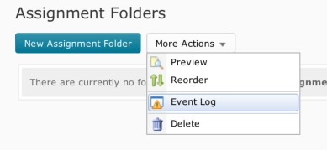

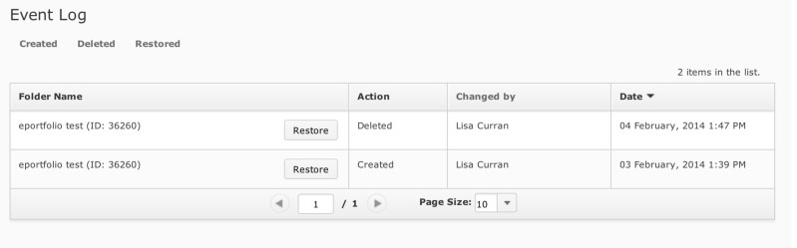
Download all submissions, provide feedback, upload
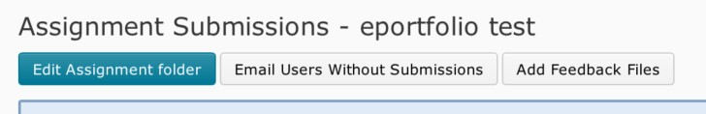
In addition to the existing bulk download of student Assignment (Dropbox) submissions, you can now evaluate and annotate submitted work using the desktop software of your choice, and finish the process by bulk uploading these files. Downloaded Assignment (Dropbox) submissions are assigned a unique identifier enabling CloudDeakin to recognize the files upon upload.

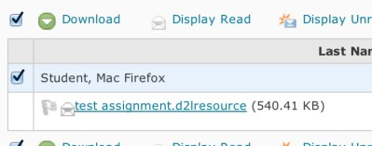

Appendix 5 – Groups (now grouped under More)
Groups can be used to organise students' work on projects or assignments.

Students can belong to any number of groups in the same unit. Each group can have its own discussion forums, assignment folders, and locker area to work in. Members of groups can be graded as a team or individually. When you grade a group assignment all team members receive the same grade automatically, which means you only need to input this once for the team. This doesn’t mean however if you wish to alter grades for team performance you can’t, you still can alter individual grades via the gradebook.

Please note: It is important that you make students understand that they cannot un-enroll themselves from a group.

New Features for Groups in CloudDeakin

With the CloudDeakin v10.6 upgrade, staff members will now be able to:

- Set a self-enrolment expiry date for students: This means that the self-enrolment option will automatically cease on a set date and time and students will no longer be able to enroll themselves.
- Set a pre-fix for each group: This allows adding a prefix, for example, ‘MMM132’, ‘Part A’, ‘Cloud’, etc. before the name of each created group under a category.
- Students can now choose to un-enroll themselves from groups: This means that can change groups till the self-enrollment expiry date.
- Several CloudDeakin elements including groups can be used to apply selective release conditions.
For example, topic files, news items, dropboxes, discussion forums, etc. can be selectively released to a particular group or to several groups.

Understanding how groups are setup
Before you setup groups in your unit you should know how you want them to be organised. A number of things can affect how users are enrolled in groups:

  - Are students already enrolled in the unit or is the classlist empty?
  - Do you allow students to enroll themselves in groups or would you prefer to auto-enroll and distribute students randomly to groups?

Please note: In most cases, especially for large cohorts, it is better to set up groups after students are enrolled in your course. This gives you a better idea of how many students you have and therefore how many groups you will need. Setting up groups after enrollment can also ensure better random distribution of users between groups.

The following descriptions explain the options available when creating new groups and how the different options can be used:

  - # of Groups – No Auto Enrollments – A specified number of groups are created, which you can manually add any number of users to through the Enroll Users page. This option requires the Unit Chair to enroll users into groups. Use this enrollment type when you know, how many groups you want to create and which users you want in each group.
  - Groups of # - The minimum number of groups needed to place users in a groups of a specified maximum size are created. More groups are created when they are needed to accommodate students that enroll after the groups are created when the option “Auto- enroll new users” is selected. You can also choose to have the students randomly distributed to groups. Use this enrollment type when you know how many users you want in each group and don’t allow students to self-enroll.
  - # of Groups – A specified number of groups are created where you can choose to have the users randomly distributed or not. Make sure you select “Auto-enroll new users” so any new students who are enrolled in your unit are automatically allocated a group.
- Groups of # - Self Enrolment – This option enables Unit Chairs to cap the number of students in a group. The minimum number of groups needed based on the numbers of students enrolled divided by the capped amount are created automatically. If you do not wait until students are enrolled in the unit to create this type of group you will have to create each group manually. If you require additional groups due to being flexible about how many students can work on a group project, ie. the group may be capped at 3 but you might allow 2 to work in a group, you will need to manually create extra groups to accommodate this. You should be aware that you cannot add extra groups once you get to 200 groups. If you have large cohorts of students that require more groups contact BL- Learning Innovations CloudDeakin Support (bl-learninginnovations@deakin.edu.au) for assistance with this. Use this enrollment type when you know how many users you want in each group.
  - # of Groups – Self Enrolment – This option creates a specified number of groups where students can self-enroll into groups. Use this enrollment type, when you want to make a specific number of groups available for users to join.
  - # of Groups of # - Self Enrollment - This enrollment type is useful in situations where students are self-enrolling into groups with a fixed capacity. Use this enrollment type to determine the structure of groups (number of groups and size of each group) in advance. Users can choose which group they would like to join, subject to the constraints of the group structure.
Enrolling/Un-enrolling Users in Groups
Users are enrolled in groups based on the enrollment options select on the New Category page. Use the enroll users page to:

  - Manually enroll users in groups if you selected # of Groups – No Auto Enrollments.
  - Manually change which group a student is enrolled in.
  - Add users who enrolled late to a unit if auto enroll new user is not selected.
  - Search for students who have not been assigned to a group.

Modify or add enrollment

- Select Groups from the Site Tools menu in the navigation bar.
- If you have more than 1 group category select the group category you wish to change enrollment for.

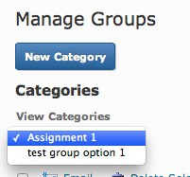

- Select the group you wish to alter enrollment for.

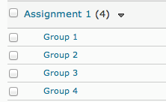

- Select the button enroll users.

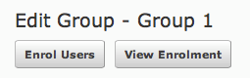

- Search for the student you wish to enroll or un-enroll. To enroll the student tick the box next to the student’s name and select save. To un-enroll, deselect the tick next to the student’s name and select save.

What happens when you move a student to a new group?

Discussion messages remain in the old group and do not count towards a student’s grade if the forum or topic is associated with a grade item. Locker files remain in the old group. Students must add any files they want to keep to the new locker area themselves. Assignment files submitted for the old group remain with the old group. The student receives the grade achieved by the new group on any group assignments. To override this score you can change the student’s grade in the grades tool.

Setting up self-enrollment in groups
Self-enrollment allows students to enroll in groups on their own. Use this option when you want students to have the freedom to choose their own group members.

Students can self-enroll in groups by selecting the choose group link in the groups tool, which can be accessed from site tools in the navigation bar.

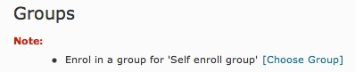

Students should be made aware that once they have enrolled in a group they cannot un-enroll themselves. Therefore they should decide as a group which group number they are going to enroll in first and then try to do this at the same time to avoid other students enrolling in that group. If students see that there are already members listed in the group they have chosen to enroll in they can double check to see who has enrolled by selecting the number of members link for the group.

To make it easy for students to find the sign-up group page you can place a link on your content page in the group assignment module.

- Go the groups tool, select collaborate > groups from the navigation bar.
- Select the category of the group in the dropdown menu view categories
- Copy the URL from the browser
- Go to content from the navigation bar and select the module in the table of contents where you want to place the link.
- Select New Link from the drop down menu new.
- Give the link a title e.g: Group Signup Sheet Assignment 1
- Paste in the URL you copied from the browser.
- Select Create.
- Test the link by selecting it in the content list.

Please note: If you have published your assignment feedback and grades and don’t want students to see this you will also need to remove the groups tool from the navigation as students can access their assignment feedback from this link also. Contact bl-learninginnovations@deakin.edu.au for assistance in placing the link on your content page or removing access to the group tool.

What students see in the groups tool
Students access the groups tool through the collaboration link in the navigation bar. You can also place a link to the groups tool on the content page as explained above.
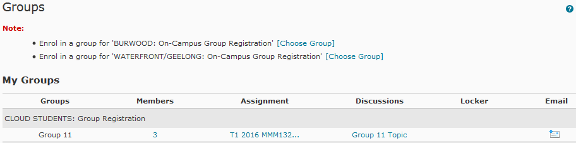

On the manage groups page, students can do the following:

- Select choose group link beside an enrollment message to enroll in a new group.
- Select the number in the members column to view the member list for a group.
- Select an assignment folder to view its contents.
- Select a discussion forum to view its postings.
- Select a link to a groups locker files.
- Select email group to email all members of a group.

Creating Marking Groups for Tutors
Do you need to distribute student's assignments for marking, in the assignment folder, to marking tutors? You can use the group function to allocate a randomly distributed group of students to each tutor.

Here are the steps on how to do it:
  - Create a new group category in your CloudDeakin unit with the option to automatically enroll students in the required number of groups, i.e. 1 group per tutor. Select the option to randomise users in groups and auto-enroll new users.

  - From within the assignment folder select view by "Groups" and click the apply button
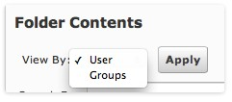

  - select the marking group allocated to you from the drop down list and click apply

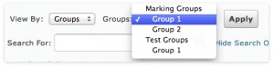

  - To keep a track of who has and hasn't been marked you can use the feedback drop down list. To view students in your group who haven't been marked yet, from the feedback drop down list select "Users without feedback".
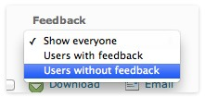

Tips and hints using the groups tool
  - You can find out what group a student is enrolled in by going to the classlist and then selecting “View Group Enrolments For” from the dropdown list next to the student’s name.
  - You cannot automatically create capped groups on mass before students are enrolled. Groups are automatically generated based on capped amount and how many students are enrolled, therefore if there are no students in the classlist you have to manually create each group.
  - You can now setup self-enrolling groups before students are enrolled in the unit. There is a new option “# of Groups of # - self enrollment”.
  - You cannot have more than 200 groups in a category, however if you have automatically created capped groups the system will generate more than 200 to accommodate the number of students enrolled. Please note you will not be able to add additional groups to categories exceeding 200.
  - You cannot hide groups and or restrict groups based on campus, date etc.
  - You cannot add a student to a group that is capped and full.
  - If a student withdrawals and then re-enrolls they are put back into the group they initially enrolled in which could cause the capped group to go over if another student has joined that group in the meantime.
  - You cannot setup restrictions for an assignment folder whilst adding an assignment folder during creation of a group, you need to go into the assignment folder after it’s been created and edit the settings to add the necessary restrictions such as start, end and due dates.
  - You need to remove the groups function whilst marking as students can access the assignment folder and feedback via groups. Contact BL Learning Innovations support (bl-learninginnovations@deakin.edu.au) for assistance with this task.
  - If you setup a group that automatically assigns students to the group, make sure you select the “Auto-Enroll new users” option in case students enroll into your unit after you have setup groups.

Additional Information
Additional information on setting up and managing groups in CloudDeakin is available on the CloudDeakin Guides Website

If you need further assistance with setting up this functionality in your CloudDeakin unit please contact bl-learninginnovations@deakin.edu.au.

Appendix 6 – Quizzes
The quizzes tool is used to create, categorise, store, manage, publish and grade questions you set for your students to respond to either as self-assessment or as formal assessment tasks.

New Features of Quizzes in CloudDeakin:
- Staff can now ‘late behaviour’ options to quizzes such as, grading student as zero if they are late or simply flagging the late submissions or allowing/not allowing students to make changes after the enforced time of the quiz has elapsed.

Important:

Staff are not to use questions or any learning material from external publishers for assessment purposes (quizzes, etc.)

All online tests included as part of the unit/course's summative assessment should meet the standards outlined in Assessment (Higher Education Courses) Procedure - Schedule C: Standards for Administering Unsupervised Online Tests which are Automatically Computer-Marked at Deakin University.

- Staff are required to prepare their testbank questions in the correct Respondus format
- We require at least two weeks, and sometimes longer for large (eg. 100+ questions).
- Incorrect formatting of testbank questions and/or incomplete forms will delay the process.

There are three steps to quiz creation (online support links are provided below if you would like to attempt it on your own)

Request for set up of an online quiz in CloudDeakin

The BL Learning Innovations Support team can provide assistance in setting up your online quiz.
Phone: Ext 73303 (03 5227 3303) Email: bl-learninginnovations@deakin.edu.au.

There are three steps to quiz creation:

Preparing your testbank of questions for CloudDeakin - three options:

Option #1: Preparing the testbank in a suitable rich text format/word document.

Option #2: Creating a quiz testbank directly in Respondus

Option #3: Creating new testbank questions directly in CloudDeakin

Importing your testbank in CloudDeakin via Respondus.

Setting up your quiz parameters in CloudDeakin.
Help guides can be found at Respondus Help Guide (This opens best in Mozilla Firefox).

Alternatively, if you would like our assistance, please fill in the form. (online request form.)

Appendix 7 – Grades
From the grade book you control the grading formula used to calculate grades; what projects, assignments and tests are graded; how grade items are associated with other tools; and when grades are released to users and what information they see. Before you create a grade book, you should be familiar with the concepts the tool uses.

Instructions on setting up and managing grades in CloudDeakin are available on the CloudDeakin Guides website

Tips and hints using grades
    - You can enter grades in Excel and import them into CloudDeakin using a CSV file. Import files must follow a standard format, to ensure you have the correct format it is recommend that you set up your grade book in CloudDeakin first, create the columns for your assessment items. Then use the “Export Grades” option to export a file you can use in Excel. Please note: Make sure you use Firefox as your browser.

Export Grades
        - Select Grades from the assessment tab in the navigation.
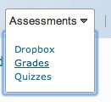
        - Select Enter grades tab
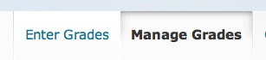
        - Select Export Grades button and select the fields, org defined ID, points grade, Last Name and First Name.

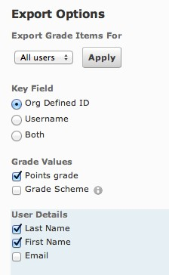

Select Export to CSV
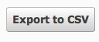

o Open CSV in Excel and input grades.

Importing grade items
            - Select Grades from the assessment tab in the navigation.

            - Select Enter grades tab

            - Select Import Grades

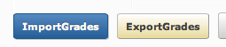
            - Select the Choose File button and find the file on your hard disk.

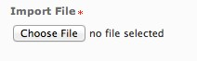
            - If you have created extra grade columns in the spreadsheet select the option “Create new grade item when an unrecognized item is referenced”.

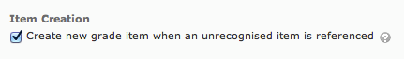
            - Click Continue

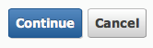
            - Check any new grade items that are being imported that they are set as the correct type.

            - Select continue

            - For new grade items, fill in the information for max. points
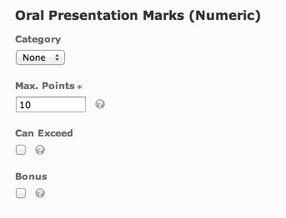
            - Make sure there are no warnings
            - Select continue to finish.
    - To preview the grades a student can see select the grades tool from the assessment tab in the navigation.
      - Select enter grades
      - Search for the student
      - Click on their name in the grade book
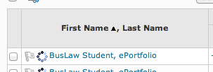
      - Select the dropdown menu next to their name and select preview. The grades will appear in a new pop-up window.
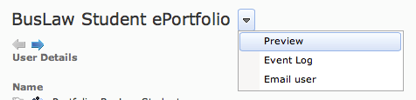
      - This is what the student sees.
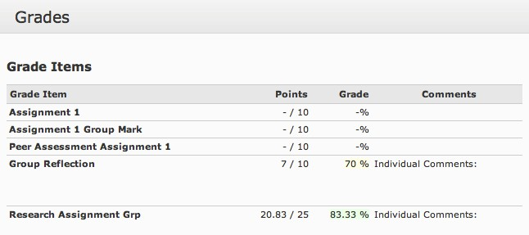

- The discussion, quiz and assignment tools can be linked to the grades area, which means when they are marked the marks are automatically transferred to the grades tool.
  - In the assignment tool make sure you create a new grade item or link to an existing grade item in the properties tab.
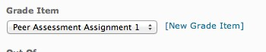
  - In the discussion tool, select the assessment tab and make sure you create a new grade item or link to an existing grade item in the properties tab.
  - In the quiz tool, make sure you create a new grade item or link to an existing grade item in the properties tab.

Appendix 8 – Bb Collaborate
Elive was upgraded to Blackboard (Bb) Collaborate on July 1 2014. Bb Collaborate is a synchronous communications tool that can facilitate communication and collaboration between staff and students. Bb Collaborate allows you to:

- Talk online in real time
- Chat via text online
- Share videos, presentations and applications.

Instructions on getting started, creating, accessing and using Bb Collaborate are available on the CloudDeakin Guides website
Staff can now easily create Bb Collaborate sessions from within CloudDeakin.

Tips and hints using Bb Collaborate

Preparation:

- You will require a web enabled computer and microphone USB headset to talk and listen.
- In order to participate in a Blackboard Collaborate session, you will need to ensure your computer and other hardware are set up correctly. It is highly recommended you follow these instructions - Blackboard Collaborate Setup Guidelines - Setup info for first time users (half way down the page) before the start of your session to ensure any issues are resolved.
- It will take a few minutes to load the first time you log in. Accept any pop-up warnings/prompts that appear.

Instructions for Unit Chairs:

IMPORTANT: Please follow the naming conventions for Blackboard Collaborate room set up for unit sites:

Trimester (space) Year (space) Unit Code (space) Context/purpose e.g. T2 2016 MMMXXX Tutorial Room or T2 2016 MMMXXX Revision Seminars

Getting off to a good start with Bb Collaborate

- ETHERNET (NOT WI-FI): Avoid using Wi-Fi connections if running a Bb Collaborate session. It is recommend that Wi-Fi be disabled and an Ethernet cable directly connected to the computer be used. This is particularly important if conducting the Bb Collaborate session off-campus.

- PREPARE: It is recommended that staff are prepared and log in at least 20 minutes before the BbC session to have time to load ppt slides, check audio settings and iron out any technical glitches.

- SET UP: If using a home or shared computer it is recommended that staff go through the set up for ‘first time Bb Collaborate users’ each time. This is particularly important as computer settings especially audio settings may have been changed by others.

- SUPPORT: Do not hesitate to contact technical support if needed. The eSolutions IT Service Desk is available between Monday to Friday 8am-8pm or Weekends 11am-5pm and BL CloudDeakin Support and central CloudDeakin support teams are available between Monday to Friday 9am to 5pm. If you are not confident with your technical abilities, it may be best to schedule your BbC sessions within these times.

Appendix 9 – Echo Recordings
EchoSystem gives you the ability to capture and record presentations in an Echo recording venue, from your computer using Echo360 Personal Capture or to upload media recorded on another device or software to the EchoSystem and link these to your CloudDeakin site.

Instructions on booking a venue, uploading media, manage and using Echo are available on the CloudDeakin Guides website

Tips and hints using Echo

The scheduling of lecture class capture is now automated via SyllabusPlus (timetabling). Staff do not need to book their lecture classes for capture.
- When teaching spaces with lecture capture facilities are timetabled for a class, a corresponding booking is now automatically created in EchoSystem so that a recording can be made available to students through CloudDeakin. Last minute change of venues is also catered for in the system. A list of venues and additional detail are available on the CloudDeakin Guides website
  - You only need to use the online booking form to book a section in Echo to upload recordings created by Echo Personal Capture or to book a one off recording in a lecture theatre.
  - It is the responsibility of the Unit Chair to upload the link after the first lecture to their CloudDeakin site. A module in content has been created for the Echo Recordings. There are instructions on CloudDeakin Guides website on how to add the Echo link to content.
- If you need assistance in adding the link to your CloudDeakin unit please contact bl-learninginnovations@deakin.edu.au
- If you want to link to individual recordings in weekly modules you will need to complete the following steps each week.

- Click the resources link from the Navigation Bar at the top of the Unit page.
- Go to the module you wish to add the Echo recording link.
- Click the Add Activities link then select Additional Applications.
- A pop-up box will appear, select EchoSystem from the second dropdown menu labeled Additional Applications.
- Click ‘EchoSystem’. (review the below – add new image for echosystem LTI)

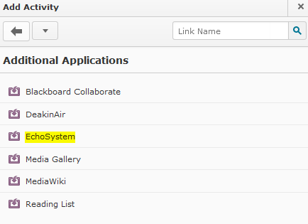

- From the Table of Contents, click on the link to EchoSystem that you have just created. Note: If you receive a security Warning Message, press continue.
  - Link to individual Echo recordings. Click the + button next to the section ie Burwood (T2 2013) to expand the unit offering and show the available individual recordings. Click on the Link to Echo button to link to the desired recording. You can also preview a recording before you create the link (this will open in a new tab). Please note: Linking to the individual Echo Recordings rather than the EchoCenter means that students will not be able to get PodCasts/VodCasts.
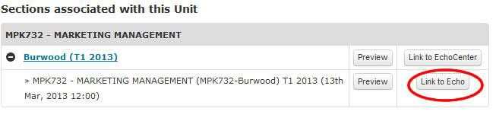

Old Echo Recordings
If you require access to old echo recordings please notify BL Learning Innovations CloudDeakin Support so they can import them into the Echo Centre and add a link to your site. You will need to provide the following details so they can easily source your recordings: Unit code, trimester and year it was used, campus, old iLecture name and date for each recording. In addition please provide the new title for the Echoes to go into your site e.g. Topic 1 Introduction to Accounting if you do not provide preferred titles recordings will be uploaded as recording 1, recording 2 etc.

- To pre-record lectures use Echo360 Personal Capture. Instructions on how to download and use Echo360 Personal Capture are available on the CloudDeakin Guides website. (select the tab upload media)

Appendix 10 – eReadings
Sourcing and adding online readings - the library has an extensive and rapidly growing collection of e-books and e-journals that can be used in CloudDeakin. The licence agreements for these online resources normally allow direct links which can be used immediately in your CloudDeakin unit. For more information on adding information resources to CloudDeakin such as direct linking to online information resources and digitisation of print materials as e-readings, refer to the Library for instructions.

  - You can send your requests for digitised e-readings to libinfo@deakin.edu.au .
  - Please note that the use of Library online resources is governed by licence agreements, refer to the Library web information on Open Access and Licensing (OPAL) -
  - Copies of third-party material must not be uploaded directly into CloudDeakin without copyright approval. If in doubt, please contact Copyright Services, Library.

For further information and advice about sourcing learning resources and adding online information resources to CloudDeakin contact your Liaison Librarian.

Appendix 11 – CloudDeakin Advanced Features
CloudDeakin has a number of advanced features that enables you to interact and engage with your students, here are some you might like to try:

- Audio and Video feedback can be recorded when you are providing feedback in the dropbox
- Intelligent Agents enable you to send automated emails based on selective release criteria, i.e. when a student receives a high or low grade.
- Forms can be used for peer/team evaluation or for gathering information for an assignment
- DeakinAir enables students and staff to upload their videos to Kaltura, Deakin's YouTube.

As of T1 2016, Deakin upgraded to the new DeakinAir platform. Essentially this new service allows you to very easily browse and contribute video to teaching sites in CloudDeakin and other web-based products including our internet and intranet pages and social software sites (Web2.0) both internal and external to Deakin.

If you have existing video that you would like to share with your students, peers, colleagues, DeakinAir can help by offering an easy and intuitive interface by which to browse existing video content or upload your own, including the ability to make a quick and simple webcam recording!

The underlying DeakinAir platform transcodes your original video and streams it out in various flavours that are compatible across multiple platforms including iOS devices (iPhones and iPads). More information regarding the upgrade can be found here.

A complete guide of the latest features with video tutorials can be located here.

- Echo has two options of linking your lecture recordings; you can either select to link individual weekly recordings or have 1 link to all recordings.
- Replacement Strings allow you to personalize messages by providing the code to replace information that is specific to a student such as their first and last names. This allows you to send personalized messages to each student in your site without having to enter their personal details numerous times.

For further assistance with using these advanced features in CloudDeakin please contact bl-learninginnovations@deakin.edu.au support team.

