Schedule a Skype for Business Meeting Instruction (Windows Only)

This instruction will show you how to schedule the Skype for Business Online Meeting Session from Outlook 2013 (Windows) Note: Settings on Outlook 2011 (Mac) are very limited.

Step 1: left click on "Calendar (push button)" in "Inbox - - Outlook"
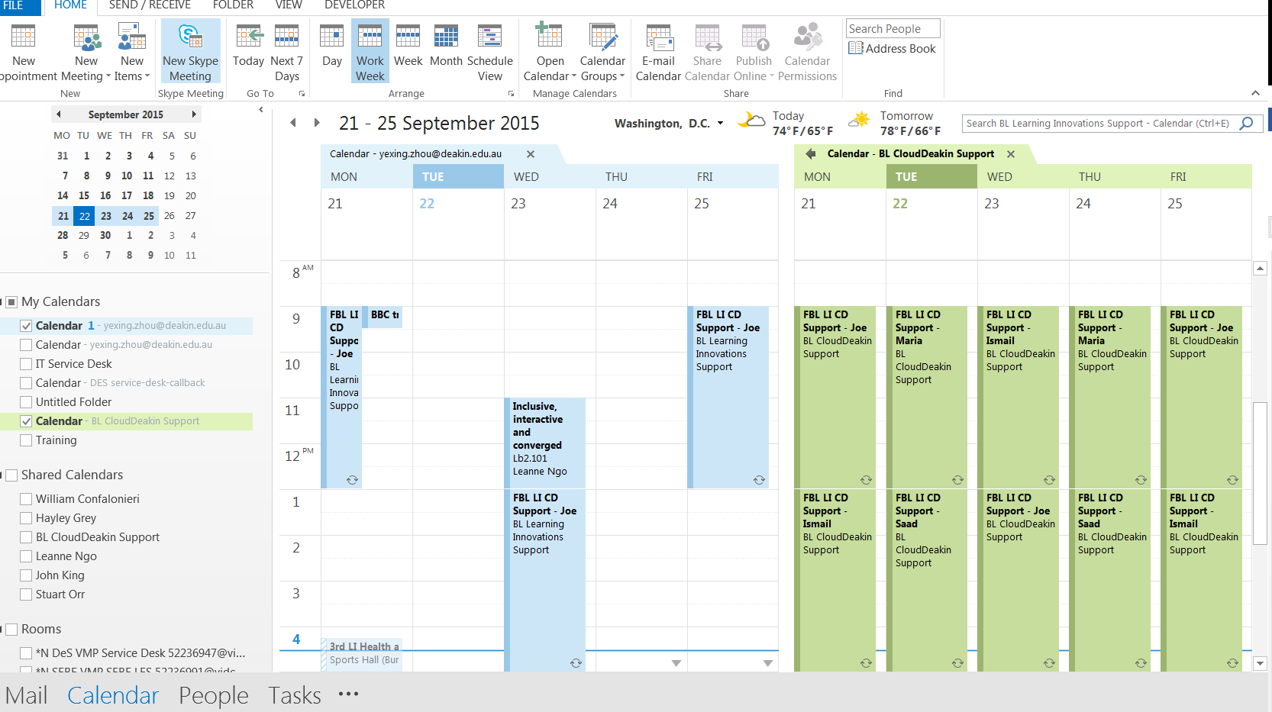

Step 2: left click on "New Skype Meeting (push button)" in - - Outlook
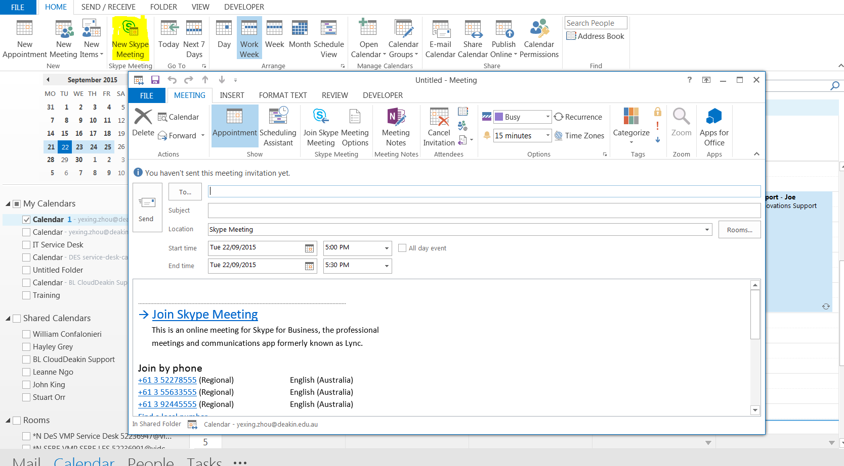

Step 3: Type in the name of the presenter or guest presenter, put in the subject, start and end time of the meeting
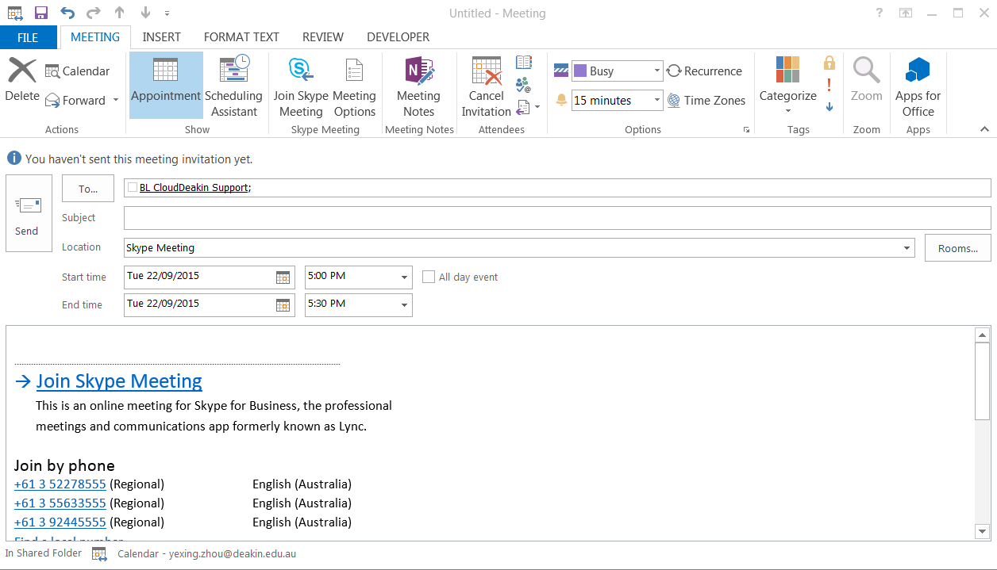

Step4: left click on "Meeting Options (push button)"
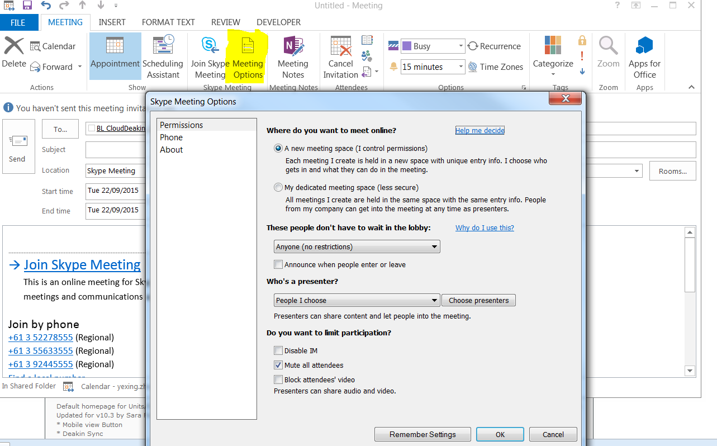

Step 5: left click on "A new meeting space (I control permissions)" in "Skype Meeting Options" and choose anyone (no restriction to let the guest presenter or external person to join the session)
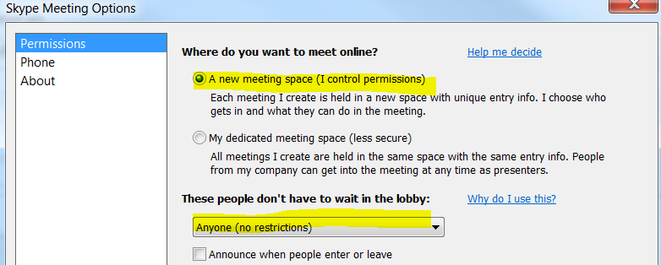

Step 6: Use people I choose option and click on ‘Choose Presenters’ button. Add the presenter’s name from the left column into the right column.

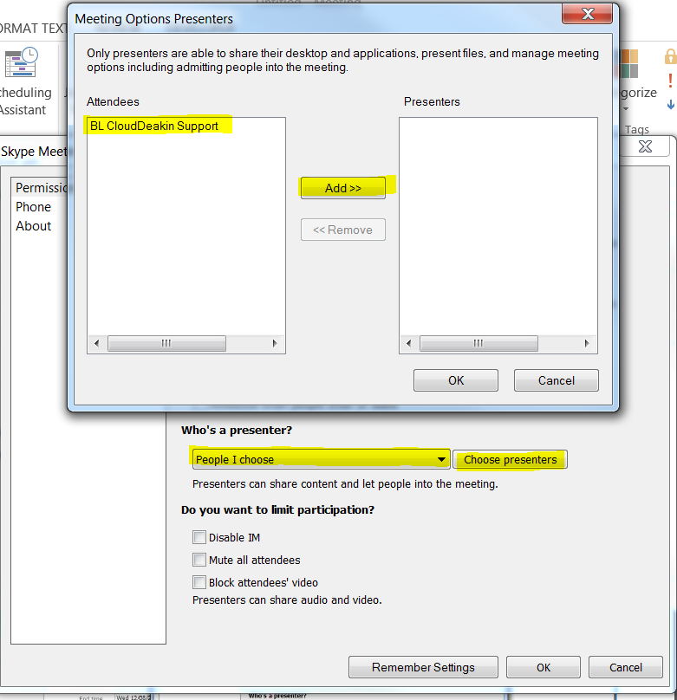
Step 7: left click on "Mute all attendees (check box)" in "Skype Meeting Options" and remember settings.
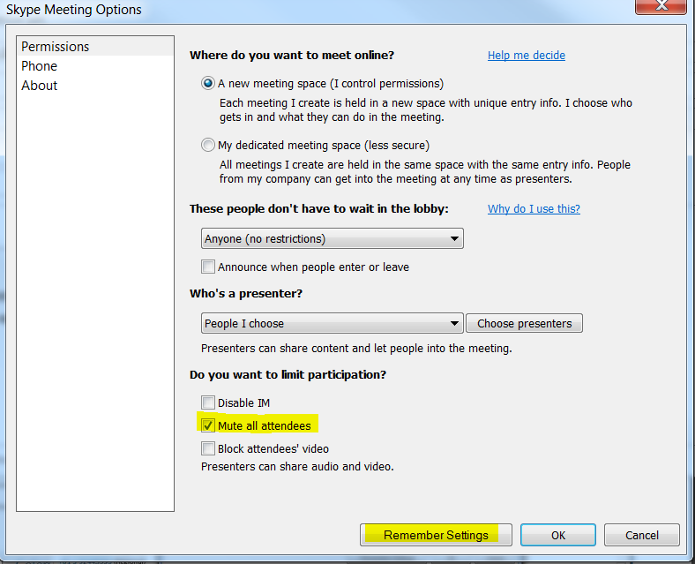

Step 8: Copy and paste the link: join skype Meeting into the news item on CloudDeakin site to distribute it to online students.
