Designing Feedback

Unit chair/team:

Unit code and title

- PURPOSE: What are the purpose/s of feedback for my students in this unit?

- PRINCIPLES: What principles of feedback will have most impact on students’ learning?
Criterion referenced: helps student understand the standard (Rubric assessment criteria, performance levels and quality indicators)
Precise: Provides specific, relevant information on the students’ level of performance in relation to the standard
Actionable: Assessment regime is designed to enable students to use feedback to improve subsequent performance
Feedforward: Provides information students can use to improve their performance
Key areas: Focusses on one or two key aspects of the student’s performance
Personalized: Communicates that the teacher is interested in the students’ work, and in their learning and development
Differentiated: Feedback differs for students at different levels of achievement
Participatory: Students actively participate in the feedback process. For example, students self-evaluate their work; students use or co-create rubric
Dialogic: Students ask for and respond to the feedback they need
Capacity building: builds students’ ability to evaluate the quality of their work and that of others through self and peer evaluation

- PROCESS: What feedback process will most effectively support students’ learning or engagement?

- SOURCE: Who should provide the feedback?

- PLATFORM: What platform or tool/s will be most effective to use to provide feedback and why?

- CONTENT: What is the overall content of the feedback? What will it address?

- DIFFERENTIATION: How will the content of the feedback differ for students at different levels of achievement?

- FEEDFORWARD: How will students use the feedback in this unit to improve their subsequent performance?

- CAPACITY BUILDING STAFF: How will feedback providers be trained and mentored?
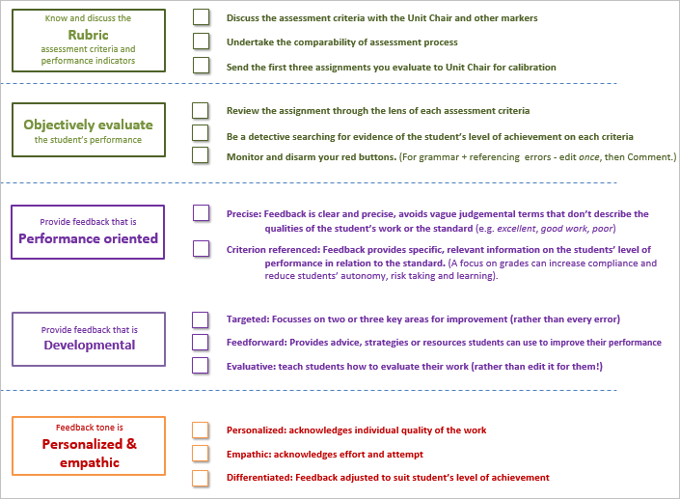
CAPACITY BUILDING STUDENT AUTONOMY:
Evaluation: How will students evaluate the quality of their work and that of others?
Calibration: How will students receive feedback on the quality of their evaluation?

- CLOSING THE LOOP:
How will I know whether students have learnt from the feedback?
How will I evaluate students’ learning - how they have used the feedback to improve?

