AMX Panel

- Press Start on the screen (If the AMX is in use, press shutdown button to reboot it until you see the Start button on the screen)
- Make sure both Speaker and Microphone are un-muted (from right hand side of the AMX screen)
- From the Right Display (on your left), tap on PC
- From the Left Display (on your right), tap on Camera, then the camera control screen will popup. Tap on Presenter then Desk Area. (Alternatively, you can tap on the auto-tracking button to let the camera follow you)
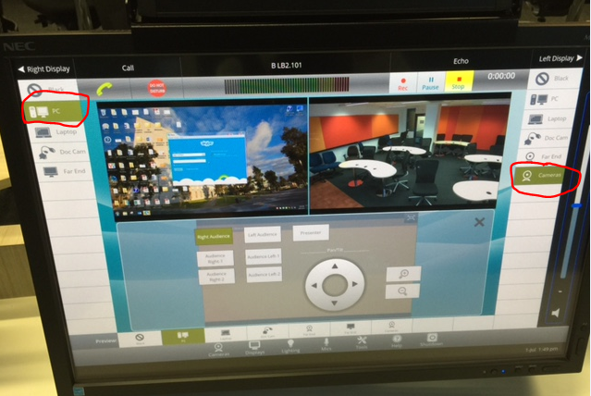
- Advise the on-campus students to use push-to-talk button
- You will repeat the step 4 to change the camera view back to the presenter.
- Once off-campus students have all joined in, they should be able to see both PC/laptop screens and camera.

- Students can install, configure and join the meeting:
Where can I download Skype for Business (Lync)?
How do I get started with Skype for Business?

Note: Lync / Skype for Business works on Windows / Mac / iOS. The current version of Lync (Skype for Business) on Android and other Linux based OS might have some limitations. We will update the instruction once a new version is released. This document is updated on 12/08/2015.

Presentation PC
- Log into the presentation PC
- Plug in your USB drive which contains your PowerPoint file for the lecture.
- Open Skype for Business from the all programs list (Start button – All programs – Microsoft Office 2013)
- Open Firefox, then go to your CD site. Find the news that contains the link of your Skype for Business Meeting session and click on the link.
- Now the Skype for Business will automatically dial into the meeting, click on OK to use the default join option (Use skype for business full audio and video experience)
- Once joined, click on present button and select Present PowerPoint file. Choose the PPT file that you need to present in the lecture.
- Make sure your Mic is unmuted.
- Make sure camera is enabled.
- Make sure chat box is un-hiddened.
- Maximize your Skype for Business meeting window.
