Laboratory LEARNING ACTIVITY

Materials Testing: Plastics

Introduction
Plastics are everywhere. They have an extraordinary range of uses, from soft drink bottles and packaging to car panels and building materials. The plastic that is used for an object has been selected because of its properties including its strength, its flexibility, its durability and its cost.
Supermarket bags are extremely convenient but also environmentally damaging. Researchers and industry continue to search for cost-effective environmentally friendly biodegradable plastics. To replace traditional supermarket bags, the new bioplastics must be as strong and resilient as the plastics used currently. Just how strong will these new plastics need to be to match the plastics used in the current supermarket bags? Are the biodegradable and recyclable bags being used as good as the traditional bags?
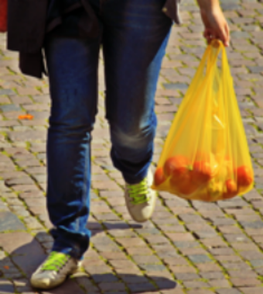 | 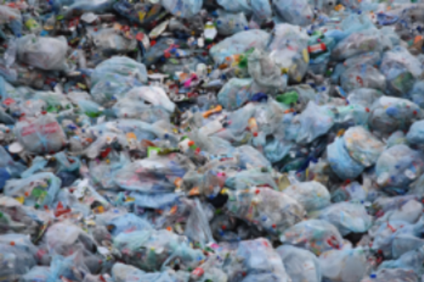

Key ideas
Force - a push or a pull.
Strength - can be thought about in many ways. In this activity, strength will be measured either as the load required to stretch and break a piece of material, or the puncture force to push an object into or through that material.
Load – A downwards force that is being applied to an object.
Puncture force is the force required to push an object into or through a material.
Fair test - When testing different materials all the variables except the one being tested need to be kept the same.
Variable - Something that can change.
Independent variable - Variable that is deliberately changed.
Controlled variables - Variables that are kept constant.
Dependent variable - Variable that changes in response to changes in the independent variable and that is observed or measured.

Equipment and materials
- Different plastic bags (3)
- Retort stand and clamp arm
- Paper clips or wire to make hook from which to suspend weights
- Scissors
- Sticky tape
- Icy pole sticks
- Bamboo skewers
- Weights
- Ruler (and/or measuring tape)
- Rubber bands
- One beaker or cup (approx. 8-10 cm diameter)
- Safety glasses/goggles

Part 1: Strength
In this activity, you will work out just how strong the plastic is in different supermarket bags. The principles in the testing procedure you will use are the same as those used by materials scientists in their labs.

Part 1: Hazards
The main hazard will arise when samples of plastic give way under load. Things may fly in unpredictable directions. You must wear safety glasses/goggles, and also keep faces well away from the plastics when they are heavily loaded. Keep clear if you think the plastic is about to snap. Set up a tray with something soft in it so the weights do not crash to the floor and keep feet clear.

Part 1: Investigation Instructions
From the samples of plastic bags for testing, cut strips 30 cm long and 2 cm wide. Wind the plastic strip around the one icy pole stick as shown leaving 20 cm between the sticks. Use sticky tape to hold the plastic in place. Tape a second icy pole stick to the first one for extra support.
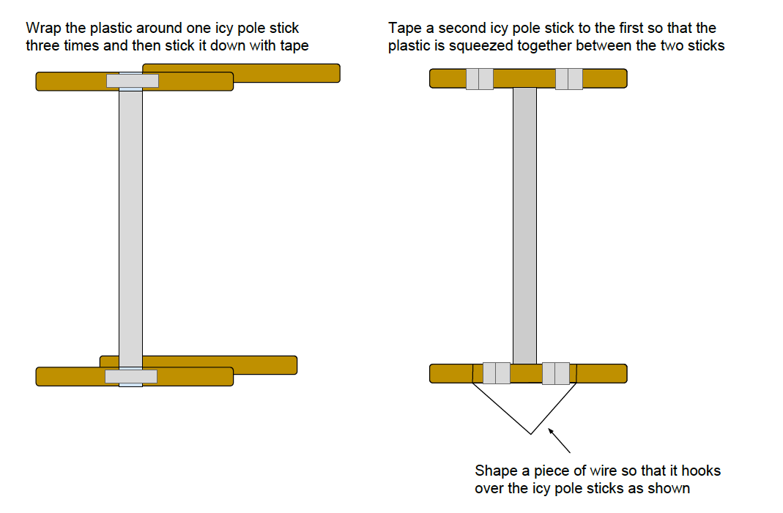
Suspend the top icy pole sticks from a clamp on a retort stand as shown below. Add weights to increase the load on 50 – 100 g at a time initially and 50 g at a time when you think the plastic is about to snap. Place something soft underneath the weights so that when the plastic breaks the weights do not crash to the ground. The supports on brass weights can be easily broken. Each time you add the load measure the distance between the top and bottom icy pole sticks i.e. the length of the plastic and also measure the width of the plastic at the midpoint of the length of plastic. Continue to add weights until the plastic test strip breaks.
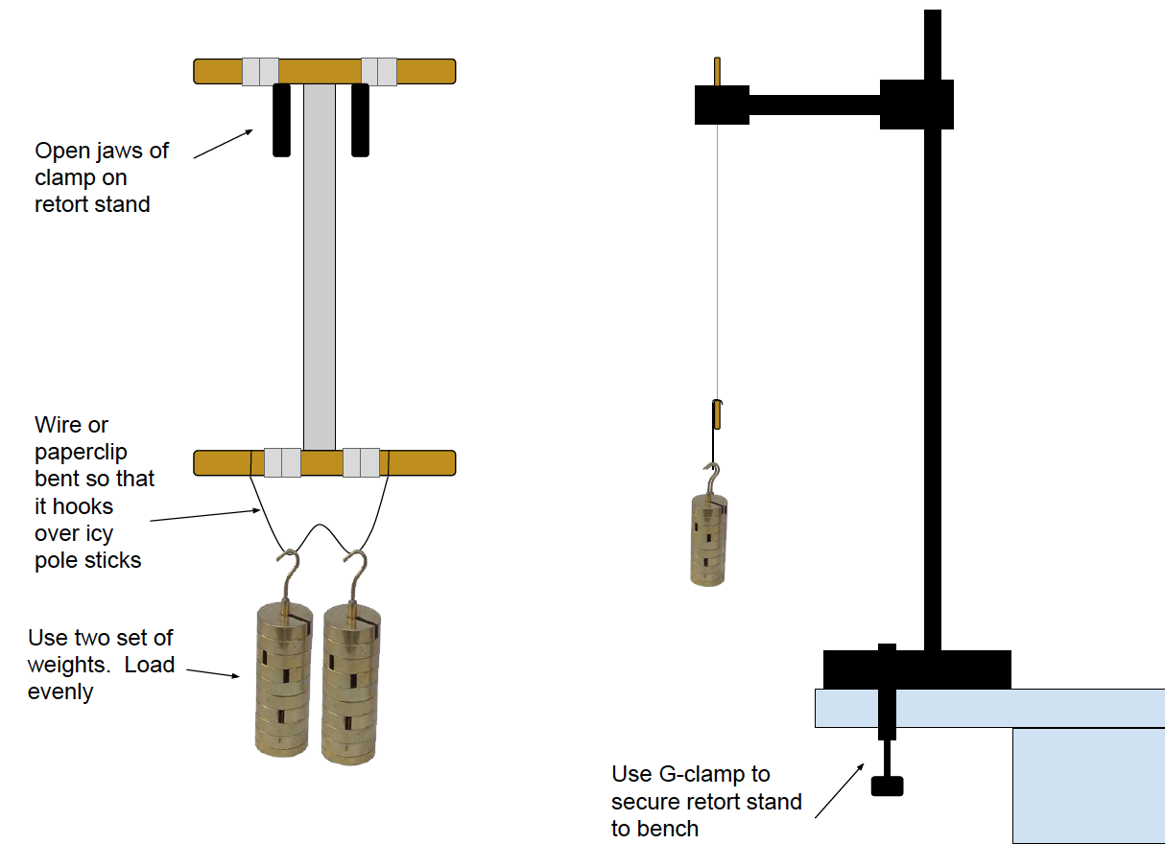
As well as the measurements, note other observations you make while the weights are being added.

Part 1: Results
Record your results in the spaces below.
Source of plastic
Plastic 1
Plastic 2
Plastic 3

 | Plastic Bag 1 |  | Plastic Bag 2 |  | Plastic Bag 3
Load | Length | Width | Length | Width | Length | Width

Part 1: Analysis
Calculate the percentage change in length versus load.
Plastic 1: percentage change in length versus load
Load | Length | Change in length | Percentage change in length

Plastic 2: percentage change in length versus load
Load | Length | Change in length | Percentage change in length

Plastic 3: percentage change in length versus load
Load | Length | Change in length | Percentage change in length

Draw graphs of the change in length versus load and percentage change in length versus load. Put your different graphs on the same set of axes.
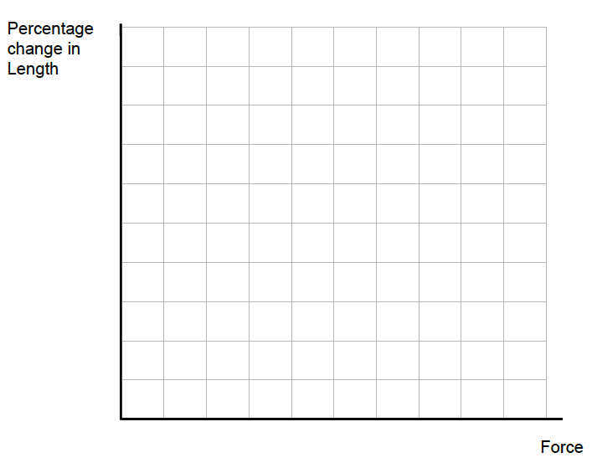

Part 1: Discussion and Conclusions
How did the plastics compare? Which one is strongest? What is the evidence?

How did each of the plastics behave as the load was increased? Were there differences?

Represent what you think is happening at the particle (molecular) level as the plastic is stretched and eventually breaks. Represent the elastic phase, the plastic phase and the point of failure.

Are there variables you have not controlled in your tests? How might these variables affect your conclusions?

Identify two improvements to the method to ensure it is a well-controlled experiment.

Suppose you had to increase the strength of the handles of the plastic bag — what could you do? Describe a test you could do to gain evidence for your proposal.

Part 2: Cutting and tearing
Not only are items purchased from the supermarket heavy requiring supermarket bags to be strong but they also often come in packages with sharp edges and corners. Bags may be punctured or cut and eventually tear.
In this activity, you use the materials and your own improved version of the suggested testing technique provided to compare the resistance of the bags to puncturing.

Part 2: Hazards
There are hazards in this activity from sharp objects. Care should be used with scissors to keep fingers clear while cutting. Both scissors and the bamboo skewers are sharp and care that they are not poked into skin or eyes. Wear eye protection.

Part 2: Investigation Instructions
From the samples of plastic bags for testing, cut 15 cm squares – big enough to be stretched over the beaker/cup and held in place with a rubber band.
Stretch a sheet of plastic bag over the top of a plastic cup or beaker and secure it with a rubber band as shown. Drop a bamboo skewer, point down, onto the stretched plastic, from different heights. | 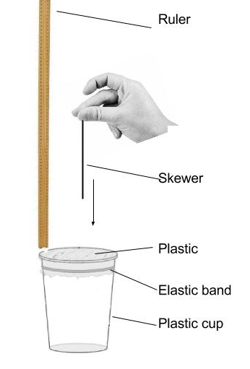

Part 2: Preliminary Observations and Results
What do you observe when you drop a bamboo skewer, point down, from a height of about 1 cm above the plastic bag onto the plastic?

Repeat this from 20 cm above the stretched plastic bag. What do you observe this time?

Using this technique compare three different plastic bags for their resistance to puncturing. What needs to be done to ensure that the tests are fair?

Part 2: Planning More Detailed Investigation(s)
Your task is to use the preliminary investigation above to work out which of the plastics has the greatest resistance to puncture with the skewer. Work with your partner or your group to decide which variables you will keep the same (controlled variables) which variable/s you will change (independent variable) and which variable you will measure (dependent variable).
Controlled variables

Independent variable

Dependent variable(s)

Record your testing procedure. How many tests will you do on each plastic?

Part 2: More Observations and Results
Record your results. What units will you be using?

Part 2: Analysis
Summarise your results in a form that visually displays the differences in resistance to puncturing.

Why did you choose to use this particular representation? Hint: what are the advantages of using this way of visually summarising your results?

Part 2: Discussion and Conclusions
How did the plastics compare? Which one is strongest? What is the evidence?

Do you think your results are reliable when making a judgement about which plastic bag will resist cutting by sharp objects? What are the strengths and weaknesses of the testing procedure you used?

Are there variables you have not controlled in your tests? How might these variables affect your conclusions?

Identify two improvements to the method to ensure it is a well-controlled experiment.

Part 3: Reflections
What other investigations could you undertake with the plastics and equipment used?

Part 4: Extensions

Stress vs strain
What extra measurements do you need Make the appropriate measurements and calculate the engineering stress and strain at different loads till failure. Design a table and record your measurements. Plot a stress vs strain curve for each plastic tested.
How do the shapes of the curves compare?
What do the shapes of the graphs suggest about the plastics used in supermarket bags?

Independent investigation
What question do you intend to investigate?
Do you have a hypothesis? Briefly state it.
Outline the procedure for conducting your test.
Record your measurements.
Present data.
Analyse your data.
What conclusions can you draw? Did the experiment produce evidence to support your hypothesis? Are there improvements you would make in your experimental method?

Copyright and Creative Commons
The moral rights of the authors, Stuart Palmer, Ian Bentley, Peta White, Russell Tytler, Kieran Lim, and John Long, have been asserted under the Australian Copyright Act 1968 (Cth).
Excepting logos, trademarks or other third-party content as indicated, this resource is distributed under a Creative Commons ‘Attribution-Non Commercial-Share Alike’ 4.0 International License.

