Laboratory LEARNING ACTIVITY

Honeycomb Structures

Introduction
A common aim of materials scientists and engineers is to create materials with the greatest strength and the minimum weight and minimum amount of materials (minimum cost). Honeycomb sandwich structures are often used to achieve these outcomes and are used in aerospace, automotive, housing, packaging, sports-equipment and other industries. These structures have an arrangement of tubes (or channels) sandwiched between two walls.
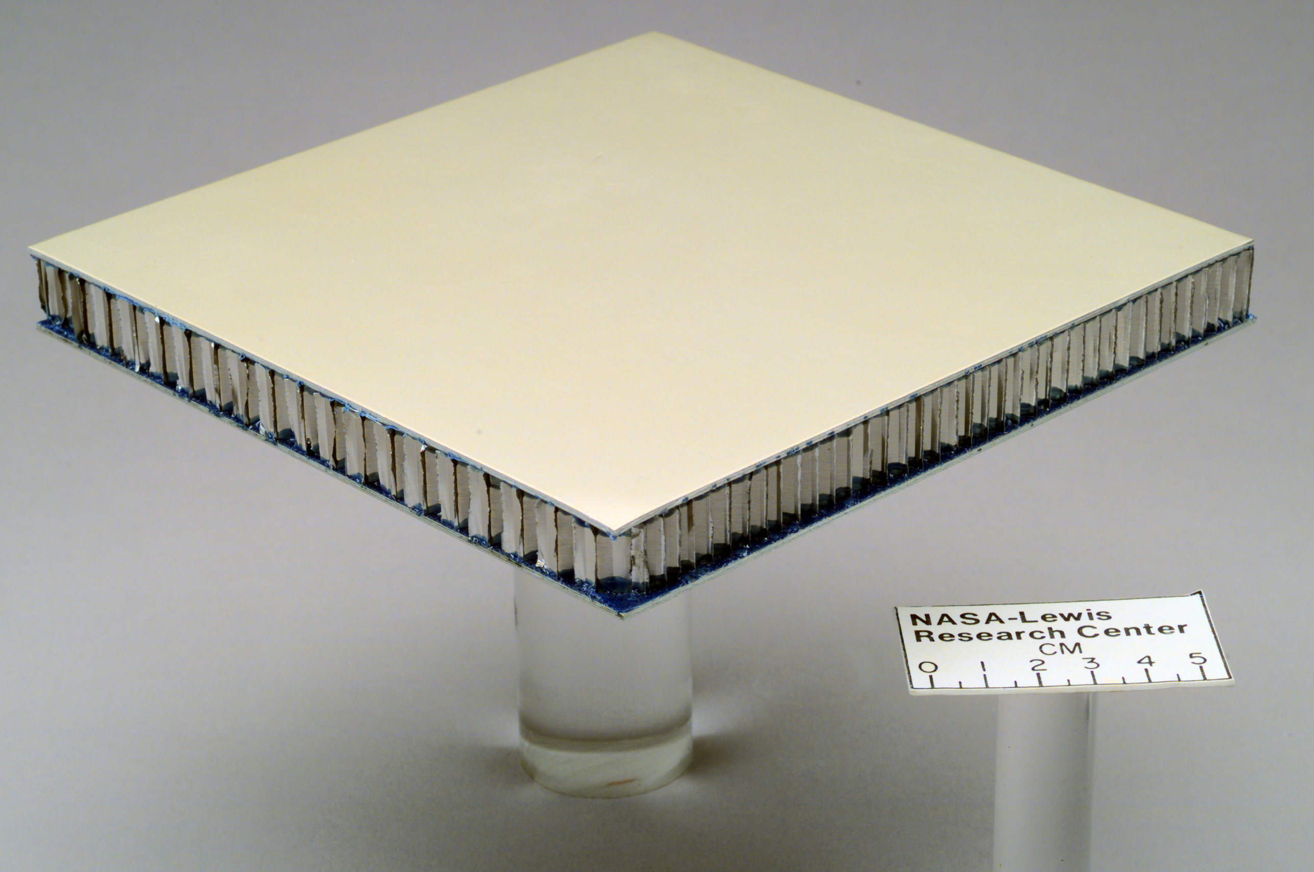
Glass aluminum reinforced (GLARE) honeycomb composite sandwich structure.
Photograph has been used and redistributed under an educational non-commercial licence by permission of NASA.
<https://commons.wikimedia.org/wiki/File:Glare_honeycomb.jpg>

Cardboard is often made by sandwiching a sheet of corrugated cardboard between two sheets of thick paper. In corrugated cardboard, the open sections run parallel to the walls.
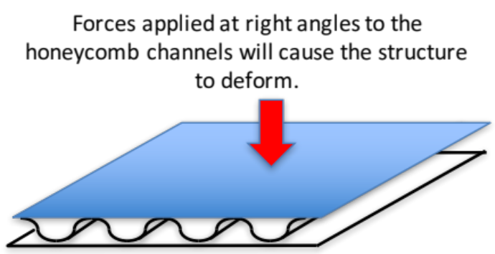
Diagram of corrugated cardboard.
Diagram by Kieran F Lim.

In some other structures the open tubes are arranged at right angles to the walls. These tubes can be different shapes in cross section. They could be circles, squares, triangles or hexagons (like honeycomb).
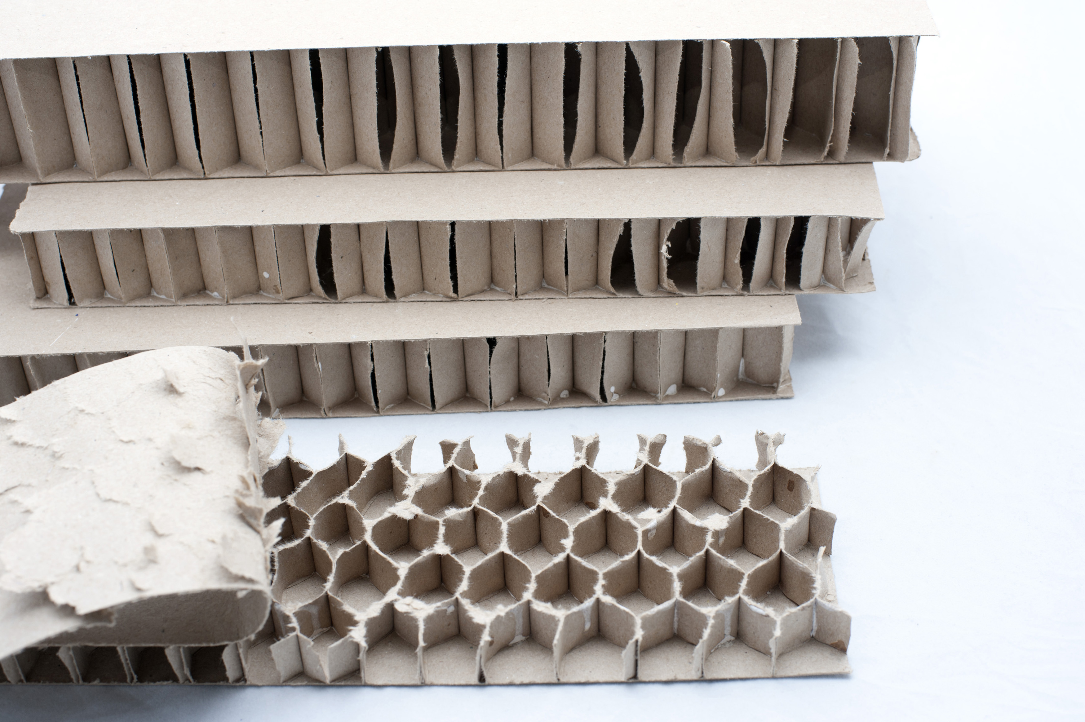
Honeycomb pattern for strength in cardboard. Image by sciencestockphotos.com.
<http://sciencestockphotos.com/free/engineering/slides/cardboard_strength.html>

Key ideas
Force - A force is a push or a pull. A force can cause movement in an object or cause compression, tension or torsion within the object.
Impact - Impact or impact force is a shock or large force applied for a very short time.
Compression force – a push that squeezes an object to try to make it smaller or shorter.
Tension force – a pull stretches an object to try to make it bigger or longer.
Strength – The ability of a material to resist breaking when a force is applied.
Strength to mass ratio - This is a measure of the strength of a material compared to its mass.
Investigation - A scientific process of answering a question, exploring an idea or solving a problem that requires activities such as planning a course of action, collecting data, interpreting data, reaching a conclusion and communicating these activities
Variable - Something that can change.
Dependent variable - Variable that changes in response to changes in the independent variable and that is observed or measured.
Independent variable - Variable that is deliberately changed.
Controlled variables - Variables that are kept constant.
Fair test - When testing different materials all the variables except the one being tested need to be kept the same.

Equipment and materials
- Paper, cardboard, straws
- Scissors
- Craft knives
- Glue
- Rulers
- Pencils
- Weights, bricks

Investigation
In this activity, your task is to investigate a question of your own about the strength of honeycomb structures and then you will formulate a hypothesis based on scientific knowledge. Once you have your question you need to design a way to answer it by constructing the different honeycomb structures out of paper, cardboard and glue and testing their strength. You will ensure that your tests will be fair and provide data relevant to answering your question. You will collect, analyse and evaluate the data communicating your findings appropriately.

Hazards
Cutting materials with scissors or blades poses the risk of cuts. Care should be taken to keep hands and fingers out of the way. Always cut way from yourself. Make sure sharp objects are stored safely when they are not being used.
Testing the sandwich materials with loads has potential for injury. Care must be taken. Ensure all people are at a safe distance.

Scientific questions
Suggest one or two scientific questions that you could ask using your experimental equipment and materials:

Some scientific questions will be more suitable for investigation in a classroom setting. Your teacher will lead a discussion to decide which scientific questions will be investigated. Your group will then decide how to investigate that question.
The scientific question that my group will investigate is:

A hypothesis is a testable “educated-guess” answer to a scientific question. A hypothesis leads to one or more predictions that can be tested by an investigation.
Our hypothesis is:

Remember to think about variables that will need to be controlled to ensure a “fair test”. Decide which variables you will keep the same (controlled variables) which variable you will change (independent variable) and which variable you will measure (dependent variable).
Our independent variable is:

Our dependent variable is:

Our controlled variables are:

We will use the following experimental procedure. (If appropriate, make a drawing of your proposal.)

Are there any safety issues to consider?

Testing our scientific question
What happened? Record your observations or measurements. Remember to include units for all numerical measurements.

Analysis of results
Do you need to summarize your results, draw graphs or do calculations such as work out averages? If so show your analysis here.

Discussion and Conclusion
Write a discussion of your inquiry noting your conclusions and reasons. Indicate the strengths and weaknesses of your procedure and how confident you are in your results. Identifying impacts and limitations of conclusions using appropriate scientific language and representations.

Extension
Use an internet or library search to find applications of honeycomb structures.

Scientific poster
- Complete introduction:
  - One- to two-paragraph overview of the reason for completing the investigation, the scientific context and an explanation of the relevant scientific theory.
  - All sources need to be acknowledged.
- Complete the discussion section:
  - Discuss your scientific question in this section. POE is often a useful guide is to help what you put in this section:
    - Predict. Your scientific question, hypothesis and prediction of what will happen.
    - Observe. What you observed or measured.
    - Explain. Did your observations or measurements agree with your expectations and prediction? Can you explain why?
  - Discuss the implications of your results.
  - Were there any limitations to your investigation?
- Complete the conclusion section:
  - State your main result from your investigation.
  - State whether this supports or refutes your hypothesis.
- Complete References and Acknowledgements.

Acknowledgements
The contributions of members of Scouts Victoria to the refinement of this laboratory learning activity are gratefully acknowledged.
- Photograph of a honeycomb pattern for strength in cardboard has been used and redistributed under a Creative Commons (CC BY 4.0) licence <sciencestockphotos.com/imagelicense.html>.
- Photograph of Glass Aluminum Reinforced (GLARE) honeycomb composite sandwich structure has been used and redistributed under an educational non-commercial licence by permission of NASA <https://www.nasa.gov/multimedia/guidelines/index.html>.

Copyright and Creative Commons
Excepting logos, trademarks or other third-party content as indicated, this resource is distributed under a Creative Commons ‘Attribution-Non Commercial-Share Alike’ 4.0 International License.
The moral rights of the authors, Kieran Lim, Stuart Palmer, Ian Bentley, Peta White, John Long, Russell Tytler, and Mary Vamvakas, have been asserted under the Australian Copyright Act 1968 (Cth).

