Literature Summary: Including People with Intellectual Disability in Infectious Disease Management
We wanted to understand how people with intellectual disability had been involved in the management of infectious disease during the past 20 years. An infectious disease is a disease you can catch from other people, like COVID, the ‘flu, HIV, or gastro. We also wanted to know what helps people with intellectual disability be included in health communication about infectious disease.

What we did
We reviewed previous research that discussed the treatment or prevention of infectious disease in people with intellectual disability. We also reviewed studies that involved providing training or information to people with intellectual disability about infectious disease. We did a systematic review of research from any country over the past 20 years. We included any papers that described original research studies and case studies.
We also examined policies about COVID-19 in disability services from Australian institutions, State and Federal Governments, and international organisations, including the World Health Organization. This helped us to understand the current practice landscape and identify potential gaps in evidence.

What we found
The research addressed the topics of infectious disease risks, keeping safe from infection, and health communication about infectious disease.

Risks of infectious disease for people with intellectual disability
Overall, the research told us that disease outbreaks carry many risks and hardships for people with intellectual disability. We found that when there is an infection outbreak, some people with intellectual disability can:
- get sick more easily,
- get sicker than other people, and
- stay sick for longer.
When there are lockdowns, it can be difficult for people with intellectual disability to access work, recreation, or disability and health services. They may not be able to see their family or friends. Lockdowns and restrictions can make people feel confused, depressed, worried, or angry.

Staying safe from infection
There is a lot of research on stopping infections from spreading in group homes. Things that help included:
- good cleaning
- using gloves, masks and gowns
- good personal hygiene
- clear and relevant policies, and
- clear communication between staff, residents, and visitors.
It’s important that group homes have infection control policies that are clear and easy to follow. Social distancing can also help to control infection, but it can be hard to keep residents separated in the home when someone gets sick.
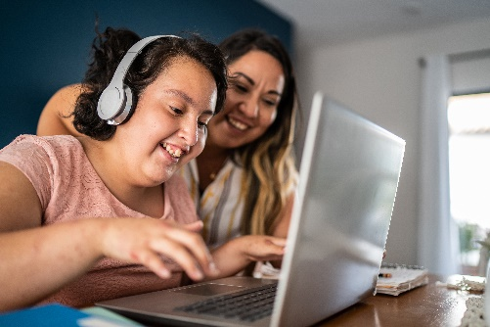
There is a lot of research about teaching people with mild-moderate intellectual disability to avoid getting sick or spreading infections. This included learning about safe sex, hand washing, and hygiene. It found that training worked best for people with intellectual disability when it was hands-on. People with severe intellectual disability may require a more tailored and reward-based training approach.

What does inclusive health communication look like?
The research we reviewed showed that inclusive health communication means many things.
- People should be supported to give informed consent for any tests or treatments. This means helping them understand what will happen to them, why it’s important, and what the risks are, before they make a health decision.
- Inclusive health communication means respecting people’s privacy, for example not sharing information about their health with other people without their permission.
- Professionals should talk directly to the person with intellectual disability and be respectful towards them.
- Communication should be accessible. This might mean using simple language, interpreters, pictures or communication aids.
- Communication should be culturally appropriate.

What research was missing?
There was very little research about:
- how people with intellectual disability understand topics like vaccination, testing, or treatment,
- helping people with intellectual disability to make their own decisions about infectious disease, or
- what people with intellectual disability want to know about infectious disease outbreaks.

What about policies?
We looked at policies about COVID-19 in disability services that were written during 2020 or 2021. We read policies from the Australian government, the World Health Organization (WHO) and the Centres for Disease Control (CDC).
We found that most policies were not a good match for disability group homes. Policies made for hospitals and nursing homes were too strict. They assumed everyone would be staying in their own room and not socialising together. But guidelines for managing COVID-19 at home didn’t provide guidance for keeping people safe in a disability group home, where people with different levels of medical risk all live together.
Service managers and leaders told us they needed more Government policies made for the group home setting.

What comes next?
People with intellectual disability have a right to be safe AND included during infectious disease outbreaks. Future research needs to ask:
- How can we make infectious disease information accessible to group home staff and residents?
- How can we support group home residents to make health choices during an infectious disease outbreak?
- How can disability group homes draw on their existing strengths, practices, and resources to make health communication more inclusive?
- What are the barriers to inclusive health communication in disability group homes, and how can we remove these?
For more information on our current research, please see our project website:
Inclusive Health Communication for SDA – Inclusive Health Research (deakin.edu.au)

Review Authors
Kate Anderson, Olumuyiwa Omonaiye, Melissa Bloomer, Joanne Watson, Meredith Prain, Jennifer David, Patsie Frawley, Nathan Wilson, Amie O’Shea, Rachel West.

