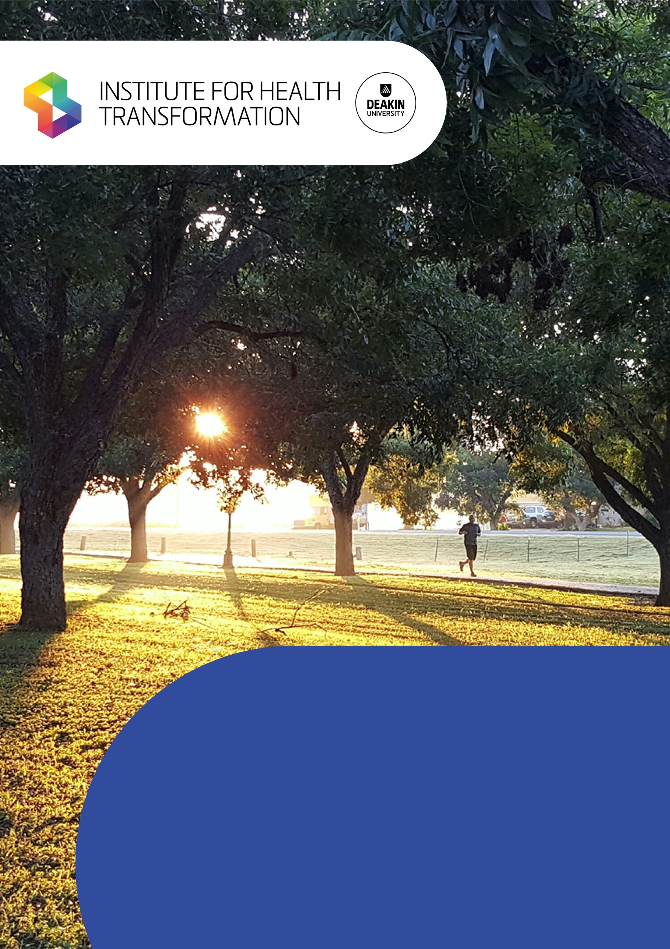

Inclusive Health Communication in Disability Accommodation

MRFF Coronavirus Research Response Communication Strategies & Approaches During Outbreaks Grant Opportunity

9th June 2023

Executive Summary
During the current COVID-19 pandemic, disability group homes have worked hard to protect their residents and staff from infection. Having access to health information is an important part of staying safe. We knew that some people living and working in group homes were having difficulty accessing accurate and relevant information, making decisions about their own health, and expressing their concerns. This was especially true for people with complex communication needs, including residents with severe or profound intellectual disability, people who were deafblind, and people who used alternative or augmentative communication modes other than speech.
We applied to the MRFF: Coronavirus Research Response Communication Strategies & Approaches During Outbreaks grant scheme to investigate the health communication needs of disability group home residents, their supporters, and their providers. We wanted to:
- evaluate how well current COVID-19 communication was working for these populations;
- identify what information was important for them to understand and express;
- learn about any communication supports or strategies that were working well; and
- create some guidelines that could inform policies or resources for future outbreaks.
We have worked together as a large research team, including researchers from four universities, advisory partners from Able Australia, Northcott, Inclusion Melbourne, Agosci Inc., and independent consultants from across Australia.
The following report presents the outcomes of our two-year program of research. We expect further work and resources to emerge from this project throughout 2023.

What we did
Our research project involved several small studies. Each stage of our research has been guided by advisory partners in industry and advocacy.

Scoping existing knowledge and practice
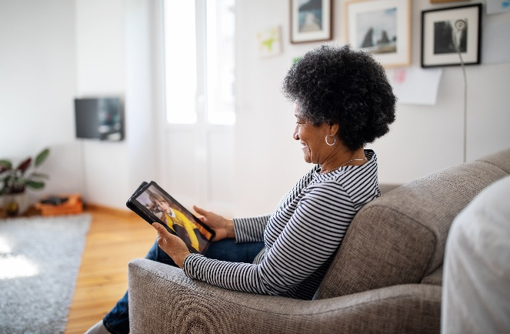
First, we gathered academic literature, including original research, reviews, and case studies. We also examined policies about COVID-19 in disability services from Australian institutions, State and Federal Governments, and international organisations, including the World Health Organization. This helped us to understand the current practice landscape and identify potential gaps in evidence.

Exploratory Research
Building on what we had learned from the reviews, we interviewed support workers and group home residents with intellectual disability about their experiences of COVID-19 communication and information. We listened to their suggestions for better practice.
To capture what it had been like to live in a COVID-Safe group home, we produced detailed video tours of two group homes, to help us to understand how communication and activities had changed in response to COVID-19 information, risks and policy.

Forming a Consensus
We put the poster inside the house everywhere. How to wash your hands properly, how to keep the social distancing ... how to correctly wear masks.
-Support Worker
Based on what we learned from our exploratory research, we created some draft practice recommendations. We used a Delphi approach to assess experts’ agreement with each recommendation.

What we found
The COVID-19 pandemic has had a significant impact on the wellbeing of people living in disability group homes due to restricted access to work, leisure, family, friends and communication supports. Residents and staff have navigated complex tensions between personal autonomy, collective responsibility, and duty of care regarding infection control. Our research showed that group home residents have been living in an “information soup” of COVID-19 policy and procedure documents, informal discussion, and news media. This information has not always been accessible or consistent. Here are four important recommendations for inclusive health communication approaches resulting from this project:
We got our most information through the news and we basically heard it from the media.
-Resident

Autonomy in information access: In line with the United Nations Convention on the Rights of Persons with Disability¹, group home residents should have autonomy in how they access, display, and act on health information relating to infectious disease. Supported decision-making techniques can enable this.
One of the clients, she's an artist, so she'll say, ‘COVID bad.’ That sort of thing. And she'll on occasion, she'll paint images of staff wearing masks, that's her way of expressing herself, I guess.
-Support Worker

Accessible and individualised information supports: Accessible health information formats should be available to group home residents with intellectual disability, including simple and familiar language, videos (which include sign language or key word sign), picture-supported text, repetition, and practical demonstrations of health protection measures. Individualised supports are critical, but they are not always feasible under current group home conditions. Inclusive communication requires time, expertise, staff commitment, tailored information resources and interpersonal rapport.
Attention to informal knowledge sharing: Some group home communities value and prioritise the informal sharing of information and knowledge, beyond official communication from the organisation or Government. This may include staff sharing personal opinions with residents and each other, and residents sharing their views with staff, other residents, family, and broader community members. Sometimes, this information and advice was different to official health information from the Government. Further research is required to understand the drivers of this information sharing, and how informal communication might be leveraged to enhance health literacy in the future.

One of the clients doesn't - he doesn't want to have injection. Instead of actually asking us [for information], he is actually telling us why we shouldn't have it.
-Support Worker

Comprehensive and collaborative change management: Improved health communication during future outbreaks is likely to require increased resourcing, targeted professional development, mandatory policies and protocols, and changes to staff recruitment or assignment. Co-designing solutions with all affected residents and staff is essential. To be effective, change management must account for the intersectional impacts of stigma, cultural diversity, gatekeeping, risk perception and compliance pressures.

Knowledge Translation
Knowledge Translation is the final step of our research and is ongoing. Our team has shared our research findings throughout the project by:
- working in close partnership with disability services and advocacy representatives;
- consulting with Government working parties and COVID-19 task force members;
- convening a free symposium on inclusive health communication; and
- creating and sharing a project website which includes information about inclusive health communication and inclusive research methods.
Working with project advisors from a range of sectors is also helping us to determine:
- the best way of sharing practice recommendations with group home residents and providers;
- how our findings might be used in other healthcare settings, such as hospitals, aged-care facilities and general practice; and
- what format the information should be shared in – for example, text, images, videos, websites, or other types of resources.
We plan to share this work as widely as possible, and we will keep updating our resources as new information becomes available. We will also learn how effective the recommendations and resources are when they are used for future infection outbreaks.

Project Team and Funding

Chief Investigators
Dr Kate Anderson^{1,2,9}, Dr Joanne Watson^{1,2}, Dr Meredith Prain³, A/Prof Nathan Wilson⁴, Prof Angela Dew^{1,2}, A/Prof Patsie Frawley^{5,1}, Dr Amie O’Shea^{1,2}, Prof Melissa Bloomer^{6,7,8}, Prof Catherine Bennett^{1,2.}

Additional Investigators
Dr Muyiwa Omonaiye (Project Manager; Research Fellow); Dr Jennifer David (Senior Research Fellow); Dr Jenny Crosbie (Senior Research Fellow); Dr Cadeyrn Gaskin (Senior Research Fellow); Mr Dion Williams (Research Assistant); Ms. Renee Haw (Research Assistant); Ms Rachael West (Liaison Librarian).

Project Partners
- Able Australia
- Northcott
- Inclusion Melbourne Inc.
- Agosci Inc.

Research Funding
This research project was supported by the following grants:
- Anderson, K., Watson, J., Prain, M. Wilson., N., Dew, A., Frawley, P., O’Shea, A., Bloomer, M., Bennett, C. (2020-2022). Inclusive Health Communication in Specialist Disability Accommodation. Medical Research Future Fund (MRFF) 2020 Communication Strategies and Approaches during Outbreaks Grant Opportunity. $109,047.00.
- Anderson, K., Dew, A., & O’Shea, A. (2022). Inclusive Health Communication in Specialist Disability Accommodation. Institute for Health Transformation Determinants of Health Small Grant. Ref. #PJ05025. $4,895.10
- Anderson, K. (2022). Inclusive Health Communication – Research and Practice Symposium. Institute of Health Transformation Partnership Grant. $4,910.00

¹Deakin University School of Health and Social Development, Burwood, VIC, Australia
²Deakin University Institute for Health Transformation, Burwood, VIC, Australia
³Able Australia, Surrey Hills, VIC, Australia
⁴Western Sydney University School of Nursing, Penrith, NSW, Australia
⁵School of Education, University of Waikato, Hamilton, New Zealand
⁶ Intensive Care Unit, Princess Alexandra Hospital, Metro South Health, Brisbane, QLD, Australia
⁷School of Nursing and Midwifery, Griffith University, Brisbane, QLD, Australia
⁸Deakin University School of Nursing, Burwood, VIC, Australia
⁹School of Computing Technologies, RMIT University, Melbourne, VIC, Australia

