Deakin University Inclusive Education Principles
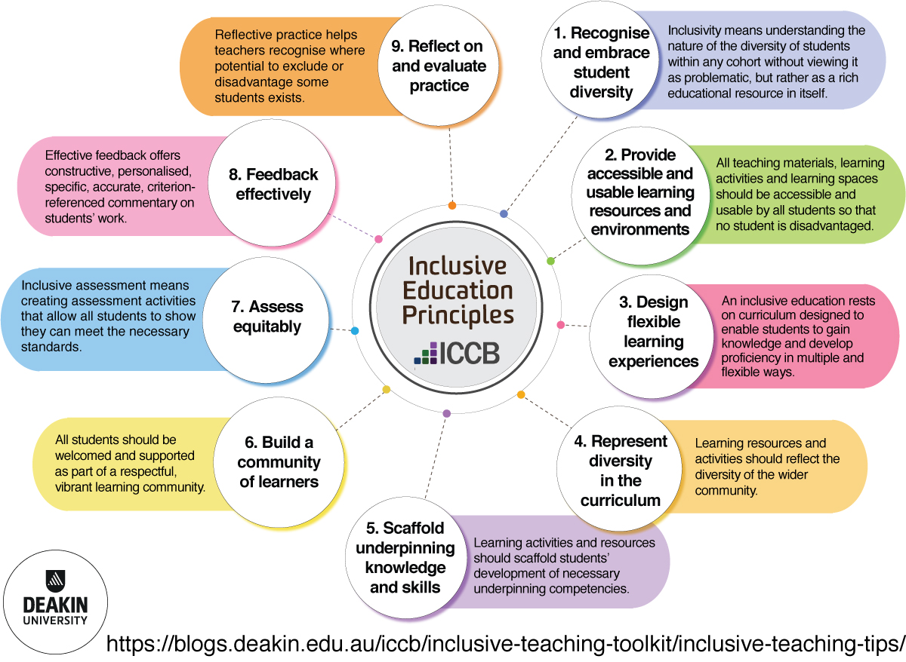
Inclusive education refers to the ways in which the Deakin University community creates a meaningful, welcoming and engaging environment (both on campus and in CloudDeakin) for all its students, to facilitate equitable and successful participation. Inclusive education is characterised at Deakin by a positive stance towards diversity and difference that anticipates learner variability, recognises diverse strengths, and employs multiple ways of engaging with students. This document describes key inclusive education principles that inform pedagogy, curriculum design and teaching at Deakin.
Deakin’s Inclusive Education Principles

Inclusive practices to apply the principles

1. Recognise and embrace student diversity

Inclusivity means understanding the nature of the diversity of students within any cohort without viewing it as problematic, but rather as a rich educational resource in itself.
- Students will vary in obvious ways, e.g. appearance, language, able-bodiedness, age, race / ethnicity and gender. Other diversities may be less obvious, e.g. career aspirations, motivations for study, learning skills, socioeconomic status, sexuality, cultural and religious background, remote / regional location, health issues and work experiences. Use the unit dashboard’s domestic equity student profile to identify major groups of students in your unit.
- Choose examples, activities and readings that will be relevant to the types of students in your unit, and plan to make the best use of the perspectives diverse students bring
- Encourage students to contribute their own experiences to group work and assignments. The variety of perspectives will enrich all students’ learning.
- Avoid cultural stereotyping; rather, focus on acknowledging the complexity of individuals themselves.
- Design learning experiences to engage all students equitably from the outset, rather than ‘adding on’ adjustments and supports as the need arises.
Read more about student diversity

2. Provide accessible and usable learning resources and environments

All teaching materials, learning activities and learning spaces should be accessible and usable by all students so that no student is disadvantaged.
- Accessibility means making learning experiences user friendly to all students through removing barriers, catering to existing strengths, and promoting clarity, consistency, predictability and flexibility.
- Learning resources and environments should be simple to use, intuitive, and able to accommodate equitably a wide range of abilities, disabilities, ages, and culturally and linguistically diverse backgrounds.
- Plain English should be used and any necessary jargon explained.
- Digital accessibility includes describing meaningful images; using appropriate structure; ensuring sufficient colour contrast; not relying on colour to convey meaning; providing informative links; including transcripts, captions and audio description for audio-visual resources; and using resource formats that work with assistive technologies.
Read more about learning resources and environments

3. Design flexible learning experiences

An inclusive education rests on curriculum designed to enable students to gain knowledge and develop proficiency in multiple and flexible ways.
- Give students practicable choices over how, when and where they engage in learning.
- Where possible, provide learning resources in a variety of media such as text, images, infographics, videos and podcasts; with alternative formats available for critical items.
- Use learning activities that provide scope for students to engage meaningfully with ideas that are relevant to their aims and interests.
Read more about flexible learning experiences

​4. Represent diversity in the curriculum

Learning resources and activities should reflect the diversity of the wider community.
- Students of all types need to see themselves mirrored in the curriculum, not be invisible in that which is read, discussed, written about and assessed. Design / choose examples, images, case studies, texts and assessments representing the legitimacy and contributions within the discipline of people with a wide range of cultures, ethnic groups, religions, abilities, geographical locations, genders and sexual orientations.
- Work towards embedding Indigenous knowledges and perspectives in courses across the university.
- Allow students to contribute readings and topics that reflect their lived experience.
- Written and spoken language should reflect diversity by using gender-neutral pronouns (‘they’ instead of ‘he’ and ‘she’).
- Classrooms and discussion forums need to provide safe places for critical discussion of diversity issues that arise in the context.
- It is preferable to embed a diverse view of society across whole courses, but a first step may be to introduce weekly topics on diversity issues (though this needs to be done in a way that avoids overt tokenism, which will result in reinforcing the assumption that the male, white, middle-class person is the norm and other identities are ‘other’).
Read more about representing diversity in the curriculum

5. Scaffold underpinning knowledge and skills

Learning activities and resources should scaffold students’ development of necessary underpinning competencies.
- Explain and model academic skills such as academic reading and writing using the conventions and language of the discipline.
- Provide tasks to develop students’ academic study skills, such as time management, research planning and referencing.
- Examples of scaffolding techniques include optional guides and demonstrations on how to use e-learning technologies, glossaries, step-by-step activity guides, annotated readings and example assessments. These are critical in early stages of study.
- Point students to university information and support services including Language & Learning Advisors, Peer Mentors, Librarians, the IT Service Desk and Counsellors.
Read more about scaffolding student learning

6. Build a community of learners

All students should be welcomed and supported as part of a respectful, vibrant learning community.
- Regular dialogue, interaction and collaboration should be encouraged through regular discussions and supported group activities. Interaction with teachers and peers can occur across a variety of platforms and modalities, depending on the curriculum, study mode and the needs of students.
- Make efforts to get to know students as individuals and develop a salient presence in the community (whether physical or virtual). For example, be available and approachable; and use clear, consistent and encouraging communications.
- To foster a respectful culture, establish a class code of conduct or protocols to ensure safe spaces of interaction, and model respectful interactions, including conflict and disagreement resolution techniques where relevant.
Read more about building a community of learners

7. Assess equitably

Inclusive assessment means creating assessment activities that allow all students to show they can meet the necessary standards.
- Use a variety of assessment methods that enable students to demonstrate their achievement of intended learning outcomes via a range of modes.
- Assessment tasks should not favour students with particular characteristics not relevant to the task.
- Be prepared to adjust tasks where necessary to ensure that learners with diverse characteristics can demonstrate achievement of a standard in a different way.
- Describe tasks in plain English with clear, concise marking criteria; and provide scaffolding activities and resources such as step-by-step guides and example assessments where necessary.
- Staged assessments that break a large task into parts with feedback input provided well before the final submission can help students develop underpinning skills before high-stakes assessment.
- Authentic, meaningful tasks where students have some capacity to choose between topics—or suggest their own—can help students engage optimally in assessment tasks.
Read more about equitable assessment

8. Feedback effectively

Effective feedback offers constructive, personalised, specific, accurate, criterion-referenced, commentary on students’ work which is oriented to students improving the quality of their work.
- Feedback can be effective whether the work is presented in set formative or summative tasks, or in seminar-based learning activities.
- Feedback should be timely and focused particularly on early tasks in a unit.
- It should target key aspects upon which students need to focus further and where they need to adjust their learning strategies.
- The mode of feedback used (e.g. written, verbal) may need to be varied to accommodate different student characteristics.
- All students should be taught how to elicit, interpret and use feedback information to best effect, to improve their future performance.
Read more about giving effective feedback

9. Reflect on and evaluate practice

Reflective practice helps teachers recognise where potential to exclude or disadvantage some students exists, and assess the effectiveness of strategies to teach more inclusively.
- Regularly pause to evaluate your teaching practices, using self-reflection in a journal, student feedback, analysis of students’ grades, peer review of one’s teaching/learning designs or formal professional development opportunities.
- Examine the assumptions, beliefs, attitudes and values you bring to teaching tasks, and consider how these may impact on specific students’ learning and participation.
- Imagine how students with particular characteristics you wouldn’t normally anticipate in your unit cohort would perform—this could pre-empt the need for later just-in-time adjustments.
- Reflection and evaluation are not ends in themselves, but should aim to continually improve the equitability of the learning experience one provides to all students.
Read more about reflective practice (pp. 24-25)

These principles were compiled by Dr Janet Watson and Dr Mary Dracup from the Inclusive Education Project, in Deakin Learning Futures. They incorporate findings from key pieces of research in this area including the Universal Design for Learning (CAST 2018) framework, Hockings’ (2010) Inclusive learning and teaching in higher education: a synthesis of research, Devlin et al’s (2012) Effective teaching and support of students from low socioeconomic status backgrounds, and Stone’s (2017) ‘Opportunity through online learning’ national guidelines. The principles align with the Deakin University Minimum standards for unit sites.

See the Deakin Inclusive Education website for further information and tips to apply these principles.

