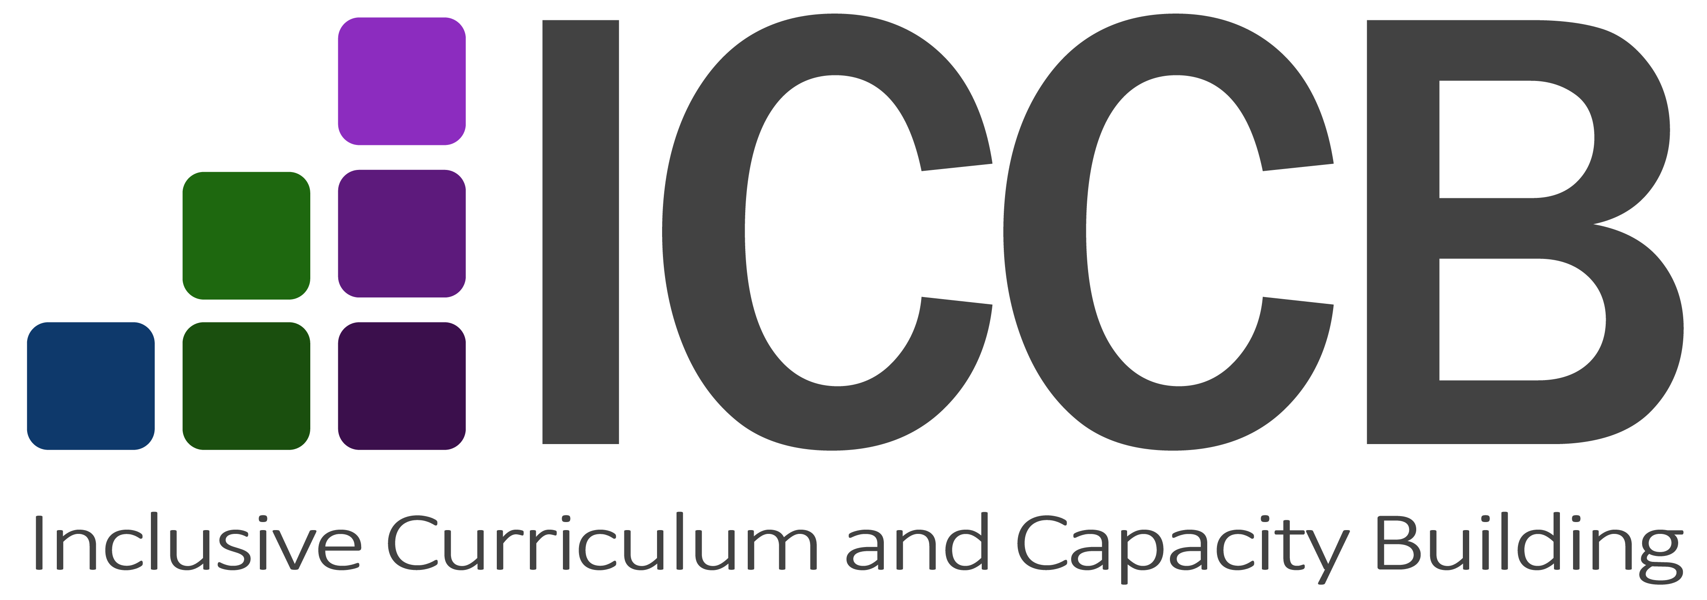

Produced for the Inclusive Curriculum and Capacity Building Project
Equity and Diversity, Deakin University
Dr Janet Watson, 2017

Modelling culturally inclusive pedagogies
Internationalisation of curriculum (IoC) promotes and develops the core values of global awareness, global citizenship and intercultural competence. This aligns with Deakin’s LIVE the Future Agenda 2020 to offer an educational experience that will: widen participation and support students from diverse backgrounds; be responsive to the fast changing global environment and to the diverse needs of the communities Deakin serves; and deliver globally connected education.
IoC involves embedding global, international and multicultural dimensions in curriculum design, learning activities, teaching practice, learning activities, assessment, and evaluation (Barker 2011).

Curriculum design
Provide clear, accessible and broadened topic areas that integrates multiple societal perspectives including:
- Case studies (including both real-life and simulated), research studies, databases, and other materials that reflect local, global, indigenous and multicultural viewpoints and ethical issues
- Comparison of local and global studies, research and findings
- Recently published international and cross-cultural textbooks, journals, class materials and online resources
- Digital literacy and critical analysis that draws on a variety of learning materials and content
- Content delivery using a range of multi-media methods (text, audio, video, slide presentations, Cloud concepts)
- Discipline specific glossaries
- Reading guides and strategies
- Annotated examples and exemplars of assignment tasks such as essays, reports and reviews

Learning activities
Support the development of graduate students as globally competent and inter-culturally aware citizens by:
- Incorporating local, global and multi-cultural perspectives in learning activities
- Encouraging critical reflection on societal issues and problems from a variety of perspectives
- Examining cultural influences on knowledge construction and application of knowledge
- Exploring the role and operation of multiculturalism in different nations
- Drawing on the experiences and narratives of international/NESB students as a learning resource
- Setting group or paired student activities that cultivate collaboration and dialogue between local and international students, such as writing tasks and allocation of roles
- Cultivate critical thinking by examining different points of view in class or small group activities and asking questions that prompt students to critically reflect on an issue or problem; be aware that students from some cultural backgrounds are not familiar with the notion of critical analysis and critical inquiry
- Inviting guest lecturers with international experience and expertise
- Including practical seminar exercises that demonstrate application of ideas delivered in lecture classes

Teaching practices
Cultivate culturally open, inclusive, sensitive and mutually respectful teacher-student engagement and a safe learning environment by:
- Acknowledge and value cultural and linguistic diversity of international and domestic students
- Correct pronunciation of students' names
- Be approachable, welcoming, supportive and hospitable—and encouraging all students to convey these qualities
- Avoiding stereotypes or generalisations of cultural or ethnic groups
- Cultivate a climate of respect and equity for all forms of diversity
- Establish inclusive and respectful ground rules for group discussions
- Speak clearly and measuredly (consciously avoid speaking quickly as international students may have trouble with accents)
- Respect and allow for silences: in many cultures, silence is a part of communication while for others, verbal expression is not encouraged in educational forums; silence and pauses also allow for ‘cognitive processing time’
- Cultivate international students’ confidence to ‘speak up’ gradually and by encouraging small group discussions.
- Remember that some students may be code-switching between their own language and English in trying to understand content, therefore separate listening activities from reading activities
- Avoid jargon, colloquialisms and humour as this excludes those who are not familiar with Australian vernacular—explain any colloquial language, unfamiliar terms, analogies and metaphors that you or local students may use
- Give clear, plain language instructions—ensure that written instructions are clearly set out (heading and dot points rather than long paragraphs) and are not overlong and too complicated.
- Be aware that writing conventions in other cultures are often markedly different from Australian universities and may have serious implications regarding plagiarism—clearly explain the Western convention of referencing others’ ideas and writing and what is meant by plagiarism
- Incorporate activities about digital literacy so that all students become skilled in critically evaluating multi-media sources
- Refer struggling students to appropriate study skills or language support programs

Assessment tasks
These should assess global citizenship competencies, knowledge and skills and aim to:
- Develop critical analysis of global and intercultural perspectives
- Include comparative exercises that involve comparing and critically reflecting upon similarities, differences and links between local and global issues, findings, practices and standards
- Draw connections between cultural contexts and disciplinary knowledge
- Encourage peer learning and engagement between local and international students through group work including self and peer assessment
- Clearly explain the purpose, expectations and marking criteria of the assessment and subject content
- Cater to a variety of learning capacities, preferences and skills through offering a range of assessment options and formats
- Progressively build academic skills through a step-by-step learning approach for both formative and summative tasks
- Provide inclusive feedback

Student feedback
- Review eValuate data and other sources of student feedback that provide comment on international and multicultural aspects of their learning experiences, and course content, design and delivery.
- Compare feedback from domestic and international/culturally and linguistically diverse students to determine differences in learning experiences.

Adapted from:
Arkoudis, S, n.d. Teaching International Students: Strategies to Enhance Learning, Centre for Study of Higher Education, University of Melbourne, retrieved 16 May 2017.
Barker, M 2011, The GIHE good practice guide to internationalising the curriculum, Griffith Institute for Higher Education, now Griffith University Learning Futures, Southport. Reproduced for Deakin staff with permission by Griffith University, 26 April 2018.
Federation University 2017, Guidelines for internationalising your curriculum , retrieved 16 May 2016.
Morgan, H & Houghton, A-M, 2011, Inclusive Curriculum Design in Higher Education: Considerations for Effective Practice Across and Within Subject Areas, The Higher Education Academy, retrieved 16 May 2017.

