UNIVERSAL DESIGN FOR LEARNING EVALUATION—template

This document outlines an evaluation of universal design for learning (UDL) within an example unit at Deakin University. The aim of this document is to identify existing areas of good practice, and highlight areas where further development may be undertaken.

methodology
This evaluation has been undertaken primarily through a review of the Cloud Deakin site for this unit. A curriculum review was completed using the CAST UDL Curriculum Self-Check Tool, and the content and resources were also mapped against the Universal Design for Learning Guidelines (CAST, 2011).

summary of current univeral design for learning within example unit
See Appendix One for a copy of the Universal Design for Learning Guidelines. The following is an example of rating the high level principles as a snapshot evaluation of the unit.

Multiple means of representation | Multiple means of action and expression | Multiple means of engagement
- Provide options for perception | - Provide options for physical action | - Provide options for recruiting interest
- Provide options for language, mathematical expressions and symbols | - Provide options for expression and communication | - Provide options for sustaining effort and persistence
- Provide options for comprehension | - Provide options for executive functions | - Provide options for self-assessment

Key:
- All checkpoints reflected in good practice
- Some checkpoints reflected in good practice
- No checkpoints reflected in good practice

existing areas of good practice
There are several examples of good practice in unit… as it is currently configured. The provision of recordings for all lectures provides an alternative way of perceiving the lecture information, whether the student attends in person or not. While these recordings are not fully transcribed, they are supported by the lecture notes and slides. Multiple means of representation are also evident in the provision of feedback, as assignment marks are provided throughout written comments, rubrics and audio records.
The current platform for displaying information (Cloud Deakin) can be customised, and is amenable to assistive technology. The unit explicitly seeks to minimize threats and promote self-management by referring students to the PASS program, and provides links to other sources of support at the university. The unit is available across campuses and includes independent learning within each lesson, which provides some opportunity for individual choice and autonomy.
Good use of the discussions forum are made to encourage students to ask questions, and some alternative formats are provided as supplementary materials (i.e. songs, podcasts etc.). A full rubric is available for the major essay, indicating what each level of mark would ‘look like’. The use of quizzes are supporting of students learning how to self-monitor their progress, and seem to be timed to occur at appropriate moments in the trimester.

General areas for further development
- The overall unit goals are could be written in clearer, more specific language, and learning outcomes are not always provided week to week (in lecture and tutorial notes). Inclusive goals 1) separate the goal from the means to achieve it, 2) support various pathways to success and 3) reflect any changes which may occur as a result of this review

- Virtually all learning materials are text based, although there are some links to other resources which use a range of media.

- The unit has a substantial focus on written assessment, which may disadvantage students for whom this is not their preferred learning style. Given the variety of communication media available which could support this unit, a broader range of opportunities for students to demonstrate their competence might be considered. All assessment are undertaken individually, and there are no peer assessed tasks.

  - Potential opportunities;
    - Including an element of ‘response’ in the requirement to participate in discussions (i.e. students need to comment to other postings / comments, and not just contribute their own thoughts or complete quizzes).
    - providing a space for the students to self-assess or reflect about their assignments before they submit them

- Marking criteria and a rubric provided for Assignment One, but does not explicitly states what would constitute an Excellent, Good, Satisfactory, Poor or Very Poor answer like the extended criteria for the Major Essay. This information support students to plan their work and self-assess.

- The discussion forums appears to be used somewhat sporadically. There are many sub-discussions which have relatively few responses, although off campus students appear to be using them more consistently. You might like to consider cutting down the number of discussions to make this section easier to navigate.

- The PowerPoint presentations reviewed used many different colours and fonts, while the study guides were more consistent in their approach. Consideration could be given to the accessibility of the font being used, and layout of information to simplify and clarify the display.

- The majority of information presented is text based. Consideration could be given to illustrating the content through multiple media, to maximize the student’s opportunities to engage with the information.

Appendix ONE: UNIVERSAL DESIGN FOR LEARNING GUIDELINES

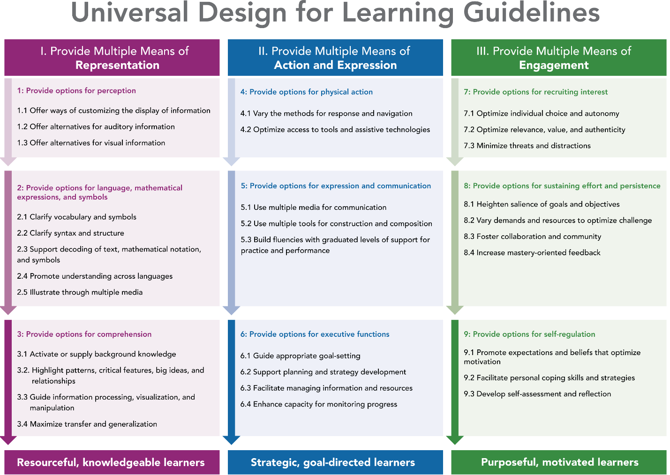

Appendix TWO: Mapping of unit guides against UDL Guidelines

multiple means of representation
Guideline 1: Provide Options for Perception
Checkpoint | Evaluation
1.1 – Offer ways of customizing the display of information | Information available on platforms which allow customisation (i.e. Cloud Deakin, forums, Echo)
1.2 – Offer alternatives for auditory information | Lecture recordings and notes made available weekly. Unclear whether the recordings include inclusive practices (i.e. referring to which slide is being viewed at the time).
1.3 – Offer alternatives for visual information | Lectures recorded, but no direct transcripts of these recordings  Text to speech is possible in Cloud Deakin

Guideline 2: Provide options for language, mathematical expressions, and symbols
Checkpoint | Evaluation
2.1 – Clarify vocabulary and symbols | Terms are explained in lectures, but no unit glossary provided
2.2 – Clarify syntax and structure
2.3 – Support decoding of text, mathematical notation, and symbols | Discussed as part of some lectures (i.e. clarifying terms
2.4 – Promote understanding across languages | Links made to support resources to assist with academic writing
2.5 – Illustrate through multiple media | All media/resources are text or audio with a limited degree of interactivity.

Guideline 3: Provide options for comprehension
Checkpoint | Evaluation
3.1 – Activate or supply background knowledge | Some background knowledge is activated – i.e. students are asked to reflect on previous knowledge.
3.2 Highlight patterns, critical features, big ideas and relationships | Larger themes are highlighted on a week by week basis, but unclear how these are interlinked with other content in the unit
3.3 – Guide information processing, visualization and manipulation | Rubrics provided for assessments
3.4 - Maximise transfer and generalisation | Discussed as part of the content of the unit

multiple means of ACTION AND EXPRESSION
Guideline 4: Provide options for physical action
Checkpoint | Evaluation
4.1 – Vary the methods for response and navigation | Lessons available in face to face or online modes (with supporting exercises and readings).  A few web links offered as additional resources, but the majority of sources are text based
4.2 – Optimise access to tools and assistive technologies | Current formats are amenable to tools and assistive technologies to some degree.

Guideline 5: Provide options for expression and communication
Checkpoint | Evaluation
5.1 – Use multiple media for communication | All media/resources are text or audio with a limited degree of interactivity.
5.2 – Use multiple tools for construction and composition | All assessments are in traditional written formats, as the tutorial participation element is assessed via quizzes and writing. Some choice evidence in essay/assignment questions.
5.3 – Build fluencies with graduated levels of support for practice and performance | Short written assessment is used to provide feedback prior to the major essay

Guideline 6: Provide options for executive functions
Checkpoint | Evaluation
6.1 – Guide appropriate goal setting | Only general statement available for Assessment 1 indicating how marks are allocated  Unit goals could benefit from clearer language, and not every lesson/tute appears to have specified learning goals.
6.2 – Support planning and strategy development | Provides some information on how to engage with the unit
6.3 – Facilitate managing information and resources | Resources highlighted during the course (linked to specific lessons)
6.4 – Enhance capacity for monitoring progress | Several mechanisms for monitoring progress – quiz and short written assessment results, feedback from tutors, discussion boards

multiple means of engagement
Guideline 7: Provide options for recruiting interest
Checkpoint | Evaluation
7.1 – Optimise individual choice and autonomy | Available at multiple campuses  Independent learning built into unit  Choice of assessment questions
7.2 – Optimise relevance, value and authenticity | Some references to thinking about students own leaning context  Learning resources based on Australian examples, and those relevant to the lives of the students
7.3 – Minimise threats and distractions | Staff introduced by name in unit guide and individually in first lecture  Friendly tone adopted throughout unit guide

Guideline 8: Provide options for sustaining effort and persistence
Checkpoint | Evaluation
8.1 – Heighten salience of goals and objectives | Learning goals in unit stated, and aligned to graduate learning outcomes, and graduate learning outcomes mapped to all unit learning outcomes.  Goals and objectives for each lesson are not always present in the lectures, and there don’t appear to be opportunities for students to set their own goals.
8.2 – Vary demands and resources to optimise challenge | Limited chances to change the level of challenge – each week has set exercises / activities with few opportunities for customizing
8.3 – Foster collaboration and community | Many discussion forums set up, but they are currently used inconsistently – some seem to have been engaged in while others haven’t
8.4 – Increase mastery oriented feedback | Quizzes help students to check their knowledge  Clearly stated that the assessments are based on the learning materials

Guideline 9: Provide options for self-regulation
Checkpoint | Evaluation
9.1 – Promote expectations and beliefs that optimise motivation | Encouraging tone adopted throughout, communicating a belief that students can succeed
9.2 – Facilitate personal coping skills and strategies | Students encouraged to develop study skills to work with this unit
9.3 – Develop self-assessment and reflection | Some prompts to self-reflect when reading

