KOALAS AT CAPE OTWAY

Acknowledgement
This teaching sequence was developed by students in the Issues in Science and Environmental Education (ESS439) unit in trimester 1, 2017. Peta White lead the unit and had support from colleagues Kieran Lim, John Cripps Clark, Ian Bentley, Russell Tytler, Jorja McKinnon, and Connie Cirkony who supported the students in the initial sequence design. Research scientists were invited from the Faculty of Science and the Built Environment and contributed their research and ideas as the basis for the students to then develop teaching sequences that result in contemporary science practices being infused into secondary school science. All sequences were edited by Mary Vamvakas prior to publishing.
Thanks to the following students for their efforts in generating this innovative teaching sequence:
James Kanjo; Mark Quiambao, Jessica Rowe, Caitlin Stamper, and Christopher Stucley

This teaching and learning sequence is based on the research of Dr Desley Whisson and her research into population dynamics of Koalas at Cape Otway.

Our focus is on the year 9 & 10 Science Understanding, Biological sciences section of the Victorian Curriculum with respect to “the transmission of heritable characteristics from one generation to the next involves DNA and genes” (VCSSU119) and “ecosystems consist of communities of interdependent organisms and abiotic components of the environment; matter and energy flow through these systems (VCSSU121).

This research is important to present in a school community because it is real world science that students can become involved with. Bringing real world science in to the science classroom acknowledges that "the values and needs of contemporary society can influence the focus of scientific research (VCSSU116)" and provides students with knowledge that is current and can be directly applied, leaving them with a sense of relevance. Since the science being presented is so raw and close to home, it also leaves students with a feeling of ownership and connectedness with their learning.

Throughout the teaching and learning sequence there are all facets of the Science Inquiry Skills incorporated. There is a strong focus on scaffolding learning to have the students formatively assessed as the lessons roll on to have regular communication and feedback from teacher to learner and vice versa. Clear learning intentions and success criteria for each lesson allow the students to anticipate and understand what is expected of them. The lesson sequence is set up initially with a focus on data analysis, then populations of koalas and finally has the students reflect on the similarities of these population dynamics in the human world.

The lesson sequence will consist of five lessons:

- Introduction to the topic and population density data graphing and analysis

- Introduction to data and data analysis

- Tree health and data collection and data analysis

- Koalas, population dynamics and human intervention

- Summative assessment in the form of a poster

Curriculum Links taken from the Victorian Curriculum, 2016,

www.victoriancurriculum.vcaa.vic.edu.au
Teaching and Learning Sequence

Lesson One

Learning Concept | • Understanding of how people exist in the numbers they do
Teaching Input | - Settle class and take role  - Students are asked to leave their laptops closed until instructed to open them  - Learning Intention (LI) & Success Criteria (SC) are presented on board along with the starter question  - Students are to copy LI & SC in their workbooks, possibly attempt starter question  Video  - Show "YouTube video: Overpopulation – The Human  Explosion Explained"  - Students are to complete Worksheet 1 Activity 1 (Appendix 1)  Role play activity  - 4 x 1m rulers are to be placed in the classroom and an  attempt is made to fit the maximum number of students in the space  - Students lookup city densities on the internet and ascertain how much space each person has in that city and graph their findings.  - Refer to “population densities’ worksheet provided Worksheet 1 Activity 2 (Appendix 1)  Class discussion  - Ask students to describe what they believe is overpopulation  Think; pair; share  - Ask the students how many people live in their house and possibly their street to get a gauge of population dynamics in their area  - Have students reflect on their research and their role play activity
Student Activity | - Worksheet 1 (Appendix 1)  - Brainstorm  - Constructive scientific evidence-based arguments for  populations
Resources | Whiteboard; Video “Overpopulation – The Human Explosion  Explained” https://www.youtube.com/watch?v=QsBT5EQt348 ;  •  Discussion within class  Worksheet 1; 4 x 1m rulers; internet access
Assessment for learning | - Discussion within class  - Worksheet on video and population densities
Victorian Curriculum Links | - Formulate questions or hypotheses that can be investigated  scientifically, including identification of independent, dependent  and controlled variables(VCSIS134)  - Construct and use a range of representations, including graphs, keys, models and formulas, to record and summarise data from students’ own investigations and secondary sources, to represent qualitative and quantitative patterns or relationships, and distinguish between discrete and continuous data (VCSIS137)  - Analyse patterns and trends in data, including describing relationships between variables, identifying inconsistencies in data and sources of uncertainty, and drawing conclusions that are consistent with evidence (VCSIS138)  - Use knowledge of scientific concepts to evaluate investigation conclusions, including assessing the approaches used to solve problems, critically analysing the validity of information obtained from primary and secondary sources, suggesting possible alternative explanations and describing specific ways to improve the quality of data (VCSIS139)  - Communicate scientific ideas and information for a particular purpose, including constructing evidence-based arguments and using appropriate scientific language, conventions and representations(VCSIS140)

Lesson Two

Learning Concept | - Importance of Data and Data Collection and Analysis  - Guidance surrounding gathering and analysing data due to the data-heavy nature of the overall teaching concept
Teaching Input | - Brainstorm (mind map): where do we see data? List  students’ ideas on the board – relate these ideas to everyday life  - Discuss: How is data collected?  - Organise students in to groups to brainstorm how data is helpful – how does it help individuals? Businesses? (at least four ideas per group)  Data Activity  - Hand out worksheet 2  - Project PowerPoint, spend 5 minutes on each slide asking students to collect the “data” that they think is significant to them  - Instructions on what data to collect can be limited as it is  up to the individual student to collect and justify their data  Class Discussion  - How did you analyse the pictures? What data did you feel was necessary? Why did you feel they were necessary?
Student Activity | - Engage in brainstorm activities as a class or in small groups  - Participate in data activity; create four lists of “relevant data” (Extension: Graph data)  - Participate in class reflection and discussion
Resources | - Data PowerPoint (Attachment)  - Worksheet 2 (Appendix 2)
Assessment for learning | - Discussion/ collaboration/ brainstorming activities with peers: broadens individuals’ “knowledge umbrella’s”  - Entire class reflection
Victorian Curriculum Links | - Independently plan, select and use appropriate investigation types, including fieldwork and laboratory experimentation, to collect reliable data, assess risk and address ethical issues associated with these investigation types (VCSIS135)  - Construct and use a range of representations, including graphs, keys, models and formulas, to record and summarise data from students’ own investigations and secondary sources, to represent qualitative and quantitative patterns or relationships, and distinguish between discrete and continuous data (VCSIS137)  - Analyse patterns and trends in data, including describing relationships between variables, identifying inconsistencies in data and sources of uncertainty, and drawing conclusions that are consistent with evidence (VCSIS138)  - Use knowledge of scientific concepts to evaluate investigation conclusions, including assessing the approaches used to solve problems, critically analysing the validity of information obtained from primary and secondary sources, suggesting possible alternative explanations and describing specific ways to improve the quality of data (VCSIS139)

Lesson Three

Learning Concept | - Understanding the importance of the health of trees within an ecosystem.  - Analysing and evaluating real data from a scientist
Teaching Input | - Arrange students into groups of 4: Research using the following links some of the Pest (biotic) and Non-Living (abiotic) influences on trees. Complete a mind map/table of the various factors and their visible effects on trees.  Why Trees Become Unhealthy: http://www.fao.org/docrep/007/y5041e/y5041e06.htm#TopOfPage  Trees are Good: https://www.treesaregood.org/treeowner/planthealthcare  - This information can then be used in the following activity.  - To apply the knowledge, the teacher will be taking students outside into the school environment to judge the health of the trees. This practical allows students to see first-hand how we can inspect and assess trees within the ecosystem to ensure they are not being impacted by negative external factors.  - To conclude the class, the teacher will be providing students with data from the scientist, Desley. This data has been sourced from Cape Otway and will allow students to see how tree health can have a significant impact on an ecosystem and the organisms (in this case koalas) within it.
Student Activity | - At the beginning of the class, students will participate in a group activity to gain knowledge about features of tree health. This will give students a basis of knowledge in tree health and the impacts this has on the environment.  - To engage students with the content, they will participate in an outside practical to judge the health of the trees within the school. This practical task allows students to exercise and apply their understanding.  - To further practice their ability to analyse data and tree health, students will be using real life data from scientist Dr Desley Whisson and analyse this in groups to determine the health of 6 manna gum woodland sites in Cape Otway and the koala numbers in this area.
Resources | - Sample data sheet for vegetation and a file explaining the codes (Appendix 3)  - Canopy cover reference chart (Appendix 4)  - Investigating behavioural response of koalas to food resources in manna gum woodland in Cape Otway. Worksheet 3 (Appendix 5) Source: http://journals.plos.org/plosone/article?id=10.1371/journal.pone.0144348
Assessment for learning | - Group Activity mind map  - Participation in outside practical Data Analysis group task  - Data Analysis of manna gum woodland in Cape Otway
Victorian Curriculum Links | - Independently plan, select and use appropriate investigation types, including fieldwork and laboratory experimentation, to collect reliable data, assess risk and address ethical issues associated with these investigation types (VCSIS135)  - Select and use appropriate equipment and technologies to systematically collect and record accurate and reliable data, and use repeat trials to improve accuracy, precision and reliability (VCSIS136)  - Construct and use a range of representations, including graphs, keys, models and formulas, to record and summarise data from students’ own investigations and secondary sources, to represent qualitative and quantitative patterns or relationships, and distinguish between discrete and continuous data (VCSIS137)  - Analyse patterns and trends in data, including describing relationships between variables, identifying inconsistencies in data and sources of uncertainty, and drawing conclusions that are consistent with evidence (VCSIS138)  - Use knowledge of scientific concepts to evaluate investigation conclusions, including assessing the approaches used to solve problems, critically analysing the validity of information obtained from primary and secondary sources, suggesting possible alternative explanations and describing specific ways to improve the quality of data (VCSIS139)

Lesson Four

Learning Concept | - How koalas and their resources must exist in equilibrium  - Human interventions in habitats
Teaching Input | - Brainstorm: How healthy are the trees around our school? What threats are they exposed to?  - Have students watch Catalyst video and respond to Worksheet 4 (Appendix 6)  - Discuss questions on worksheet  - Class discussion: Why are koalas leading to the destruction of their own habitat?  - Carrying Capacity Roleplay - read through background of carrying capacity roleplay as a class and get a scope of general understanding of this passage (thumbs up/ middle/ down) - complete roleplay as advised by Worksheet 5 (Appendix 7)  - Discuss natural occurrences, and human interventions that could disrupt the balance of an ecosystem  - fire/ lack of fire  - deforestation  - disease  - low/ high breeding season  - introduced species
Student Activity | - Participate in brainstorming activity  - Watch catalyst video and complete worksheet 4  - Participate in class discussion  - Participate in Carrying Capacity Roleplay and related discussion
Resources | - http://www.abc.net.au/catalyst/stories/3715819.htm  - + Worksheet 4 (Appendix 6)  - Carrying Capacity Roleplay Worksheet 5 (Appendix 7)
Assessment for learning | - Class discussion  - Thumbs up/ middle/ down  - Participation and engagement with topic
Victorian Curriculum Links | - Ecosystems consist of communities of interdependent organisms and abiotic components of the environment; matter and energy flow through these systems (VCSSU121)  -using modelling to examine factors that affect population sizes, for example, seasonal changes, destruction of habitats, introduced species  -investigating how ecosystems change as a result of environmental change, for example, bushfires, drought and flooding

Lesson Five

Learning Concept | - Human population dynamics  - Humans exceeding carrying capacity
Teaching Input | - Discuss: What resources are humans likely to exceed the carrying capacity of?  - Discuss: What will be the effect of humans exhausting these resources?
Student Activity | - Separate students in to small groups to each select a resource that we have exceeded carrying capacity of, or that we are at risk of exceeding  – research the effects of exhausting this resource and develop a poster presentation - water, food, land, fossil fuels, agriculture, overfishing, etc - what is the issue?  - what are we doing to distort the stability of this issue? - what do we need to do to maintain the stability of this issue?
Resources
Assessment for learning | - Participation and engagement in topic  - Participation in discussion
Assessment of Learning | - Poster presentation. Teacher and Peer Assessment
Victorian Curriculum Links | - Communicate scientific ideas and information for a particular purpose, including constructing evidence-based arguments and using appropriate scientific language, conventions and representations (VCSIS140)

Appendix 1
Worksheet 1: Population Densities

Learning intention:
- Explain the impact of population growth on population densities
- Compare the population densities of major cities.

Activity 1
Use the following video to fill in the table below “Overpopulation – The Human Explosion Explained https://www.youtube.com/watch?v=QsBT5EQt348
Demographic Transition is a 4-step process. Fill in the table by naming each stage and outlining what happens at each stage and give an example from the video.

Name of Stage | Cause of Demographic Transition Stage | Example where observed

Activity 2: Population Densities in different countries.
- Define what is meant by population density.

b. Use the link provided to record in a table the population densities (people per sqKm) of the following cities. http://www.citymayors.com/statistics/largest-cities-density-125.html

City | Density  (people per sqKm) | City | Density  (people per sqKm) | City | Density  (people per sqKm)
Mumbai (India) |  | Jakarta (Indonesia) |  | Naples (Italy)
Karachi (Pakistan) |  | Los Angeles (USA) |  | Tokyo (Japan)
Lagos (Nigeria) |  | Athens (Greece) |  | Paris (France)
Shenzhen (China); |  | London (UK) |  | Berlin (Germany)
Seoul (South Korea) |  | Moscow (Russia) |  | Rio de Janeiro (Brazil)
Manila (Philippines) |  | Madrid (Spain) |  | Melbourne (Australia)
c. Using the data from part b. plot a bar graph of Density (people per sqKm) vs City. Include labelled axes and a meaningful title. (Hint: Independent variable goes on the X axis and dependent on the Y axis)

- Referring to the graph and/or table:

- Which city has the largest population density? ___________________________
- Which city has the lowest population density? ___________________________

- Tokyo has a population of 33,200, 000 while Moscow has a population of 10, 500, 00, however, they have very similar population densities. Can you explain why.

Appendix 2
Data Analysis Worksheet 2

Name

Date

Use the following tables to analyse the data from the pictures on the screen. For the sake of the activity please fill this sheet out individually as it is important to find out how each person perceives what data is important. Use as many (or as little) of the tables provided

Picture 1

Picture 2

Picture 3

Picture 4

Appendix 3
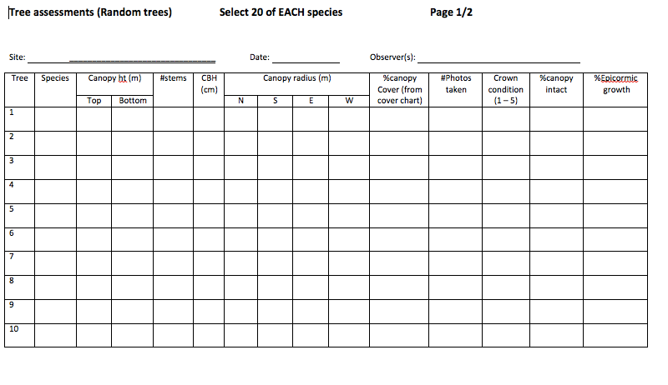

Appendix 3 page 2/2

Tree assessments (Random trees)
This is the datasheet to be used for assessing a random selection of 20 trees of each species at non-radiotracking sites. Select 20 random numbers between 0 and 50. Each random number is the number of paces walked along a transect (from previous point). Stop when you reach the random number and select the closest tree to your point. Record the following for that tree:

- Canopy ht(m) Use a clinometer to record the height in metres to the top of the canopy and height to the bottom of the canopy
- #stems Number of main trunks from close to ground level.
- CBH(cm) Circumference at breast height (cm). For multi-stemmed trees, record for ALL stems and record each on a separate line.
- Canopy radius (m) Measure the radius in 4 cardinal directions from base of tree to canopy edge
- %Canopy cover Use cover charts to estimate leaf cover. If some leaf cover but less than 40%, write <40. Write 0% if no leaf cover
- #Photos taken Record number of canopy photos taken. First take a photo of the tree tag for identification and then up to 4 photos from random points looking directly up through the canopy. Try to avoid locations of canopy overlap with neighbouring trees.
- Crown condition
- No leaves present in the crown
- Clumps of leaves are sparse and poorly spread (includes epicormic growth)
- Clumps of leaves have average density with reasonable distribution or dense clumps very unevenly spread
- Dense leaf clumps distributed unevenly over the crown (includes epicormic growth)
- Very dense leaf clumps with even distribution of clumps over the crown. Very little light penetrating the leaf clumps (includes epicormic growth)
- %Canopy intact = 100% - proportion canopy senesced (i.e. indicated by dead limbs).
- Epicormic growth: Percentage of total foliage present provided by epicormic shoots and branchlets. Shoots are considered to be epicormic when they are initiated from old stems and < 3 cm in diameter. Shoots of larger diameter are considered to be successful growth and no longer an indication of poor condition.

Appendix 4
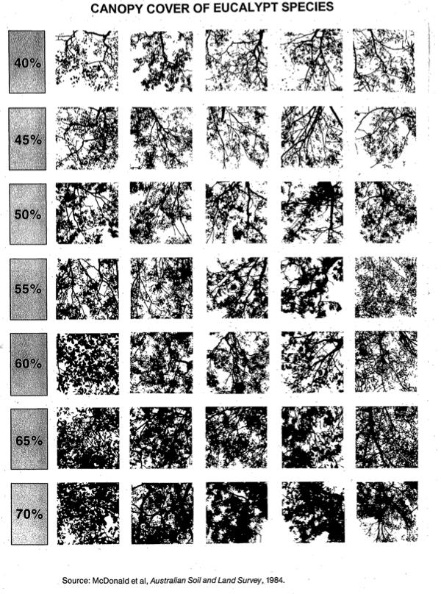

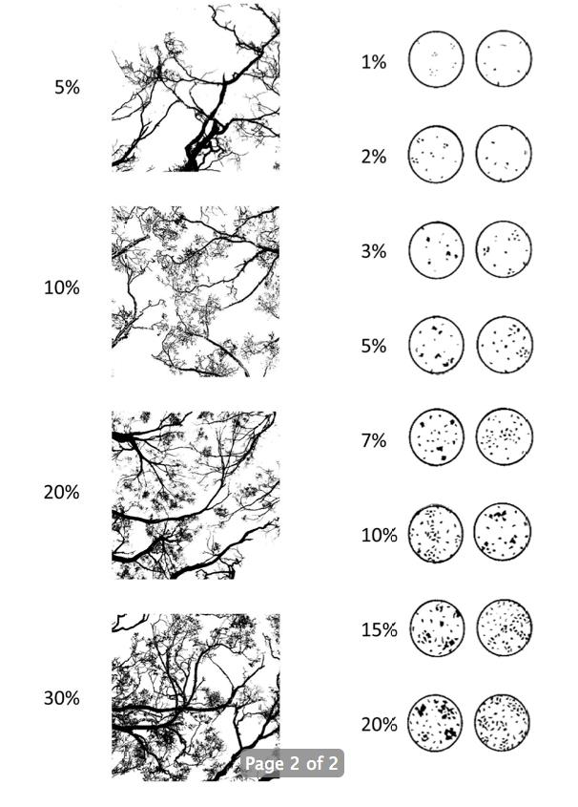

Appendix 5
Data Analysis Task
Investigating the behavioural response of koalas to declining food resources in manna gum (Eucalyptus viminalis) woodland at Cape Otway, Victoria, Australia, from September 2011 to November 2013.

Introduction: In order to better understand conservation of species and their habitat, Dr Desley Whisson and her colleagues conducted research on koalas and their manna gum woodland habitat. They “monitored the behavioural response of koalas to declining food resources in manna gum (Eucalyptus viminalis) woodland at Cape Otway, Victoria, Australia, from September 2011 to November 2013” (Whisson, Dixon, Taylor & Melzer, 2016 p. 1). Their research findings are shown in Tables 1 and 2 provided in this activity.

Aim: To investigate the behavioural responses of koalas to declining food resources.

Data Analysis:
Question 1. Refer to the table below showing canopy conditions of manna gum trees from 2011 to 2013 in six woodland sites.
- Draw 4 (four) line graphs (1 for each canopy condition) on the same axes of percentage of trees in each canopy condition for the years 2011-2013. Include appropriately labelled axes.
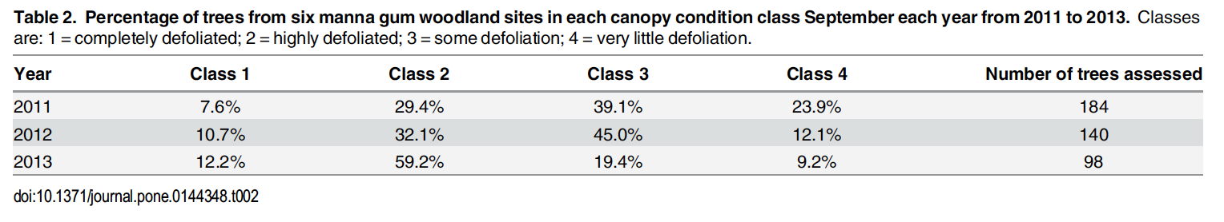

- Which class of tree (1-4) has the most amount of leaf cover and which has the least?

- Referring to the graph you drew, describe the trend observed in percentage of trees from 2011 – 2013 for each Class (1-4) of manna gum tree.

- Given that the manna gum tree is the main food source of the koala in Cape Otway what conclusion can you make about their impact on the manna gum trees from 2011 - 2013?

- What implication do you think these results may have for the density of the koala populations in these six woodland sites?

Question 2: The table below shows the average density (number of koalas per hectare) for the years 2011-2013 in the six manna gum woodland sites

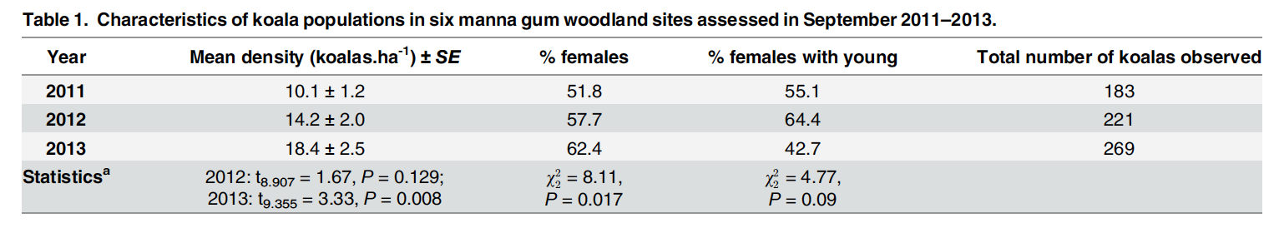

- Referring to the data in the above table:
- Describe the trend in mean density of koalas for the years 2011 to 2013.

ii. Compare the change in %females koalas with % female koalas with young from 2011 to 2013.

- i. Referring to your graph analysis of Table 2 of change in canopy condition of the manna gum trees and Table 1 results of koala numbers, can you explain the difference in the %female koalas and %female koalas with young?

ii. What consequence might this have for future koala numbers at Cape Otway?

- In her research Desley found that although the Great Otway National Park was close to the manna gum woodland sites there was limited movement of the koalas from the drastically depleted manna gum trees to this park to access more food. This had catastrophic consequences for koalas with 71% (15/21) of radio collared koalas dying from starvation or being euthanased due to their poor condition between September and November 2013.

- Given that Desley and her colleagues are primarily interested in how best to conserve species and their habitats. Describe some conservation measures that scientists might take to restore manna gum tree health and koala numbers in Cape Otway.

Source: Whisson, D. A., Dixon, V., Taylor, M. L., & Melzer, A. (2016). Failure to Respond to Food Resource Decline Has Catastrophic Consequences for Koalas in a High-Density Population in Southern Australia. PLoS ONE(1). doi:10.1371/journal.pone.0144348

Appendix 6
Name: ____________________
Catalyst Story: Koalas

http://www.abc.net.au/catalyst/stories/3715819.htm

In the Cape Otway National Park and surrounding private land, there are as many as 18 koalas per hectare – the highest density ever recorded.
Watch the program and answer the following questions.

1. How many koalas are estimated to be in the Great Otway National Park in total?
• 9,000 koalas over 350 hectares

2. Why were koalas brought to the National Park? Why was this National Park appealing to bring the koalas to?
- To increase tourism
- This park had lots of manna gums which koalas love
- French Island had an overpopulation of koalas at the time

3. What went wrong when the koalas were brought in?
- The koalas started to overpopulate, and the trees started to die

4. Why are the manna gums so popular with the koalas?
- Low in toxins, high in nutrients

5. Why can’t they move the koalas from Victoria to Queensland where the population is dying out?
- Queensland koalas are different- smaller and less dense fur
- Victorian koalas wouldn’t survive the conditions in Queensland

6. Why can’t they sterilise the koalas?
- Sterilisation is slow acting and the effects of it wouldn’t be seen for 5-10 years

Dr Desley Whisson and her team catch and put radio-collars on a few of the koalas so that they can track the koalas’ movements. Desley expects that the koalas will begin to leave the area as food becomes more and more scarce.

7. How many trees were the koalas found to be grazing on over one month?
- Only 3 or 4
- Some koalas were found to venture up to 8kms away

8. How much of the manna gum tree species is dead or in critical condition?
- 40%

9. What can be done to the trees to protect them? Why might this idea fail?
- Put a collar around the tree
- Koalas can move from tree to tree through the canopy because the trees overlap

10. How many seedlings of which tree species are planted each year? Why?
- 300 to 400 manna gum and messmate seedlings
- To maintain the number of trees in the forest
- To make sure there is a diversity of trees in the forest

Appendix 7

Carrying Capacity Roleplay

Background: The carrying capacity is identified as the number of individuals of a type that can be supported by a given area. In the Cape Otway National Park, there are more koalas in the area than it can support – the koalas have exceeded the carrying capacity of the area. The carrying capacity is determined by limiting factors, which can include food, water and shelter, and in the case of the koalas, the limiting factor that decides this carrying capacity is the number of trees in the area. It is important to ensure that all limiting factors are stable for a supportive ecosystem.
Natural occurrences can impact the carrying capacity, such as a disease, a difficult winter or a natural disaster, but humans can also increase or decrease the natural carrying capacity of an area. Humans can increase it through actions such as building nest boxes and planting extra vegetation, and decrease it through logging processes, land development and collaring trees.
Sometimes, humans can attempt to maintain the carrying capacity at a natural level by introducing predators and disease, and hunting. This activity will simulate the carry capacity of an area with a limited food supply and is better undertaken outside to limit clean up.

Equipment:
- Bucket of sand
- Four empty buckets (no holes)

Instructions:
- Create four groups of students and assign each group a corner of a cleared space to reside in. Each group represents a “herd”.
- Put a bucket of sand in the centre of a cleared space and provide each group with an empty bucket. The bucket of sand represents all the available food at the beginning of the “season”.
- Designate a minimum weight for each group’s bucket to be filled to – this represents the minimum amount of food needed for survival in that season.
- At the start of the time, one student from each group brings their groups bucket to the bucket of sand in the centre and scoops a handful of sand into their own bucket - they bring the bucket back to their group and give it to the next person in line to add a scoop and so on until the central bucket of sand is empty.
- At the end of the time, all the buckets are weighed, and any groups bucket that weighs less than the designated weight “dies”.
- Divide remaining students into four smaller groups and repeat activity, eliminating some groups each time, until all groups are consistently reaching the designated weight.

Discussion:
When each group was consistently getting enough food, the environment was at carrying capacity. Groups that were eliminated “died” because the population had exceeded carrying capacity.

- What could naturally occur to increase carrying capacity in this environment?
- What could naturally occur to decrease carrying capacity in this environment?
- How could humans increase or maintain the carrying capacity in this environment?
- How could humans decrease the carrying capacity in this environment?

Management options – reduce the population (translocate, hunt, strategic cull, introduce predators) or increase the resources (plant trees, provide food directly, provide shelters) or let the environment and population stabilise itself with no intervention.

Extension: If time allows, this activity can be repeated with the incorporation of some “natural occurrences” or “management options” as discussed and selected by the students. For example,
- Disease: slowly take away individual students from the activity Provide additional vegetation (human intervention): add more sand to the central bucket.
- Offspring: some individuals take two scoops (one for an offspring).
- Translocation of half the population: Add a bucket of sand in a different space, divide class into two and repeat activity with two separate groups.

Adapted from: https://www.fs.usda.gov/Internet/FSE_DOCUMENTS/stelprdb5073081.pdf

