Learning Sequence - Year 8: Earth and Space Sciences

Acknowledgement
This teaching sequence was developed by students in the Issues in Science and Environmental Education (ESS439) unit in trimester 1, 2017. Peta White lead the unit and had support from colleagues Kieran Lim, John Cripps Clark, Ian Bentley, Russell Tytler, Jorja McKinnon, and Connie Cirkony who supported the students in the initial sequence design. Research scientists were invited from the Faculty of Science and the Built Environment and contributed their research and ideas as the basis for the students to then develop teaching sequences that result in contemporary science practices being infused into secondary school science. All sequences were edited by Mary Vamvakas prior to publishing.
Thanks to the following students for their efforts in generating this innovative teaching sequence: Adam Dean; Esther Man; Mena Nasery; Claire Sims

Content description:
- Sedimentary, igneous and metamorphic rocks contain minerals and are formed by processes that occur within Earth over a variety of timescales

Elaborations:
- recognising that rocks are a collection of different minerals
- considering the role of forces and energy in the formation of different types of rocks and minerals
- identifying a range of common rock types using keys based on observable physical and chemical properties
Lesson 1: Geological Time Scale
Lesson  50 mins | Learning Intentions | Teaching Inputs | Student Activities | Resources | Assessment
1.Geological Time Scale | To link scientist video with topic students will be studying  To Understand the geological time scale and know the major events that occurred in the formation of the Earth  To Identify and be able to place periods of geological time on a geological timeline. | Introduce topic to students by showing interview with scientist Tamara Camilleri  Assist students with understanding the periods of geological time and filling the worksheet of major events.  Assist students in creating a geological time scale. | Students to view Tamara’s video on her research  Fill in Worksheet 1 (Earth’s time line)  Create a geologic time scale | https://video.deakin.edu.au/media/t/1_4a6u3hrj  Worksheet 1  Power point slides (attached as appendix 1)  Year 7 science books  Computers (Internet) | Assessment for learning:  Discussion, observing students’ behaviour and making sure tasks are completed.  Assessment as learning: Verbal questioning  Assessment of learning: Creating a time scale

Worksheet 1: Earth’s time line

Refer to Power Point: The Geological Time Line.

Task 1: You will create a scale timeline of Earth’s history on a long sheet of adding machine paper. You will need it to be 46 inches long.

You may instead choose to work in cm.
Scale: 1 inch = 100,000,000 years; 4.6 billion years = 46 inches

Materials
• Meter sticks (even though we’re using inches)
• Decimal inch rulers
• Your textbooks
• Copies from other textbooks
• The internet

Task 2: Use your textbook to determine when each of the four eras began. Record these dates in the table below and then calculate the distance back from “Today” on the time line for each. Remember that 100 million years is 1 inch, so 1 billion years is 10 inches, 10 million years is 1/10th of an inch and 1 million years is only 1/100th of an inch! Record the beginning of each era at the appropriate place on your time line.

Era | Date of Event: Years  Before Today | Distance back from “Today”  on Time Line
Cenozoic
Mesozoic
Paleozoic
Precambrian

Task 2: Use your textbook, the internet and the other resources provided to find out when each of the events listed below occurred. Fill in the table with the dates and then calculate the distance back from “Today” on the time line. Place them in the correct places on your time line. (Hint: although not in the right order, the times of these events were 3.5 billion, 544 million, 260 million, 225 million, 65 million, and 100 thousand years ago).

Event | Date of Event: Year  Before Today | Distance back from “Today”  on Time Line
Oldest fossils appear
Ostracods appear
Homo sapiens appear
Invertebrate “explosion” occurs
Dinosaurs become extinct
Pangaea forms
First dinosaurs appeared

If you have time remaining, attempt the following Questions

1. Research the study of Palaeontology

2. What is taxonomy?

3. What are fossils?

Lesson 2: Down to Earth

Lesson  50 mins | Learning Intentions | Teaching Inputs | Student Activities | Resources | Assessment
2. Down to Earth | Investigating the different forces and energy needed in the formation of different rocks and minerals.  Investigating the environment which the different types of rocks were formed, including the life forms present, sea levels and temperature.  Identifying different rocks based on the physical and chemical properties. | Facilitate class brainstorm. | Worksheet 2:  Investigating different rocks and their formation. Students can work individually OR be divided into groups of 4 and each complete 2 rocks and then share their findings in their groups. They could then complete a summary table of their findings.  Complete the Venn diagram showing similarities and differences of igneous, metamorphic and sedimentary rocks | Worksheet 2 and Geological Time Scale Interactive Website:  http://tlf.dlr.det.nsw.edu.au/learningobjects/Content/L926/object/  Differences between rock types  http://www.differencebetween.net/science/nature/difference-between-igneous-sedimentary-and-metamorphic-rocks/ | Assessment FOR Learning: -Think-Pair-Share  -Discussion -Observations -Questioning -Quick Nod  -Watch Body Language  -Traffic Lights  Assessment AS Learning:  Follow up verbal questions.  Self-Reflection.  Assessment OF Learning:  Completion of Venn Diagram

Worksheet 2: Investigating Rocks and Minerals

Use the following link “Down to Earth Rock Back in Time” to complete the information below on the following rocks and minerals.
http://tlf.dlr.det.nsw.edu.au/learningobjects/Content/L926/object/

Marble
What era did the rock form in and how many millions of years ago did it form?
___________________________________________________________________________

Summarise the environment in which the rock formed.
___________________________________________________________________________
___________________________________________________________________________
___________________________________________________________________________

List all the life forms present during the formation of this rock type:
___________________________________________________________________________
___________________________________________________________________________
___________________________________________________________________________

What was the temperature and sea level during this rock formation?
___________________________________________________________________________

Mark on the map below, where the rock is most abundant:

Coal
What era did the rock form in and how many millions of years ago did it form?
___________________________________________________________________________

Summarise the environment in which the rock formed.
___________________________________________________________________________
___________________________________________________________________________
___________________________________________________________________________

List all the life forms present during the formation of this rock type:
___________________________________________________________________________
___________________________________________________________________________
___________________________________________________________________________

What was the temperature and sea level during rock formation?
___________________________________________________________________________

Mark on the map below, where the rock is most abundant:

Oil Shale
What era did the rock form in and how many millions of years ago did it form?
___________________________________________________________________________

Summarise the environment in which the rock formed.
___________________________________________________________________________
___________________________________________________________________________
___________________________________________________________________________

List all the life forms present during the formation of this rock type:
___________________________________________________________________________
___________________________________________________________________________
___________________________________________________________________________

What was the temperature and sea level during rock formation?
___________________________________________________________________________

Mark on the map below, where the rock is most abundant:

Gold
What era did the rock form in and how many millions of years ago did it form?
___________________________________________________________________________

Summarise the environment in which the rock formed.
___________________________________________________________________________
___________________________________________________________________________
___________________________________________________________________________

List all the life forms present during the formation of this rock type:
___________________________________________________________________________
___________________________________________________________________________
___________________________________________________________________________

What was the temperature and sea level during rock formation?
___________________________________________________________________________

Mark on the map below, where the rock is most abundant:

Limestone
What era did the rock form in and how many millions of years ago did it form?
___________________________________________________________________________

Summarise the environment in which the rock formed.
___________________________________________________________________________
___________________________________________________________________________
___________________________________________________________________________

List all the life forms present during the formation of this rock type:
___________________________________________________________________________
___________________________________________________________________________
___________________________________________________________________________

What was the temperature and sea level during rock formation?
___________________________________________________________________________

Mark on the map below, where the rock is most abundant:

Basalt
What era did the rock form in and how many millions of years ago did it form?
___________________________________________________________________________

Summarise the environment in which the rock formed.
___________________________________________________________________________
___________________________________________________________________________
___________________________________________________________________________

List all the life forms present during the formation of this rock type:
___________________________________________________________________________
___________________________________________________________________________
___________________________________________________________________________

What was the temperature and sea level during rock formation?
___________________________________________________________________________

Mark on the map below, where the rock is most abundant:

Diamond
What era did the rock form in and how many millions of years ago did it form?
___________________________________________________________________________

Summarise the environment in which the rock formed.
___________________________________________________________________________
___________________________________________________________________________
___________________________________________________________________________

List all the life forms present during the formation of this rock type:
___________________________________________________________________________
___________________________________________________________________________
___________________________________________________________________________

What was the temperature and sea level during rock formation?
___________________________________________________________________________

Mark on the map below, where the rock is most abundant:

Granite
What era did the rock form in and how many millions of years ago did it form?
___________________________________________________________________________

Summarise the environment in which the rock formed.
___________________________________________________________________________
___________________________________________________________________________
___________________________________________________________________________

List all the life forms present during the formation of this rock type:
___________________________________________________________________________
___________________________________________________________________________
___________________________________________________________________________

What was the temperature and sea level during rock formation?
___________________________________________________________________________

Mark on the map below, where the rock is most abundant:

Lesson 2: Assessment of Learning- Venn Diagram

Research using the internet and books about sedimentary, metamorphic and igneous rocks and complete the Venn Diagram below to show the similarities and differences between the main rock types

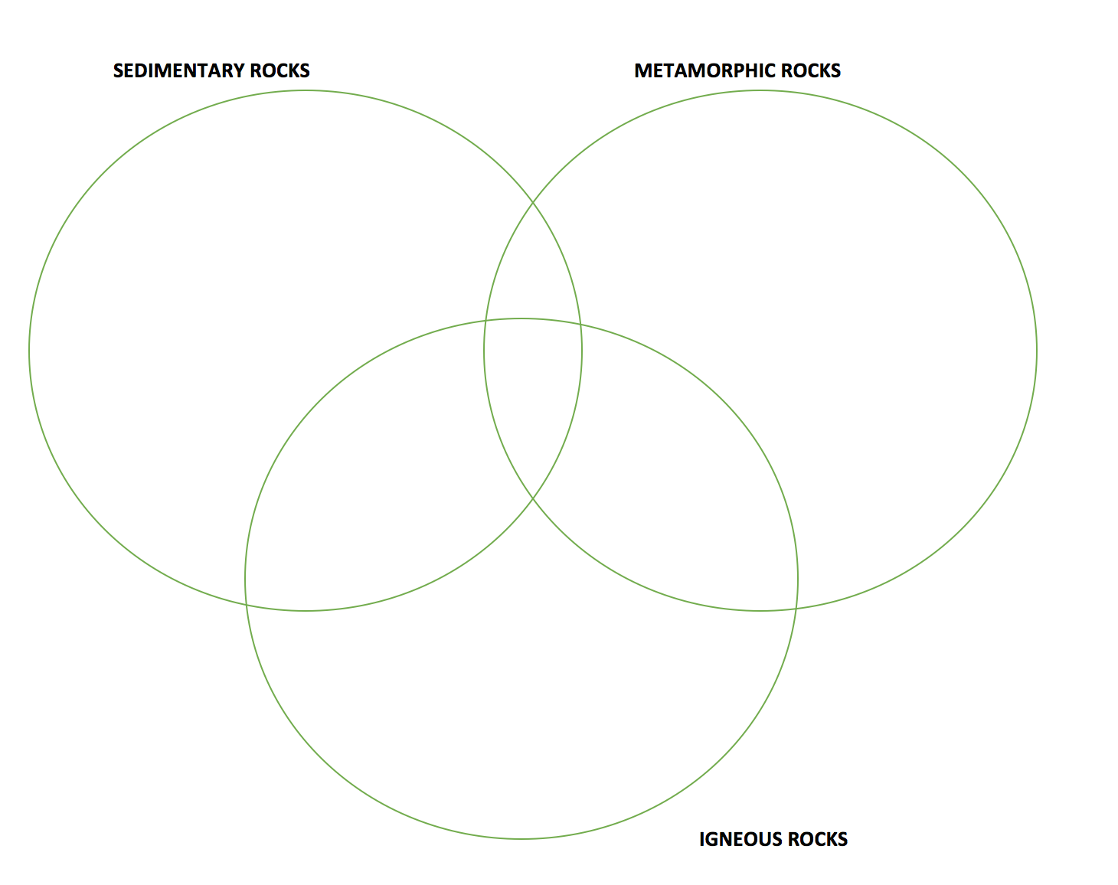

Lesson 3: Excursion
  - Place:
    - Lilydale or Woori Yallock
  - Aim:
    - Students identify sedimentary, igneous and metamorphic rocks
    - Identify different components in sand
    - Compare 4 different rocks found within the area.
  - Activity:
    - Groups of 2 or 3
    - Label the characteristics of the rock, eg. the colour, shape, sandy or solid.
    - Fill out the worksheet provided for the excursion

Lesson  100 mins | Learning Intentions | Teaching Inputs | Student Activities | Resources | Assessment
3.  Excursion | Identifying 4 different rocks within the area of either Lilydale or Woori Yallock (where Tamara’s evidence/research is based)  Understanding the difference between certain rocks found within close proximity  Linking back in timeline where the rocks came from. | Assist students where possible if they are having trouble collecting their rocks.  Assisting the students with the identification of the rock and also assisting them with trying to date when the rock was formed | Worksheet 3 provided for excursion  Identify and describe the 4 rocks found.  Provide a detailed description of the rocks  Collect sand sample for lab analysis. | Rock identifying website  http://www.minsocam.org/msa/collectors_corner/id/rock_key.htm  Students textbook  Computers: Google  Venn Diagram of the different rocks. | Assessment FOR learning:  Observing students behaviour, discussing the different rocks, making sure the students complete their worksheet.  Assessment AS Learning:  Verbal Questioning  Assessment OF Learning:  Completion of excursion worksheet, rock and sand samples collected.

Worksheet 3: Rock Excursion
Group members:

Activity 1: Collect 4 samples of different rocks within the area and draw them.
Rock | Detailed sketch | Rock | Detailed sketch
1 |  | 3
2 |  | 4

Activity 2: Provide a detailed description of your 4 rocks.
Location | Where did you find this rock? You may not remember in a few days, so write it down so that you can come back. Also, other people will be able to come see the rock you described.
Colour | · Describe the colours as clearly as you can in words. For example, "dark brown" is different than "light brown" or "reddish brown."  · Are any of the grains shiny or do they sparkle? Mention that!
Grain Size | · It's not enough to just say that the grains are "big" or "small" because what you define as big might be small to someone else. As a scientist, you should measure the grains! Use a ruler to measure the rock.  · Try to find one of the smallest grains (it shouldn't be the smallest in the entire rock, but one of the smallest) and measure its size. That is the minimum grain size. Then, measure one of the largest grains and record its length as the maximum grain size.  · If the grains are really tiny, you can write "grains too small to measure."  · If the rock looks like one solid mass and you can't see individual grains, write, "grains too small to see."
Strength | Is the rock hard and solid, or is it a bit crumbly?
Other Comments | This is space for you to write anything else interesting about the rock.

Describe each rock in the table below

Rock | 1 | 2 | 3 | 4
Location
Colours
All the same colour?
Grain Size
Minimum grain size (cm)
Maximum grain size (cm)
All the same size?
Strength
Other Comments

Assessment Task: Lab Report

Lesson 4 | Learning Concept | Teaching Input | Student Activity | Resources | Assessment
Assessment Task: Lab Report | Identifying the different types of rocks through their properties.  Labelling the collection of minerals within the rocks.  Ability to identify main life forms present in rocks. Mainly looking for Ostracods. | Provide assistance for lab report write-up, especially when writing/drawing and measuring rocks in results. | Write a lab report.  Draw, measure and write a description of rock samples.  Complete discussion questions:  - Rock cycle  - Life forms present  What major life forms would be present in these rocks?  What possible fossils could be identified in the rock samples you collected? | Rocks collected from excursion  Hands Lens  Measuring Tape/Ruler  Magnet  Rock Identification Table (Appendix 1-4)  Quick Mineral Identification  Lab Report Template  Rock Cycle Diagram  Given a list of the minerals to find within Humevale siltstone. | Assessment FOR Learning:  On task behaviour  Observe students behaviour and body language  Ask prompting questions  Exit Ticket:  Completed Lab Report  Assessment OF Learning:  Completion of lab report  Assessment AS Learning:  Self reflection questions on what they have learnt
Rock Identification sites:
http://www.minsocam.org/msa/collectors_corner/id/rock_key.htm
http://miningmatters.ca/school-programs/students/rock-and-mineral-identification-guides/rock-identification-guide
The Rock Cycle:
http://www.cotf.edu/ete/modules/msese/earthsysflr/rock.html
https://fitz6.wordpress.com/2012/05/29/rock-cycle/

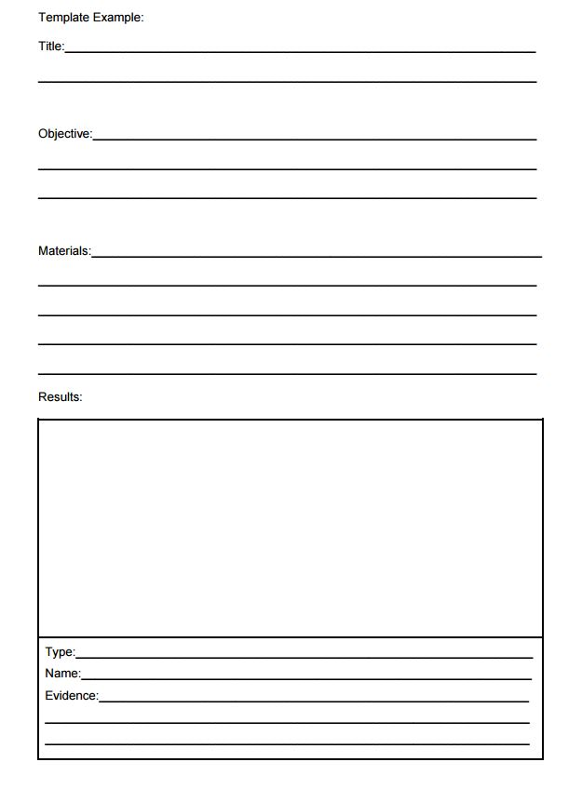
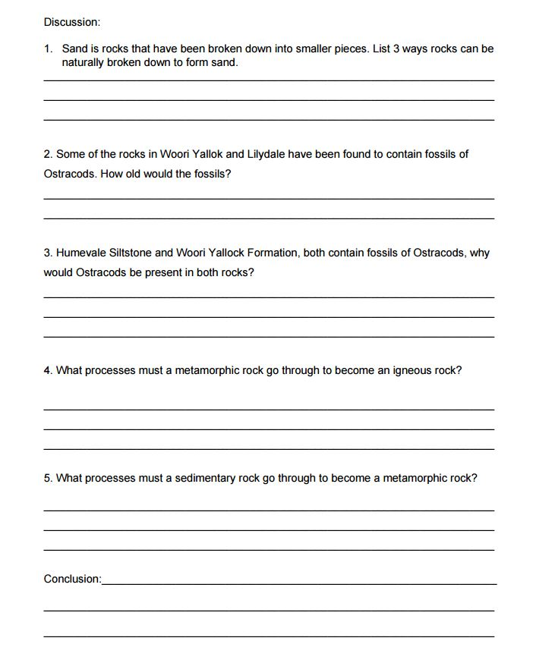

Appendix 1 Rock Types Table
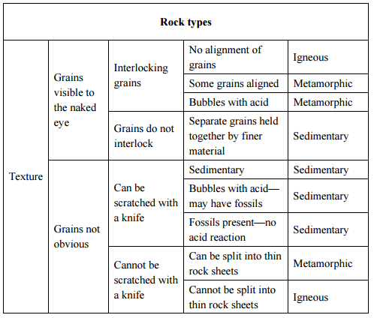

Appendix 2 Igneous Rocks Key
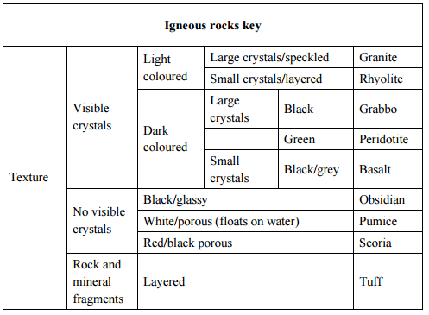

Appendix 3 Metamorphic Rocks Key
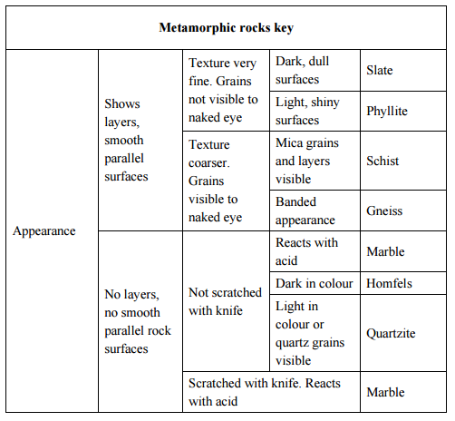
Appendix 4 Sedimentary Rocks Key
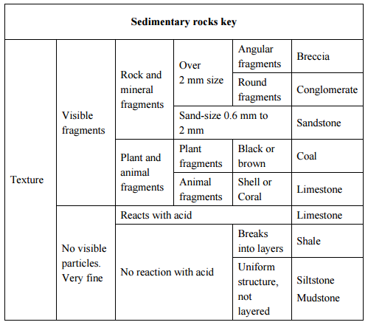
References

Tch Teaching channel, 2017, ‘history of the earth’, Retrieved 14th March 2017 <https://www.teachingchannel.org/videos/teaching-geological-time>

Rocks and Soil, Deakin University, retrieved 20 March 2017, <https://www.deakin.edu.au/arts-ed/education/sci-enviro-ed/early-years/pdfs/rocks-soil.pdf>

Development, O. (2017). Description Table | USGS Schoolyard Geology. [online] Education.usgs.gov. Available at: https://education.usgs.gov/lessons/schoolyard/RockDescriptionTable.html [Accessed 29th March. 2017].

