Laboratory LEARNING ACTIVITY

Titration of citric acid in juice

Introduction
One common task that chemists must perform is to determine the concentration of a chemical using titration. There are a variety of reasons that this may be necessary, ranging from finding an unlabelled container in the stick room to applying forensic techniques in order to identify a sample at a crime scene. In this experiment you will titrate a measured volume of citric acid (C₆H₈O₇) with a solution of NaOH of a known concentration. The acid and the base react with one another according to the equation:
C₆H₈O₇ (aq) + 3 NaOH (aq) → C₆H₅O₇Na₃ (aq) + 3 H₂O (l)
Note that each 1 molecule of citric acid contributes 3 ions of H+ to the reaction. For a simple acid-base titration, the equivalence point is defined as that point where the amount of base (OH-) have been added as there were the amount of acid (H+) initially present in the solution being titrated.
1:3 ratio in reaction
In order for a reaction to be useful for quantitative analysis, it should have a clear and easily identifiable endpoint (ie a visible and definite change in colour or other observable property). A suitable indicator has a colour change (endpoint) coinciding with the equivalence point of the titration.
The trick to this titration
During the first stages of the titration, the NaOH will be completely neutralised, and an excess of acid will remain. The trick to this titration is to have minimal stirring or swirling of the reaction mixture. As you get close to the endpoint, each drop of NaOH will cause a localised colour change, which is seen as a splash of red. The endpoint is when the localised splash of red persists for more than 15 seconds. At this point, the amount of NaOH used will be equal to three times amount of citric acid in the sample.

Aim
To determine the concentration of citric acid in fruit juice using titration techniques.

Materials
- Sodium hydroxide solution (NaOH) 0.1 M
- Diluted lemon juice (1+9 dilution in water)
- Phenolphthalein indicator  - Burette  - Retort stand  - Burette clamp  - Pipette | - Bulb pipette  - Beaker  - Conical flask  - White tile  - Funnel

Method
- Set up the burette, retort stand and clamp as shown in the diagram.
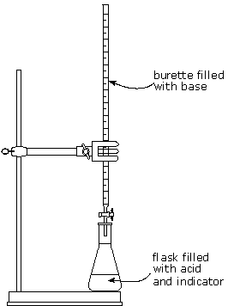
- The burette has an open and closed valve called a stopcock. The closed and open positions are shown below:
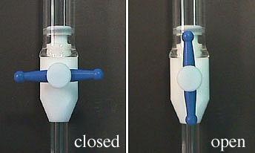
- Rinse the burette: add 10 mL of NaOH to the dry burette and let the solution run through burette tip to a ‘waste’ beaker. Complete this process a total of three times.
- Fill the burette using a funnel so that the meniscus of the NaOH solution is above the 0 mL mark. Let some of the solution run rapidly from the burette to expel all air bubbles from the tip and bring to below the 0 mL marking.
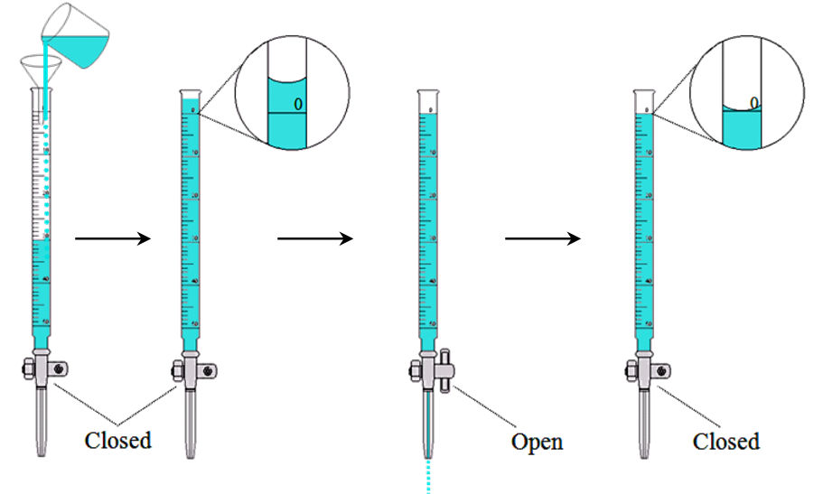
- Read the initial volume of the NaOH solution at the bottom of the meniscus and write the initial value of the NaOH in your data table. Your eye must be at the same level as the meniscus. When you first start, just read the bottom of the meniscus to the nearing marking. (Later, you will estimate the position of the meniscus to a second decimal place.) Remember that the scale increases as you go down.
- Using a pipette transfer 20.0 mL of the diluted lemon juice into a clean conical flask. Add six drops of phenolphthalein indicator.
- Place the conical flask under the tip of the burette and place a white tile under the flask to make it easier to see the colour changes.
- While continuously swirling the flask to ensure thorough mixing, run the NaOH solution from the burette. Initially, a red/pink colour will appear at the point where NaOH comes in contact with the solution in the flask, but this colour quickly disappears. As the endpoint nears, the colour will disappear more slowly. Eventually the NaOH should be added drop by drop until the red/pink colour caused by one drop of NaOH remains for at least (roughly) 15 seconds. The trick to this titration (with a pre-coloured reaction mixture) is to have some-but-not-too-much stirring/swirling of the reaction mixture.
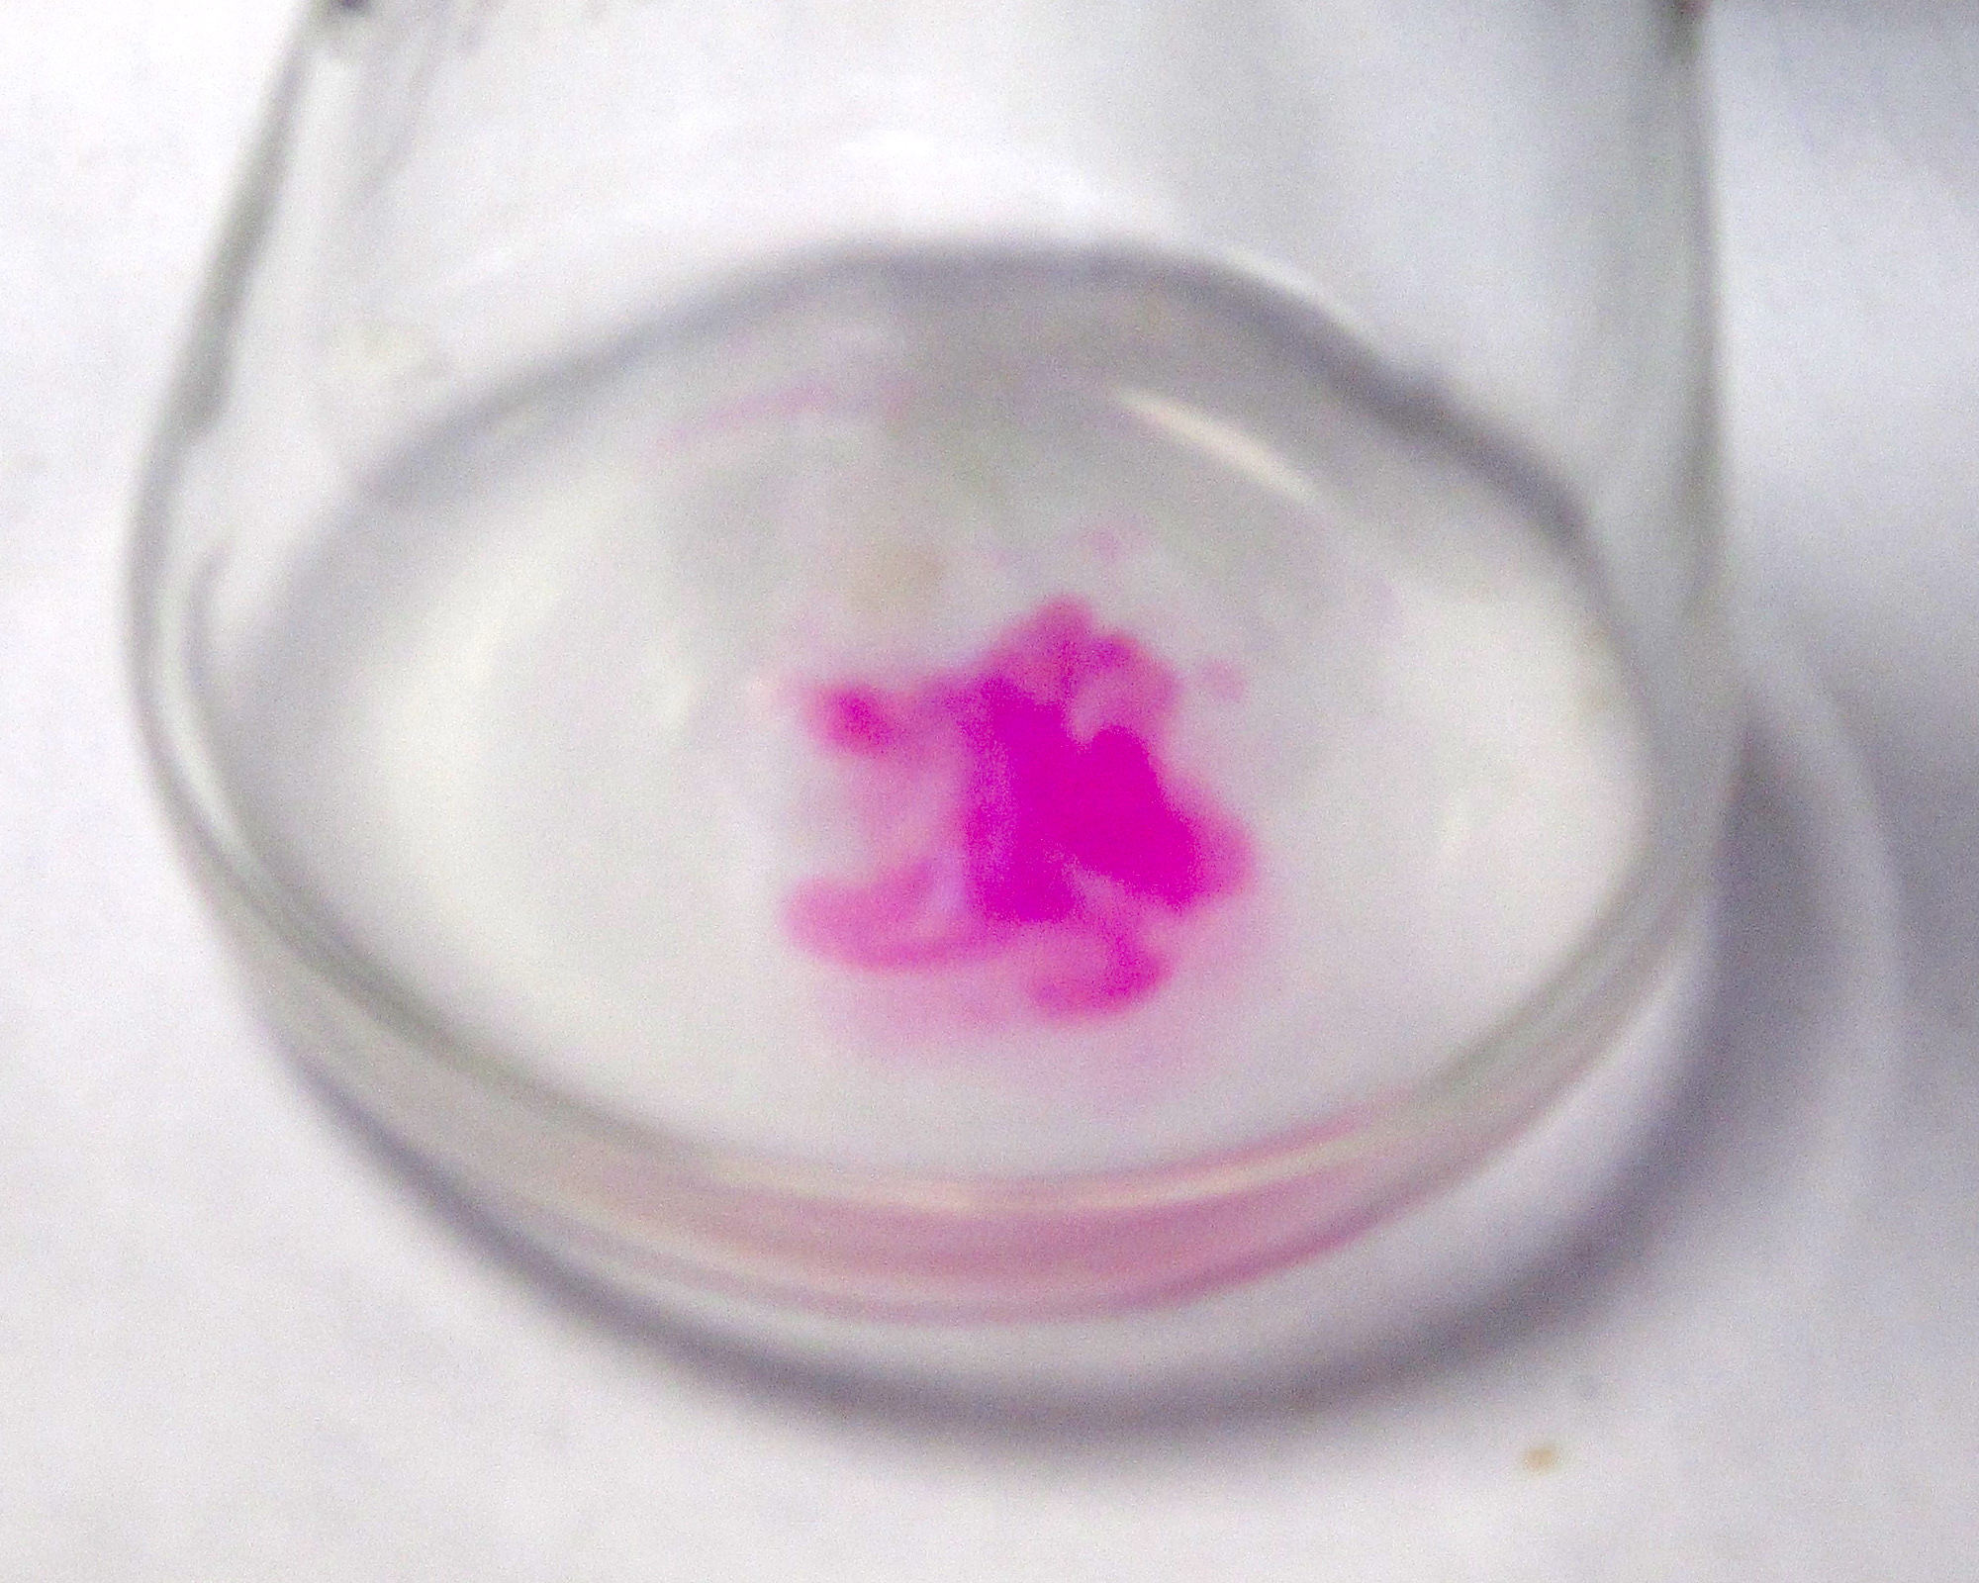
Photo: Jessica Saw and Kieran Lim

- Read the final volume of the burette and write the volume of the NaOH used in your data table. Remember that the scale increases as you go down.
- Refill the burette and complete the titration twice more.

Results:
My NaOH concentration is needed below but is recorded here:
Concentration of NaOH (mol L⁻¹)

(Titrated volume) = (Final volume) – (Initial volume)
Trial | Initial NaOH volume (mL) | Final NaOH volume (mL) | Titrated NaOH volume (mL)
1
2
3

Based on your results in the previous calculation, determine the concentration of NaOH for each trial. Remember to convert all measurements from mL to L by dividing by 1000.
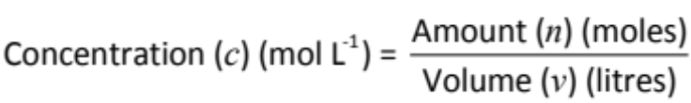
The amount of NaOH used is equal to three times the amount of citric acid reacted. Based on your results in the previous calculation, determine the concentration of citric acid for each trial.
C₆H₈O₇ (aq) + 3 NaOH (aq) → C₆H₅O₇Na₃ (aq) + 3 H₂O (l)
amount of citric acid (moles) = 3 × amount of NaOH (moles)
Trial | Titrated NaOH volume (L) | NaOH amount (mol) | Citric acid amount (mol)
1
2
3

Based on your results in the previous calculation, determine the concentration of citric acid for each trial. Remember to convert all measurements from mL to L by dividing by 1000. Also remember that the original juice has been diluted ten-fold (1+9 dilution) to obtain the diluted juice.
Trial | Concentration of citric acid in diluted juice (mol L⁻¹) | Concentration of citric acid in original juice (mol L⁻¹)
1
2
3

Copyright and Creative Commons
The moral rights of the authors, Elise Meehan, Kieran Lim, and Jessica Saw, have been asserted under the Australian Copyright Act 1968 (Cth).
Excepting logos, trademarks or other third-party content as indicated, this resource is distributed under a Creative Commons ‘Attribution-Non Commercial-Share Alike’ 4.0 International License.

