Laboratory LEARNING ACTIVITY
If the shoe fits: Student notes

Introduction
Shoes are one of the most important objects in our lives. There’s a variety of different types, such as shoes for different sports, shoes for schools and work, and just about anything that we need. Typically, we never really think about what the shoes do for us, but they help with providing little or no friction to the surfaces we walk on. In this investigation, students will investigate different types of shoes on different types of surfaces to see how they’ll vary, how they increase or decrease the frictional forces and find out what these differences mean.

Key Ideas
What is friction?
Friction is a force that opposes movement and is the reason things stay still or slow down. If friction did not exist, and if an object was moving, it would never stop moving until another force acted upon it. Friction is created when two surfaces move or slide across each other. Keep in mind air resistance is also friction; one of the surfaces just happens to be air.
Friction will always act in the opposite direction of motion of the object.
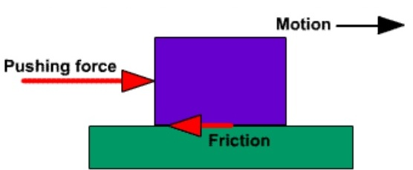

The amount of friction, or the size of the force is dependent on the surface (coefficient of friction μs) and the normal force (the mass of the object × gravity). Which you can calculate using the following:
$$F_{f}=μN$$
F_{f} = Force of friction
µ = Coefficient of friction for the two sliding surfaces
N = Normal force

There are two types of frictional coefficients, static and kinetic.
- Static: when the sliding object is stationary.
- Kinetic: when the sliding object is moving.
These forces can never happen at the same time and kinetic is always smaller than static for the same sliding surfaces.

Useful information for this experiment
The sandbags add extra weight to the shoe and put a downward force onto the ground due to gravity. The ground opposes this force in equal magnitude, so no vertical movement occurs.
Once the student pushes the shoe horizontally, when a force greater than the friction force is acting upon the shoe, it moves.
The different surfaces the students will use have different levels of imperfections. These involve crevices, troughs, ridges and peaks. The students can feel these imperfections and compare them to different materials and see which one has a smoother surface. The amount of imperfections determines the amount of friction, so those with more imperfections or courser have a higher frictional force.
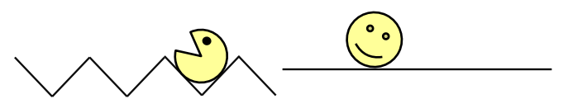
The image on the left would have more friction than that of the right.
(ASELL 2018)
If you were to compare these two surfaces above the one on the right would require less force to move the same object.
Additionally, the more friction the higher the energy loss, through heat and sound, which means a higher force required to move an object. This is due to the law of conservation of energy.

Equipment and materials
- Three shoes with different soles. E.g. Rubber, studded, leather etc
- Three surfaces. E.g. grass, wood, carpet, concrete
- Spring balance
- Weights (100 g, 200 g, 300 g)

Basic Method
- Attach shoe 1 with the spring balance.
- Pull shoe 1 across surface 1. Record results from spring balance.
- Add 100 g to the shoe and repeat step 2.
- Repeat steps 3 with 200 g and 300 g.
- Repeat steps 1-4 with shoe 2 and 3.
- Repeat steps 1-5 on surfaces 2 and 3.
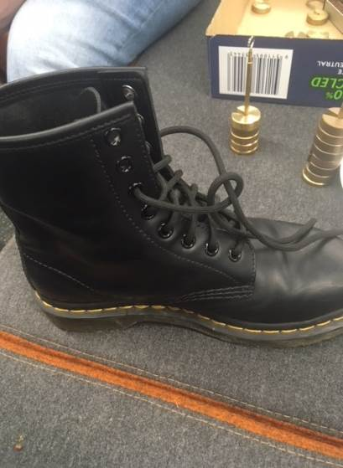
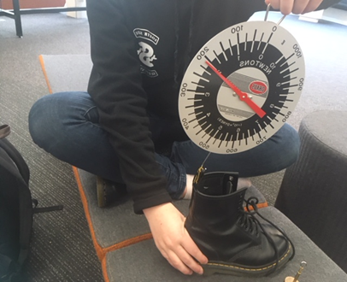

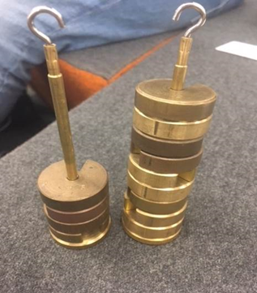
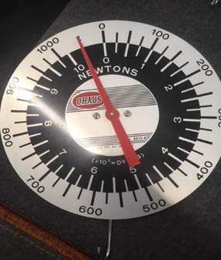
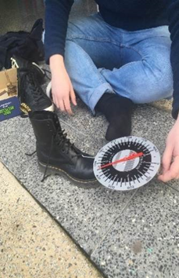

Part 1: Scientific Questions
When scientists and engineers ask a scientific question, they make a prediction: If this thing is changed, then that is expected to happen. In testing that prediction, they try to keep all other factors unchanged.
Suggest a couple of scientific questions that you could ask using your experiment equipment and materials:

Some scientific questions will be more suitable for investigation in a classroom setting. Your teacher will lead a discussion to decide which scientific question will be investigated. Your group will then decide how to investigate that question.
The scientific question that my group will investigate is:

Our hypothesis is:

Our Independent variable is (What you changed):
Our dependant variable is (what you measured):

Our controlled variables are (what did you keep the same):
Are there any safety issues to consider?

Part 2: Testing our scientific question
Get approval from your teacher of your plans (Part 1) before starting Part 2. Perform an experiment to test your hypothesis.
Shoe type | Surface Type | Weight | Friction Force (newton)
Graph: Use different colours for each shoe and make an appropriate graph that relates surface type to friction force.
Surface type
Force (Newtons)

Colour of shoe:
Shoe 1:
Shoe 2:
Shoe 3:

Part 3: Discussion
What do the trends in the graph mean?

What shoe type showed the least friction?

Which material had the most friction?

What could have caused your data to not be reliable?

Part 4: Reflection
Did your observations or measurements agree with your expectations and prediction?
Can you explain why?

Did you encounter any problems?

What changes could you have made to this experiment?
What did you discover for this experiment?

Conclusion

Copyright and Creative Commons
The moral rights of the authors, Ben Loh, Rachel McNamara, Cohen Craven, Kieran Lim, and John Long, have been asserted under the Australian Copyright Act 1968 (Cth).
Excepting logos, trademarks or other third-party content as indicated, this resource is distributed under a Creative Commons ‘Attribution-Non Commercial-Share Alike’ 4.0 International License.

