Laboratory LEARNING ACTIVITY

Motion on an incline plane: Worksheet answers

Part 1 Scientific Questions
When scientists and engineers ask a scientific question, they make a prediction: If this thing is changed, then that is expected to happen. In testing that prediction, they try to keep all other factors unchanged.
Suggest a couple of scientific questions that you could ask using your experiment equipment and materials:
- How does increasing or decreasing the slope of a plane change acceleration of an object?
- How does mass of an object effect its speed down a slope?

Some Scientific questions will be more suitable for investigation in a classroom setting. Your teacher will lead a discussion to decide which scientific question will be investigated. Your group will then decide how to investigate that question.
The Scientific question that my group will investigate is:
How does increasing or decreasing the slope of a plane change acceleration of an object?

Our hypothesis is:
As the slope decreases the speed of the object will decrease the same proportionally.

Our Independent variable is (What you changed):
The height of the ramp, angle of the ramp.

Our Dependant variable is (what you measured):
Time or distance.

Our controlled variables are (what did you keep the same):
- Same cart – different carts could have different levels of friction.

- Same surface – different surfaces could have different frictions.

- Same point of measurement for cart (front, back or line) – if you change points of measurement there would be degrees of inaccuracy.

- Method of releasing car – if a push is given on some of the trails then you would get different results.

Are there any safety issues to consider?
- Do not drop brick on hands or feet.

Part 2 Testing our scientific question
Get approval from your teacher of your plans (Part 1) before starting Part 3.

Results
Angle 1: 4.5 degrees
Time (s) | Distance (m) | Velocity (m/s)
0 | 0 | 0
0.5 | 0.2 | 0.4
1 | 0.4 | 0.4
1.2 | 0.6 | 0.5
1.4 | 0.8 | 0.571429
1.6 | 1.0 | 0.625
1.8 | 1.2 | 0.666667
2 | 1.4 | 0.7
2.1 | 1.6 | 0.761905
2.2 | 1.8 | 0.818182
2.4 | 2.0 | 0.833333
2.6 | 2.2 | 0.846154
2.8 | 2.4 | 0.857143
3 | 2.6 | 0.866667
3.2 | 2.8 | 0.875
3.3 | 3.0 | 0.909091
3.5 | 3.2 | 0.914286
3.7 | 3.4 | 0.918919
3.9 | 3.6 | 0.923077
Angle 1: 4.5 degrees

Angle 2: 8.8 degrees
Time (s) | Distance (m) | Velocity (m/s)
0 | 0 | 0
0.4 | 0.2 | 0.5
0.65 | 0.4 | 0.615385
0.8 | 0.6 | 0.75
1.0 | 0.8 | 0.8
1.1 | 1.0 | 0.909091
1.2 | 1.2 | 1.0
1.4 | 1.4 | 1.076923
1.4 | 1.6 | 1.142857
1.5 | 1.8 | 1.2
1.6 | 2.0 | 1.25
1.8 | 2.2 | 1.222222
1.9 | 2.4 | 1.263158
2.0 | 2.6 | 1.3
2.1 | 2.8 | 1.333333
2.2 | 3.0 | 1.363636
2.3 | 3.2 | 1.391304
2.4 | 3.4 | 1.416667
2.5 | 3.6 | 1.44

Angle 2: 8.8 degrees

Part 3 Forces on an inclined plane
Draw a diagram illustrating the forces on the cart on the plane
Remember to include normal and gravitational force.
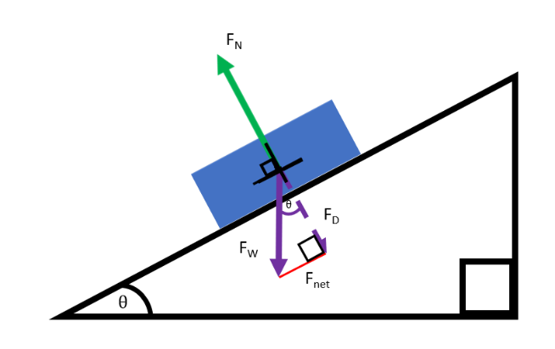

$$\sin{θ}=\frac{opposite}{hypotenuse}$$

Part 4: Calculations & Discussion
Calculations:
Using acceleration = velocity/ time
Angle 1
Calculate the average acceleration for section 1 (slope)
$$A=\frac{0.818182}{2.2}$$
$$=0.372 m/s^{2}$$

Calculate the average acceleration for section 2 (flat)
$$A=\frac{0.923077-0.818182}{3.9-2.2}$$
$$=0.062 m/s$$

Angle 2
Calculate the average acceleration for section 1 (slope)
$$A=\frac{1.2}{1.5} \\ =0.8 m/s^{2}$$

Calculate the average acceleration for section 2 (flat)
$$A=\frac{1.44-1.2}{2.5-1.5} \\ =0.24 m/s^{2}$$

Discussion:
What do the trends in the graphs mean?
For the first section in both angles the speed or the change in positive of the cart increased exponentially, evident by how this section was sloped. The second section which was flat the speed or change in position stayed at the same rate.

What do the graphs show about speed in both sections?
The speed increased significantly faster in the first section and in the second section the speed stayed relatively the same.

How does increasing the slope change the speed?
Increasing the slope, increases the acceleration and therefore increases the speed at which the car falls. Increasing the angle also means the weight force pulling the car down is larger and reduces the effect of friction.

Why is the acceleration constant in each section?
Because the angle of the slope did not change, the acceleration is constant in each section. The only forces acting on the object is gravity pulling the cart down and friction opposing it which both remained constant, meaning acceleration is constant.

Extension:
Using $a=g×\sin{θ}$ where $θ$ = angle of slope
Can you work out g?
Using slope 2:

$$A=0.8$$
$$θ=8.8$$
$$G =\frac{a}{\sin{θ}}=\frac{0.8}{\sin{(8.8)}}=5.23 m/s^{2}$$

What could cause your answer to differ from the accepted value of gravity of 9.8 m/s²?
- Using $a=g×\sin{θ}$ assumes no friction, it is an ideal, with this experiment there is friction between the cart and the plane.
- The measurements of distance and time were not exact, only to two significant figures, using a technique that could get a higher degree of reliability would also get value closer to the accepted value.
- Angle could also only be measured to two significant figures so a more accurate version of that could also improve results.

Part 5: Reflection
Did your observations or measurements agree with your expectations and prediction? Can you explain why?
This will depend on what the expectations the students had, and what they had predicted.

Did you encounter any problems?
This will vary on how the student conducted the investigation. Some students may have problems depending on their knowledge, while others will have no problems.

What changes could you have made to this experiment?
This will vary on what recommendations that the students may offer.

What did you discover for this experiment?
This will vary depending on the student’s prior knowledge.

Conclusion:
The results supported the first part of the hypothesis, that the cart would increase in speed as the slope increased, but as the cart entered the second section it did not slow down, it did not just speed up as much as the first section.

Copyright and Creative Commons
The moral rights of the authors, Ben Loh, Rachel McNamara, Cohen Craven, Kieran Lim, and John Long, have been asserted under the Australian Copyright Act 1968 (Cth).
Excepting logos, trademarks or other third-party content as indicated, this resource is distributed under a Creative Commons ‘Attribution-Non Commercial-Share Alike’ 4.0 International License.

