Laboratory LEARNING ACTIVITY
Bungee Barbie: Student notes

Introduction
Bungee jumping requires a lot of pre-planning and testing before the real thing occurs. If it wasn’t for this, if somebody just jumped off the edge of something tall with a rope, it might not be safe! In this experiment, students will be tying rubber bands to a Barbie doll to recreate bungee jumping on a miniature scale. They will be making predictions on what will be happening, measuring the distance fallen against the number of rubber bands to make a model for the bungee jump, reflecting on their predictions and investigating what happened during the jump.

Key Ideas
Forces
Standing motionless at the top of a cliff, a bungee jumper is subject to equal forces, up and down. Gravity pulls down and the earth pushes up with the same magnitude. This means that the jumper will not move. As soon as the jumper steps off the ledge the only force acting on is gravity. (Air resistance can be ignored because it is minimal.) The force of the elastic band pulling can also be ignored because when it is loose it has little affect.
When falling, the jumper will accelerate because there is an unbalanced force. Since the jumper does not get close to terminal velocity because the falling distance is short, so air resistance can be ignored for entire fall. It is only when the elastic band is at is maximum distance without being stretched that the force of the elastic band comes into play.
The kinetic energy of the jumper will transfer into elastic potential energy as the band starts to stretch, with some energy being lost as heat and sound. As the band reaches it maximum stretch, at the bottom of the fall, all the kinetic energy has been transferred to elastic potential energy.
Afterwards, the jumper will then be accelerated back up, since the elastic energy is converted back into kinetic energy. As the jumper moves up, his kinetic energy is transferred to gravitational potential energy then back to kinetic as he falls again. This cycle repeats of constant transfer between kinetic and gravitational potential energy and elastic potential energy until all the energy is lost as heat, sound and deformation until the jumper stops moving.
For a video explanation:
https://www.youtube.com/watch?v=NyVHGdrD7Bo
Equipment and materials
- A Barbie doll
- 30 rubber bands
- Tape measure (at least three meters)
- Blu-tack
- Camera with slow-motion features (i-Phone)

Method
- Attach a tape measure at top of the fall path.
- Attach the first rubber band to barbie.
- Position Barbie at top of the jump, attaching the end of the rubber band to surface
- Drop Barbie, measure and record the height dropped. (Don’t include the Barbie's hair in measurement. Use the top of Barbie's head or feet).
- Attach another rubber band to Barbie.
- Repeat steps 3 to 5 until 30 rubber bands have been reached.
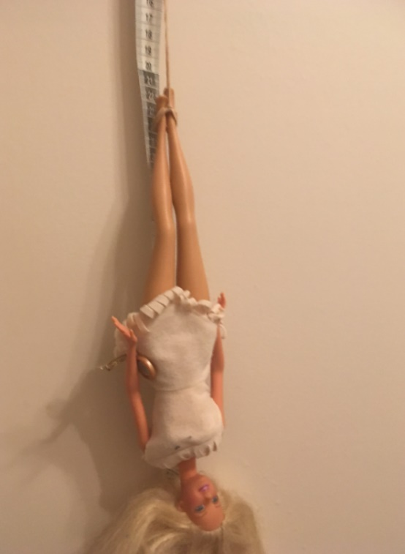
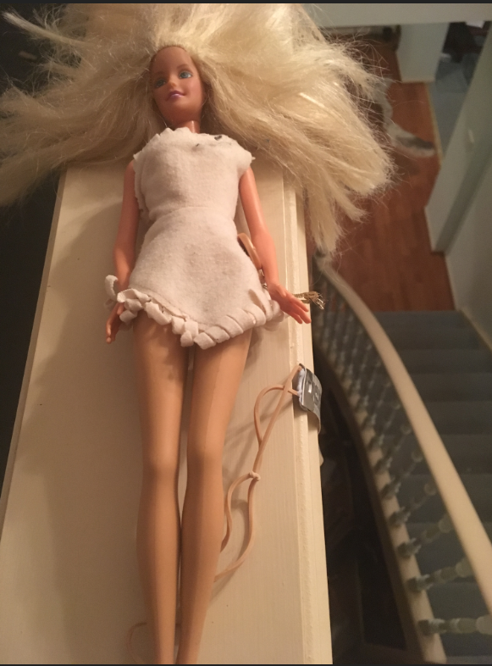

Part 1 Scientific Questions
When scientists and engineers ask a scientific question, they make a prediction: If this thing is changed, then that is expected to happen. In testing that prediction, they try to keep all other factors unchanged.
Suggest a couple of scientific questions that you could ask using your experiment equipment and materials:
Some scientific questions will be more suitable for investigation in a classroom setting. Your teacher will lead a discussion to decide which scientific question will be investigated. Your group will then decide how to investigate that question.
The scientific question that my group will investigate is:

Our hypothesis is:

Our Independent variable is (What you changed):
Our Dependant variable is (what you measured):

Our controlled variables are (what did you keep the same):

Are there any safety issues to consider?

Part 2 Testing our scientific question
Get approval from your teacher of your plans (Part 1) before starting Part 2.

Results
No. of Elastics | Distance fallen (m)
 | 1st Trial | 2nd Trial | 3rd Trial | Average
2
3
4
5
6
7
8
9
10
11
12
13
14
15
16
17
18
19
20
21
22
23
24
25
26
27
28
29
30

Graph: For this experiment a scatter plot would be best as you have an independent and dependant variable, include a trend line that goes through (0,0).

Part 3: Discussion
What does the trend in the graph mean?

If the mass of the barbie was changed, how would the graph change?

Why can’t the results be directly applied to a real bungee jumper?

What improvements could be made to make the experiment more reliable?

Part 4: Reflection
Did your observations or measurements agree with your expectations and prediction? Can you explain why?

Did you encounter any problems?

What changes could you have made to this experiment?

What did you discover for this experiment?

Conclusion:

Copyright and Creative Commons
The moral rights of the authors, Ben Loh, Rachel McNamara, Cohen Craven, Kieran Lim, and John Long, have been asserted under the Australian Copyright Act 1968 (Cth).
Excepting logos, trademarks or other third-party content as indicated, this resource is distributed under a Creative Commons ‘Attribution-Non Commercial-Share Alike’ 4.0 International License.

