Laboratory LEARNING ACTIVITY

Freshwater Indicator Species: Overview

Summary
This activity will place students in the position of a biologist who has been contracted by the Environment Protection Agency (EPA) to report on the quality of water samples. Students will have to identify different freshwater aquatic organisms from water samples, assign them SIGNAL scores, then draw conclusions on the quality of the different water samples.

Curriculum Outcomes: Victorian Curriculum F-10
Levels 9 and 10
Biological Sciences
- Ecosystems consist of communities of interdependent organisms and abiotic components of the environment; matter and energy flow through these systems (VCSSU121).

Recording and processing
- Construct and use a range of representations, including graphs, keys, models and formulas, to record and summarise data from students’ own investigations and secondary sources, to represent qualitative and quantitative patterns or relationships, and distinguish between discrete and continuous data (VCSIS137).

Analysing and evaluating
- Analyse patterns and trends in data, including describing relationships between variables, identifying inconsistencies in data and sources of uncertainty, and drawing conclusions that are consistent with evidence (VCSIS138).

Communicating
- Communicate scientific ideas and information for a particular purpose, including constructing evidence-based arguments and using appropriate scientific language, conventions and representations (VCSIS140).

Freshwater Indicator Species

Introduction
In this activity, you are playing the role of a biologist in a water pollution consultancy business. You have been contracted by the Environment Protection Agency (EPA) to report on the quality of some water samples. While other scientists will be working on the physical and chemical qualities of the water, your job will be doing a biological analysis.

Small Freshwater Aquatic Organisms
Freshwater aquatic organisms vary greatly in size. Some are microscopic bacteria that are only visible with a powerful microscope, while other organisms that can be many kilograms in weight, such as fish.
In this activity, you will be concentrating on organisms that can be just seen with the naked eye but seen clearly with low power microscopes. These organisms will include invertebrates, algae and some tiny plants.

Invertebrates
Animals without a backbone
- Protists - single-celled organisms
- Ciliates – rotifers and stentors
- Worms
- Crustaceans
- Insects
- Molluscs

Algae
- Simple photosynthesising aquatic organisms
- Unicellular e.g. chlorella
- Multicellular e.g. spirogyra

Plants
Complex multicellular photosynthesising organisms with cellulose cell walls, e.g. duckweed.

Indicator Species
An indicator species is an organism whose presence, absence or abundance reflects a specific environmental condition. For example, some organisms will only grow in very clean unpolluted water while others will grow abundantly in polluted water.

Equipment and materials
- Microscope – compound and stereo
- Petri dishes
- Cavity slides
- Flat glass slides
- Cover slips
- Droppers
A good reference is A Beginners Guide to Waterbugs produced by Melbourne Water: https://www.melbournewater.com.au/media/117.

Instructions/directions
- Collect samples to be analysed.
- Look carefully at each sample of water. Note its appearance. Make sure you look very carefully at each sample and describe it as accurately as you can.
- Put the sample into a petri dish. Use a magnifying glass and/or a stereo microscope look for small organisms. If the organisms are very small place a drop of water containing them on a flat slide. If the organism is large place it with some water on a cavity slide.
- To observe organisms more closely, use a plastic Pasteur pipette (dropper) to suck the organism up and transfer it to a microscope slide with water. Observe at low power and if necessary at high power. In each case cover with a coverslip trying to exclude air bubbles.
- Bring the specimen/s into focus. Use the information provided in the table below and any other resources available to identify the organism. Some things you see might be debris, that is, just bits of dead and decaying plant matter.
- Try to estimate the abundance of the organism. That is, the number of this type of organism in your sample. If you can count them that would that is best, but you may have to make a rough guess. In your sample is there 1, 10s, 100s, 1000s of the organism?
- If the organism has a Signal Number record it. This scoring system allows us to use the organisms in your samples to very roughly measure the pollution level of the water.
- Organisms that need unpolluted water are given a high Signal Number;
- Organisms that can live in polluted waters get a low Signal Number.
- Calculate the Signal Score from each sample, by adding up all the signal numbers of the organisms you have found and then dividing the total by the number of types of organisms in the sample. A Signal Score that is higher than six, indicates healthy water. A Signal Score that is lower than four, indicates pollution.

Results and Analysis
Sample
Appearance of Sample
Organism | Abun-dance | Signal Number | Comments
Signal Score

Sample
Appearance of Sample
Organism | Abun-dance | Signal Number | Comments
Signal Score

Sample
Appearance of Sample
Organism | Abun-dance | Signal Number | Comments
Signal Score

Sample
Appearance of Sample
Organism | Abun-dance | Signal Number | Comments
Signal Score

Drawing conclusions
Write your conclusions for each sample of water for inclusion in a report to the EPA. Be sure to write whether you think the water is polluted, in what way it might be polluted and indicate the evidence you are using to support you claims.

Further Questions

Question 1: What makes a good indicator species?

Question 2: What would an abundance of a certain species suggest?

Question 3: What could contribute to poor waterway health?

Question 4: Why is it important to monitor waterway health?

Question 5: Are there indicator species that are not aquatic?

Question 6: Would a stream with only 5 species of aquatic organisms be healthier than a stream with 50?

Short Guide to Small Freshwater Organisms
Name | Image | Where found | Signal Number
Planaria  (flat worms) | 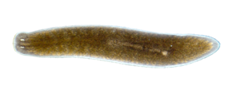  Footnote | Found in a wide range of freshwater habitats, but can tolerate polluted water. Found on the under surfaces of leaves, branches and rocks. In low oxygen conditions, they will come to the surface. | 2
Ostracods | 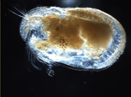  Footnote | Ostracods are found in a range of freshwater and saltwater habitats. They tend to be in abundance in warmer conditions. | 5
Backswimmers | 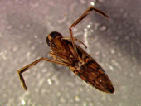  Footnote | Maybe quite large. One of several types of aquatic insects with special paddle-like legs for swimming. | 1
Daphnia | 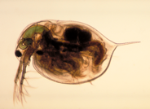  Footnote | Small semi-transparent crustaceans visible under low power microscope. | 5
Leeches | 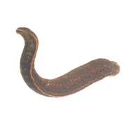  Footnote | Leeches are segmented worms like earthworms but they tend to be predators. There are a few parasitic species | 1
Damselfly Nymphs | 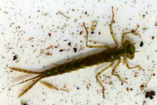  Footnote | An aquatic stage in the lifecycle of damselflies (like small dragon flies) | 8
Paramecium | 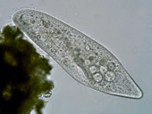  Footnote | Single-celled protists visible under low power compound microscope. Move rapidly. | N/A
Euglena | 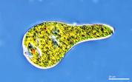  Footnote | A small single-celled prostist, which is only clearly visible at high power. | Varies
Rotifers | 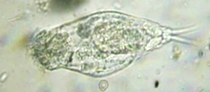  Footnote | Simple multicellular organism that uses beating cilia to move and to move food into its mouth | 5
Stentor | 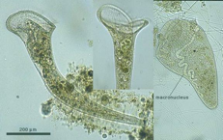  Footnote | A filter feeding multicellular ciliate. Moves food into its trumpet-shaped mouth with beating cilia. | 5
Amphipod | 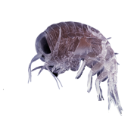  Footnote | There are many species of these small crustaceans. They feed on dead and decaying matter | 5
Vinegar eel | 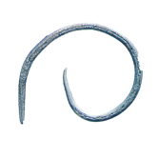  Footnote | Found in water with a low pH (acidic) | 1
Segmented worms | 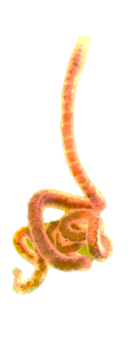  Footnote | Usually found in the mud and decaying debris at the bottom. Found in most locations but abundantly in polluted water. Often have a red blood vessel running the length of the body | 1

Short Guide to Plants and Algae
Name | Image | Where found | Signal Number
Chlorella | 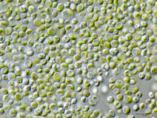  Footnote | When found in large numbers can indicate an algal bloom because of pollution from fertilisers. Clearly visible at high magnification. | Varies  In very large numbers,  1
Chlamydomonas | 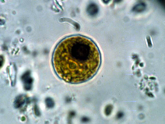  Footnote | Microscopic algae with flagella found in many habitats including stagnant water. Clearly visible at high magnification. | 5
Duckweed | 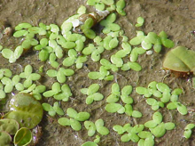  Footnote | A flowering aquatic plants which float on or just beneath the surface of still or slow-moving bodies of fresh water and wetlands. | N/A
Azolla | 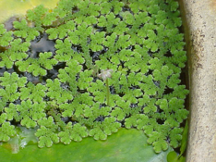  Footnote | A plant that floats on the surface of the water. In large amounts, it can suffocate a body of water preventing | N/A
Spirogyra | 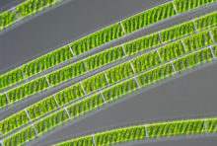  Footnote | Slimy green algae that grows near the edge of some waterways. | Varies

Copyright and Creative Commons
The moral rights of the authors, Kieran Lim, Ian Bentley, Peta White, John Long, Maria Vamvakas with support from Michael Arnold, Stella Baziotopoulos, Mika Sutawan, Arya Kutti and Josie Lam (as part of the Community Science Project unit with the Faculty of Science – 2018) have been asserted under the Australian Copyright Act 1968 (Cth).
Excepting logos, trademarks or other third-party content as indicated, this resource is distributed under a Creative Commons ‘Attribution-Non Commercial-Share Alike’ 4.0 International License.

Image by Holger Brandl, HongKee Moon, Miquel Vila-Farré, Shang-Yun Liu, Ian Henry, and Jochen C. Rink - PlanMine - a mineable resource of planarian biology and biodiversity. Nucleic Acids Res. 2016 Jan 4; 44(Database issue): D764–D773., CC BY 4.0, https://commons.wikimedia.org/w/index.php?curid=47108231
Image by Anna33 at English Wikipedia, CC BY 2.5, https://commons.wikimedia.org/w/index.php?curid=3414970
Image in Public Domain, https://commons.wikimedia. org/w/index.php?curid=378120
Are We Underestimating Species Extinction Risk? PLoS Biology Vol. 3/7/2005, e253 doi:10.1371/journal.pbio.0030253, CC BY 2.5, https://commons.wikimedia.org/w/index.php?curid=1430082
Image by Karl Ragnar Gjertsen Own work, CC BY 2.5, https://commons.wikimedia.org/w/index.php?curid=1614444
Image by Charlesjsharp - Own work, from Sharp Photography, sharpphotography, CC BY-SA 3.0, https://commons.wikimedia.org/w/index.php?curid=33922101
Image by Deuterostome - Own work, CC BY-SA 3.0, https://commons.wikimedia.org/w/index.php?curid=25530266
Image by Rogelio Moreno - Rogelio Moreno, CC0, https://commons.wikimedia.org/w/index.php?curid=19389802
Image From: https://en.wikipedia.org/wiki/Cephalodella CC-BY-SA-3.0
Image in: Public Domain, https://commons.wikimedia.org/w/index.php?curid=57073
Image by Uwe Kils - https://commons.wikimedia.org/wiki/File:Hyperia.jpg, CC BY-SA 3.0, https://commons.wikimedia.org/w/index.php?curid=50658752
Image: http://www.carolina.com/images/product/large/133266_la.jpg
Image by Michael Wigle http://www.yorkshiredalesriverstrust.com/river-processes-secondary-school-resources/
Image: Neon CC BY-SA 3.0 https://upload.wikimedia.org/wikipedia/commons/8/83/Chlorella_vulgaris_NIES2170.jpg
Image by Environmental Protection Agency - http://www.epa.gov/glnpo/image/viz_nat6.html, Public Domain, https://commons.wikimedia.org/w/index.php?curid=2776712
Image by Kurt Stüber [1] - caliban.mpiz-koeln.mpg.de/mavica/index.html part of www.biolib.de, CC BY-SA 3.0, https://commons.wikimedia.org/w/index.php?curid=5225
Image by Kurt Stüber [1] - caliban.mpiz-koeln.mpg.de/mavica/index.html part of www.biolib.de, CC BY-SA 3.0, https://commons.wikimedia.org/w/index.php?curid=6070
Image by Wiedehopf20 - Own work, CC BY-SA 4.0, https://commons.wikimedia.org/w/index.php?curid=45272023

