Laboratory LEARNING ACTIVITY

Understanding Cancer:

How does cancer start and spread?

Introduction
The Understanding Cancer worksheet introduces the abnormal division of cells involved in the formation of cancer. Students will partake in activities that primarily focus on cancer cells in the body. They will be concentrating on identifying the characteristics of a cancer cell in comparison to a normal body cell and using this knowledge to build further upon their understanding of different type of cancer in the human body.

Aim
Through the provided images, tables and internet links, students can distinguish the differences between normal cells and cancerous cells in structure and function; and able to demonstrate the impact cancers cause to our health. In addition, creating a digital animation helps students to easily understand and remember the process of cancer in different stages.

ACTIVITY 1 - Comparing Normal Cells to Cancerous Cells

TASK A:

Methods
- Go to the following link: http://www.mhhe.com/biosci/genbio/virtual_labs/BL_23/BL_23.html
- Use the simulation program “Virtual Lab Cell Reproduction: How can cancer cells be recognised?” that enables the comparison normal to cancerous cells. Select similarities and differences between cells.
- Follow the procedure in the virtual lab and fill in your data and answer the questions below.

Results
Differences in cell cycle of normal cells and cancerous cells in lung, stomach and ovary:
 | Interphase | Prophase | Metaphase | Anaphase | Telophase | Percentage of cells dividing | Percentage of cells at rest
Normal lung
Cancerous lung
Normal stomach
Cancerous stomach
Normal ovary
Cancerous ovary

Discussion

Question 1: Based on your data and observations, what are some of the differences between normal cells and cancer cells?

Question 2: Which type of cancer shows the most aggressive growth? Explain.

Question 3: When studying cell division in tissue samples, scientists often calculate a mitotic index, which is the ratio of dividing cells to the total number of cells in the sample. Scientists often calculate the mitotic index to compare the growth rates of different types of tissue. Which type of tissue would have a higher mitotic index, normal tissue or cancerous tissue? Explain.

TASK B:

Materials
Study the following diagrams and information:

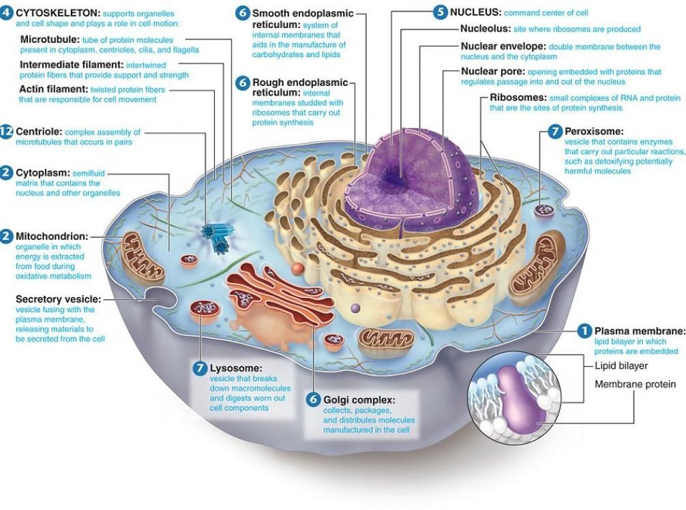
Diagram. Structure of cell and organisation of cells into tissues

Normal Cells | Cancer Cells
- Highly organised | - Show varying degree of disorganization, proportional to severity of disease
- Cells have specific structure and function | - Cells have lost their structure and function
- Normal genetic material | - Abnormal genetic material, often DNA/chromosomal duplications, rearrangement of DNA, mutations
- Cells have strong contacts with each other | - Cells have lost their adhesion to each other
- Cells are attached to the extracellular matrix (environment) | - Cells detach from the extracellular matrix
- Cells can’t move | - Cells become motile
- Cells don’t secret enzymes unnecessarily | - Cells secrete enzymes that enable them to digest their way out of their tissue and eventually get into the blood
- Cells have a distinct internal structure | - Cells change their intracellular structure e.g. lose keratin, lose cell-adhesion molecules
- Few Immune cells | - Immune cells invade cancerous tissue to try and get rid of abnormal cells
- Normal melanocyte | - Dead cells and necrotic tissue (due to inadequate blood supply)
- Basement membrane intact | - Basement membrane /ECM broken
Table 1. The differences in mechanism between normal cells and cancerous cells
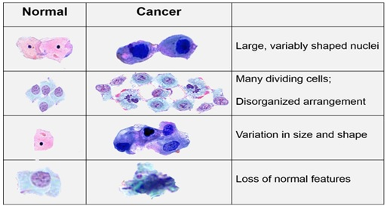
Table 2. The differences in structure between normal cells and cancerous cells

Discussion
Complete the following table that outlines 5 differences and 5 similarities between normal and cancer cells.
 | Normal cells | Cancer cells
Differences
Similarities

ACTIVITY 2 - Interpreting Graphs and Drawing conclusions

Materials
Study the following graph on incidence of various cancers in Australia and answer questions in Discussion section

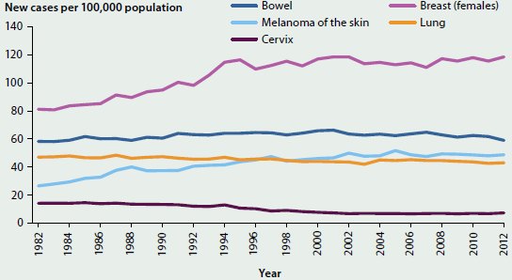
Age-standardised incidence rates of selected cancers, 1982-2012

Discussion
Question 1. Referring to number of new cases per 100, 000 population, which 2 cancer types show relatively few new cases per 100,000 population?

Question 2. New cases of cervical cancer show a slight decrease from 1990 -2010. Can you explain this decrease?

Question 3. The number of new cases of melanoma of the skin showed an increasing trend between 1982 – 2002. Calculate the percentage increase over this time. Can you explain this increase?

Question 4. Research the causes of melanoma of the skin.

ACTIVITY 3 - Representation of Skin Cell with Cancer

Methods
Label the diagram below, indicating: various cell layers, highlighting the nucleus, cell types, junctions, and blood vessels of normal healthy tissue.

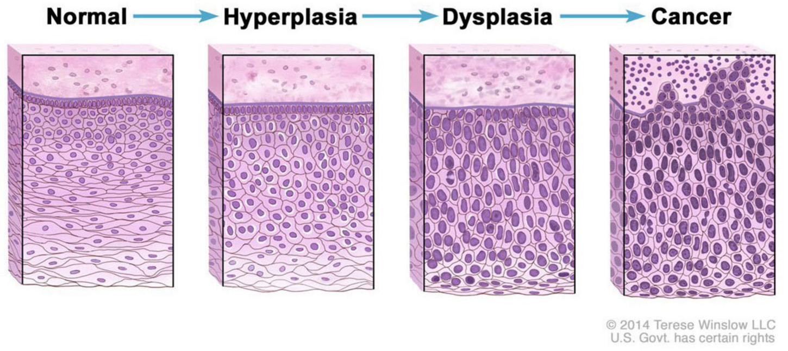

Discussion

Represent how you think a skin with melanoma will look.

ACTIVITY 4 – Digital Animation

Materials
- iPad: to access weblink
- Stop motion studio’ app on iPad
- Butchers paper, A3 paper, coloured paper
- Pencils, textas, coloured pencils, crayons
- Pipe cleaners
- Modelling clay
- Pop sticks, skewer sticks, polystyrene balls
- Glue sticks, sticky tape, elastic bands, white tac, string

Methods
Create a digital story to describe the progression from healthy tissue to cancerous tissue in skin melanoma. Animate the process that cells take to move from healthy tissue to skin melanoma. You may like to develop 3D models using the equipment provided or you may like to use a white board and drawing to help in student explanation.
- Click the links below to watch the tutorials to know what an animation looks like and to use it:
- https://youtu.be/X33pwiUT4lQ
- https://www.youtube.com/watch?v=X_M468S86HI
- Use the storyboard template below to construct the plan for how you will represent the transition. You will need to include the visual representations, the narration, and the camera actions/effects. Don’t forget to include title slides and credits (including references).

- Use STOP Motion (a free software program) downloaded to your device.
- Practice using the app based on the set up:
- Positioning the camera (retort stands, rulers, masking tape)
- Taking the shot (don’t move the iPad)
- Watch the lighting (shadows)
- Position the animations (tape things down)
- Use the onion skin to check the shot
- Plan the title and credits from the start (don’t plan to insert later)
- Narrate the video showing the progression of cell changes from normal to cancerous tissue.

Conclusion
Write a paragraph outlining the following:
- Why is cancer a health issue/biological problem and why all this research and focus into cancers?
- Explain how cancer is an imbalance of homeostasis.
- What do statistics tell us about the prevalence of certain cancers in Australia?
- How does cancer arise and spread?
- What are some of the cures of cancers?

Extension
Research one other cancer such as breast, bowel, and lung and outline the specific features of this type of cancer, causes and possible treatments.

Acknowledgements
The contributions of Peta White, and Kieran Lim to the development of this laboratory learning activity are gratefully acknowledged.

Copyright and Creative Commons
The moral rights of the authors, Kieran Lim, Ian Bentley, Peta White, John Long and Maria Vamvakas, with the support from Michael Arnold, Stella Baziotopoulos, Mika Sutawan, Arya Kutti and Josie Lam (as part of the Community Science Project – 2018) have been asserted under the Australian Copyright Act 1968 (Cth). Excepting logos, trademarks or other third-party content as indicated, this resource is distributed under a Creative Commons ‘Attribution-Non-Commercial-Share Alike’ 4.0 international License.

