Laboratory LEARNING ACTIVITY

FILL THE BILL

Aim
By observing the shape of the food and water containers, students will decide which tools can be used to get the food and drink out of the container. This is same as the association between the food source and beak shape of birds that students need to understand
In addition, the practice of using Atlas of Living Australia software on the website will help to locate the habitats and food sources of different bird species. Students will have to link the information together to determine the relationship between the appearance, food source and living location of different birds, and able to applicate this knowledges to different animals.

ACTIVITY 1 – The Best Tools to use for Different Food Sources

Materials
• 6 eyedroppers or straws
• 3 envelopes or small fishnets
• 2 large scoops or slotted spoons
• A narrow vase filled with water
• Large container filled dry oatmeal (approximately 2 cups)
• 1/2 a cup of fake worms (lollies are probably easiest)
• 4 pairs of chopsticks or forceps
• 3 nutcrackers
• 2 strainers
• 1 cup of whole walnuts or other nuts
• 2 pairs of tongs
• 1 packet of dried macaroni
• 1 aquarium or big tub filled with water
• 1 packet/1 cup of puffed rice
• 1 cup of popped popcorn or small marshmallows
• 1 packet of rice
• 1 packet of cherries (approximately 8 cherries)
• 1 roll of string

Methods
There are 8 stations that have been set up with different sources of food and tools on the side. Your job is to decide which tools will be the best to use in each station. Write down your answer in table in result section.

Hazards
There is no dangerous tools, hazardous and flammable chemicals in use.

Results
Station | Best Tool
1
2
3
4
5
6
7
8

Extension of Results

Base on your findings in results, draw a beak shape that would best suit each type of food in table below.
Food | Beak Shape

Nectar

Worms in mud

Seeds

Fish

Tiny aquatic organisms

Flying insects

Caterpillars and insects

Fruits

Discussion
Question 1. How do their beaks compare with your drawings?
To what extent do you think this modelling activity allows you to understand bird beak adaptation?

Question 2. What do these models not show about bird beak adaptation?

Question 3. How do these activities represent the way that scientists study adaptations?

Question 4. Can you link this modelling activity to the scientific practice of palaeontology (scientists interpreting dinosaur fossils)?

ACTIVITY 2 – Atlas of Living Australia Practice

TASK A:

Methods
- Go to the Atlas of Living Australia http://www.ala.org.au/
- Click the browse location tile and type the Geelong into the Search field.
- Set the radius to 10 km.
- Use the list under the heading Species: Common Name to find each of the birds listed in previous page of the website.
- Find how many recorded sightings there have been of each bird in table below and describe the habitat/s in which the bird has been sighted.
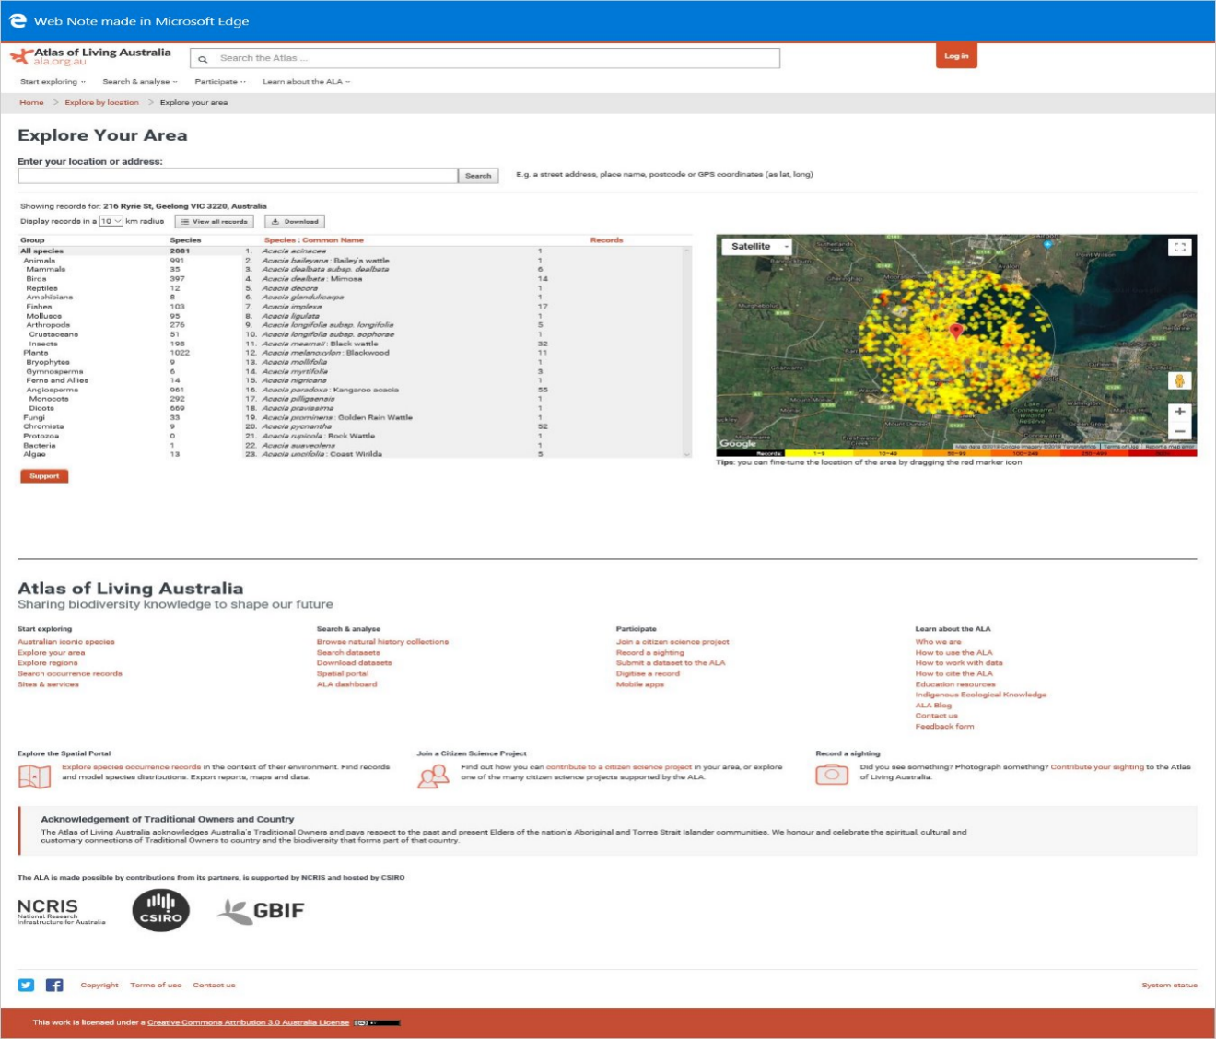Figure. The ALA ‘Explore Your Area’ web page with the location set to Geelong with a radius of 10km.

Results

Bird | No. of Records | Habitat(s)
Anas platyrhynchos
Common Mallard
Manorina melanocphala
Noisy miner
Turdus merula
Common blackbird
Pelicanus conspicillatus Australian pelican
Rhipidura leucophrys
Willie wagtail
Cacatua galerita
Sulphur-crested cockatoo
Anthochaera carunculata
Red wattle bird
Cracticus torquatus
Grey butcherbird

TASK B:

Methods
Except for the Mallard the birds listed so far are relatively common, look through the list and pick out 6 birds that are rare (10 – 30 recorded sightings).
List these rare birds in the blank parts of the table together with their habitats.

Results
Bird | No. of Records | Habitat(s)

ACTIVITY 3 – Case Study
In developing your report to the council, you have consulted a scientist who has advised against you using some of the information on the birds recorded in the Atlas of Living Australia. The scientist said that the dots on the maps are not an accurate representation of the distribution of the birds, that some of the information is unreliable and out of date.
The scientist has provided a list of birds in the table below as evidence of her claims. Examine the list of records and identify how recent the sightings of the birds were made and who has recorded those sightings.

Methods
The scientist has provided a list of birds in the table below in Results as evidence of her claims. Use ALA website, examine the list of records and identify how recent the sightings of the birds were made and who has recorded those sightings.

Results
 | Dates of Record | Number of difference | Useful data for Report (Yes/No)
Regent honeyeater
Australian bustard
Rufous songlark
Rainbow bee-eater
Australian king parrot
Chicken hawk

Discussion
Question 1. Decide whether you think that the information on the location of each bird is current and reliable enough to use in your submission to council.

Question 2. Choose one of the above that is unreliable.
What could be done to generate more accurate data about
- Distribution

- Habitat

Question 3. If a scientist is to work for the Geelong City Council in recommending habitat management what range of things should they consider? For example, food sources.

Question 4. A local Councillor objects to spending money on bird preservation. He suggests that the money would be better spent on upgrading the football ground/facilities. How would construct an agreement in support for bird preservation?
.

Conclusion
In 50-100 words, write about the learning outcomes that you have achieve through activities about the relationship between birds’ beak shape and food source as well as the application of Atlas of Living Australia in animal’s study and research.

Acknowledgments
Special thank you to Atlas of Living Australia (ALA) for allowing for their content to be used for this activity.

Copyright and Creative Commons
The moral rights of the authors, Kieran Lim, Ian Bentley, Peta White, John Long, Maria Vamvakas with the support of Michael Arnold, Stella Baziotopoulos, Mika Sutawan, Arya Kutti and Josie Lam (as part of the Community Science Project unit with the Faculty of Science - 2018) have been asserted under the Australian Copyright Act 1968 (Cth).
Excepting logos, trademarks or other third-party content as indicated, this resource is distributed under a Creative Commons ‘Attribution-Non Commercial-Share Alike’ 4.0 International License.

