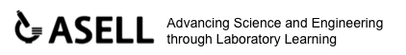Laboratory learning activity

CONSTRUCTING A PROPELLER-DRIVEN ELECTRIC CAR

Instructions for the building a propeller-driven electric car are provided here. The resulting car can be used to investigate the relationship between electrical energy input and kinetic energy output. Within the context the car provides, students can learn about and consolidate their understanding of series and parallel circuits as well as voltage and current. The design allows flexibility in the way four AA batteries are connected together to provide differences in voltage and current for driving an electric motor which is used to spin a propeller.

MATERIALS | TOOLS
Plastic bottle – preferably square section so that it has a flat base  Soft drink bottle 1.25L  Drinking straws  Two bamboo skewers  Light toy truck wheels or plastic screw tops from milk bottles  4 AA battery holders and batteries  An electric motor (1.5 – 6V) | Ruler or measuring tape  Scissors  Craft knife or blade  Hot glue gun  Sandpaper  Candle (and matches)  Spiked tool

PROCEDURE
Making a propeller  - Cut the top off a soft drink bottle as shown. Keep the screw top.  - Cut the top of the bottle to produce 8 propeller blades of the same size.  - Warm propeller blades over candle till slightly flexible and twist as shown. Practice with a couple of pieces of plastic cut from the rest of the drink bottle. Repeat with each blade so that each blade has approximately the same slight twist. All twists must be in the same direction.  - The length of the propeller blades may need to be trimmed. Blades of 6cm in length seem to work well  - Remove the screw top. Using a spike tool, poke a hole in the centre of the bottle top. The drive shaft of the motor will be pushed into this hole. Be careful not to push the spike into your hand or the furniture. Use a scrap piece of wood to support lid. | 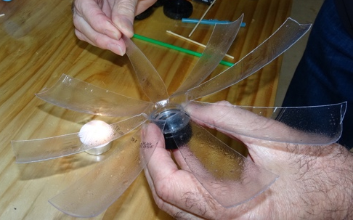

Assembling Car

- Layout all of the parts.
- Cut two straws 8 cm in length and skewers to 10 cm in length with scissors or blade.
- Shave blunt ends of skewers with sandpaper and check that the skewers push into the axel holes of the wheels.
- Push the skewers through the straws and attach the wheels
- Glue straws to bottle as shown.
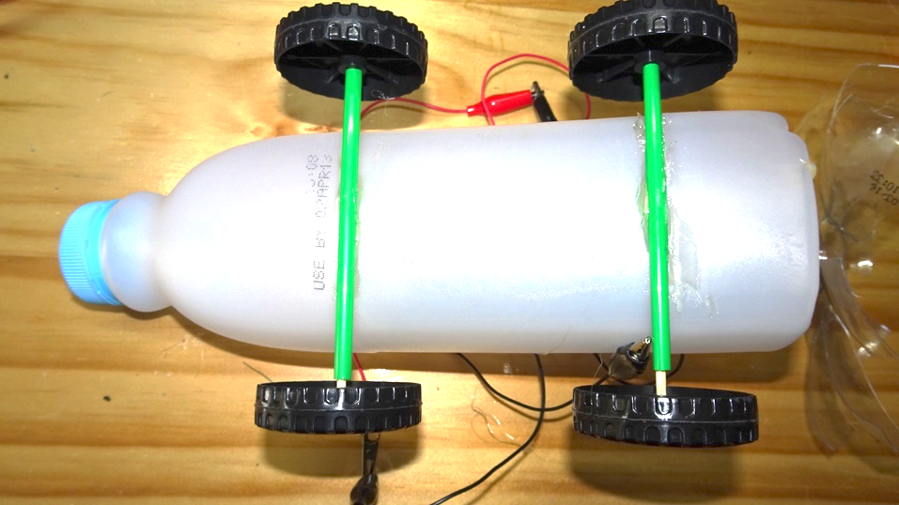
- Glue the battery holders to the bottle. Note: Alligator clips have been soldered to the wires on the battery holder.
- Glue the motor to the centre and as close as possible to theend of the bottle so that the propeller is clear of the end of the bottle.
- Attach propeller to motor drive shaft using the hole in the bottle cap.
- Connect wires and away you go.
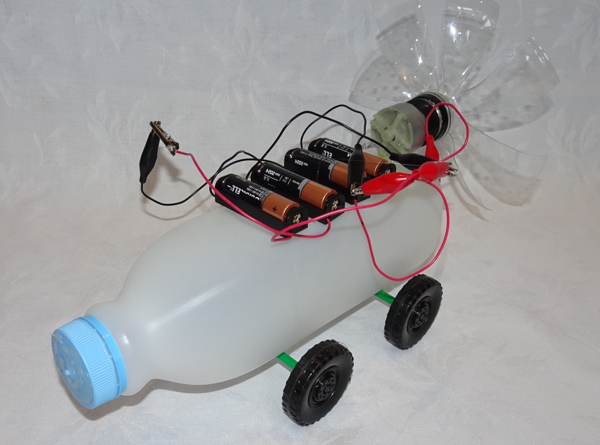

Excepting logos, trademarks or other third-party content as indicated, this resource is distributed under a Creative Commons ‘Attribution-Non Commercial-Share Alike’ 4.0 International License.
The moral rights of the authors, Ian Bentley, Peta WhiteKieran Lim, and John Long, have been asserted under the Australian Copyright Act 1968 (Cth).

